25 March 2018
Lance Corporal 29517 William REASON
1st battalion Royal Dublin Fusiliers
Birmingham City Police ‘B’ Division PC B 129
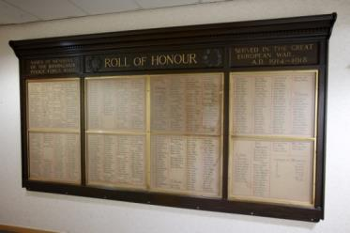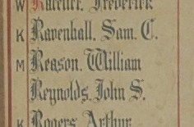
William is marked as missing on the Roll of Honour
William Died in France 3rd April 1918 aged 25
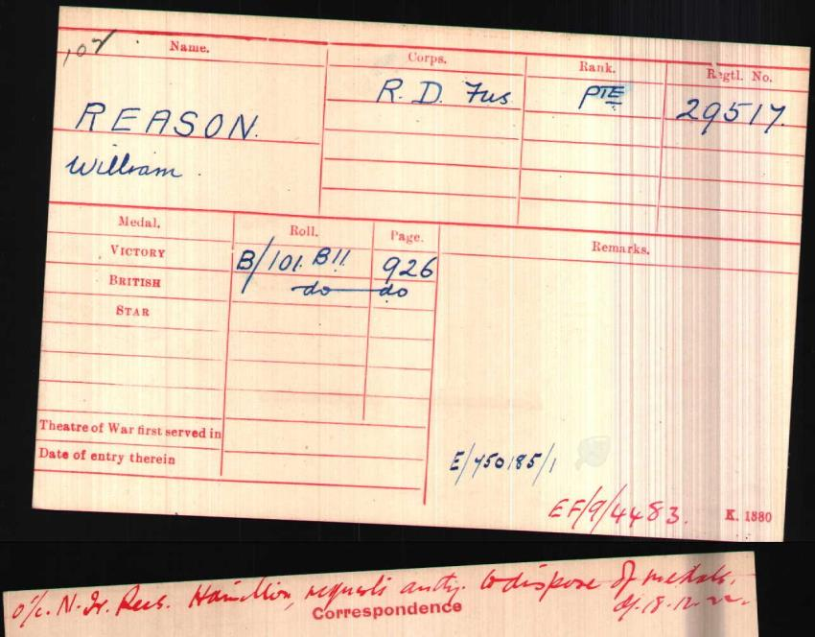
British Army WW1 Medal Index cards 1914-1920

Police Service History
27th November 1912 William joined Birmingham City Police as a 19 year old farm hand. He served on the ‘B’ Division with warrant number 8250 and collar number B129. He resigned 5th March 1917 and enlisted in the Army in Birmingham

29th August 1918 Birmingham City Police records state William is confirmed as missing
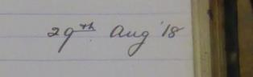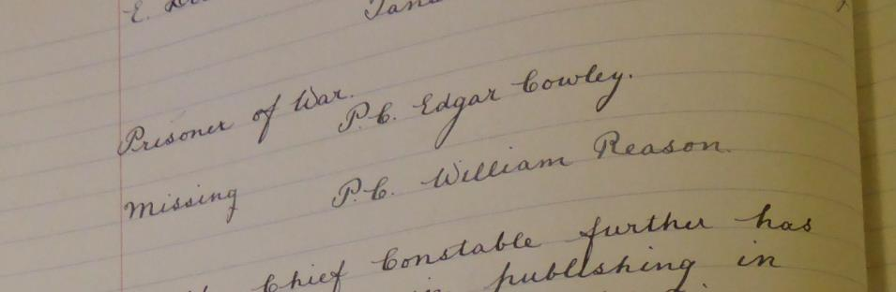

A service was held at The Parish Church, Birmingham
Sunday 5th December 1920 3.30pm
Remembering those police constables killed in action, those who died on active service and those who died from illness due to war service

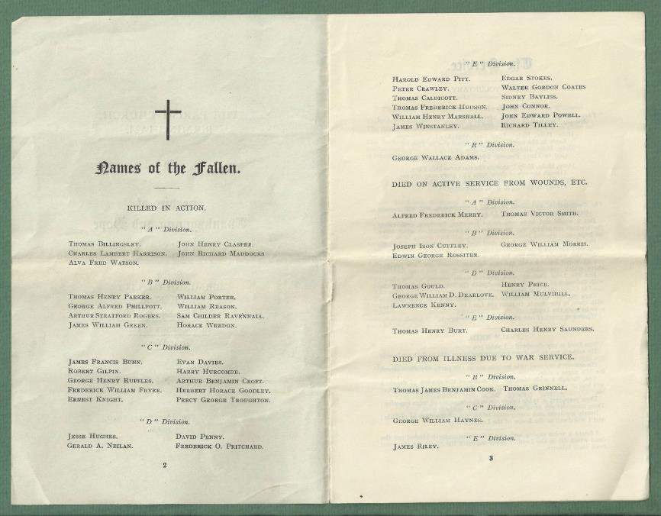
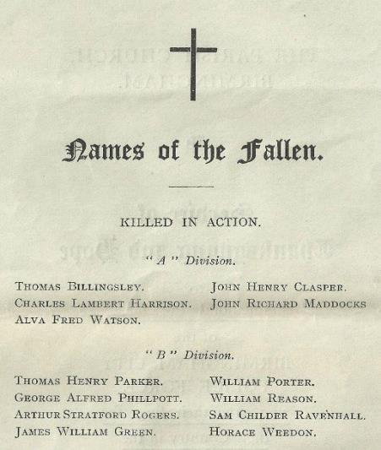

War Service History
William was killed at La Motta on the Peronne Road, France.
The German Spring offensive commenced at 4.45am on Thursday 21st March 1918, at which time William's battalion was situated in the village of Epehy. The Division to which his battalion was attached, the 16th (Irish) Division, bore the brunt of the ensuing attacks and virtually ceased to exist. Overwhelmed in the first few days, the battalion lost 141 men killed and many more times this number wounded and captured.
Retiring in the face of the attack, the battalion assembled at Hamel and on Sunday 31st March 1918 received 23 men, survivors of the 2nd Battalion, Royal Dublin Fusiliers. Between Monday 1st April 1918 and the day of William's death the battalion spent the time digging a switch line at the rear of Hamel. On Wednesday 3rd April 1918 the battalion was withdrawn from the line and split up.
William’s unit were part of the 48th Brigade; itself part of 16h (Irish) Division; and they were part of VII Corps, commanded by Lieutenant-General Sir Walter N Congreve VC; which formed part of 5th Army, commanded by General Henry Rawlinson, who had replaced Lieutenant General Sir Hubert Gough on the 28th March. On the 2nd April it was renamed the 4th Army.

Ireland’s Memorial Records 1914-1918
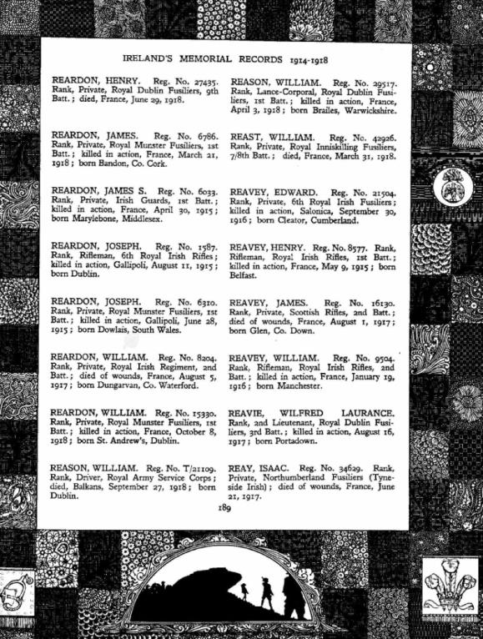
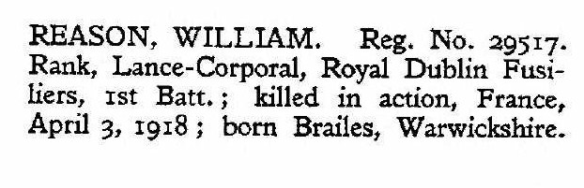

Commemorated Panel 79 and 80
Pozieres Memorial
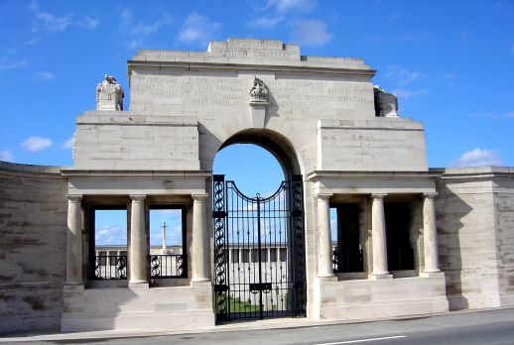
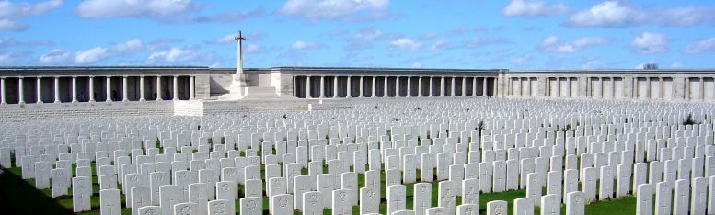
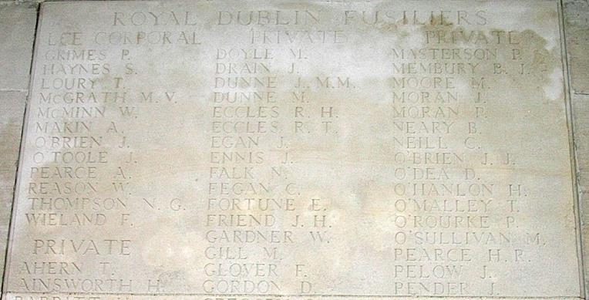
Findagrave.com

Antecedents of William REASON

- Born circa 1893 in Winderton, Brailes, Warwick and resided in Banbury
- Son of William and Mary Ann Reason, of "Hill View", Winderton, Brailes,
- He was baptised on 15th February 1893
- He resided in Banbury Warwickshire and worked as a farm hand
- In the 1901 census William and Mary are living with their children Frank (1891), William (1893), Elizabeth (1897) and Percival Joseph (1900). William's father was a general labourer. The family were still living there in 1911 when William was also working as a hotel porter.

