October 2017
Private 21909 Frederick Oscar PRITCHARD
1st battalion Coldstream Guards
Birmingham City Police ’D’ Division PC D 157
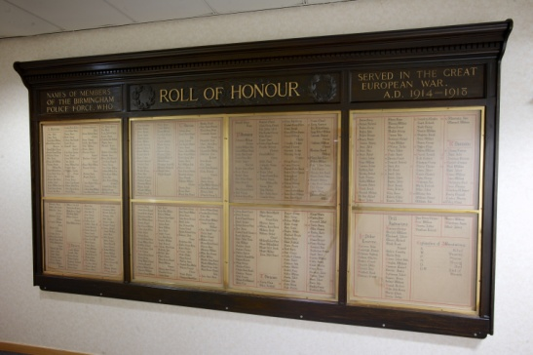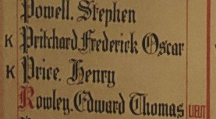

Died France 27th November 1917

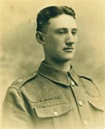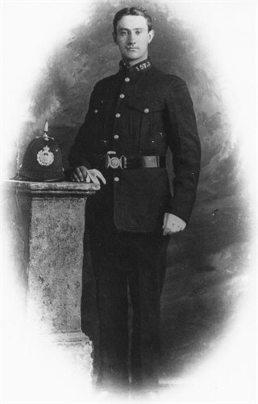
Courtesy of ancestry.com family tree roydavies46

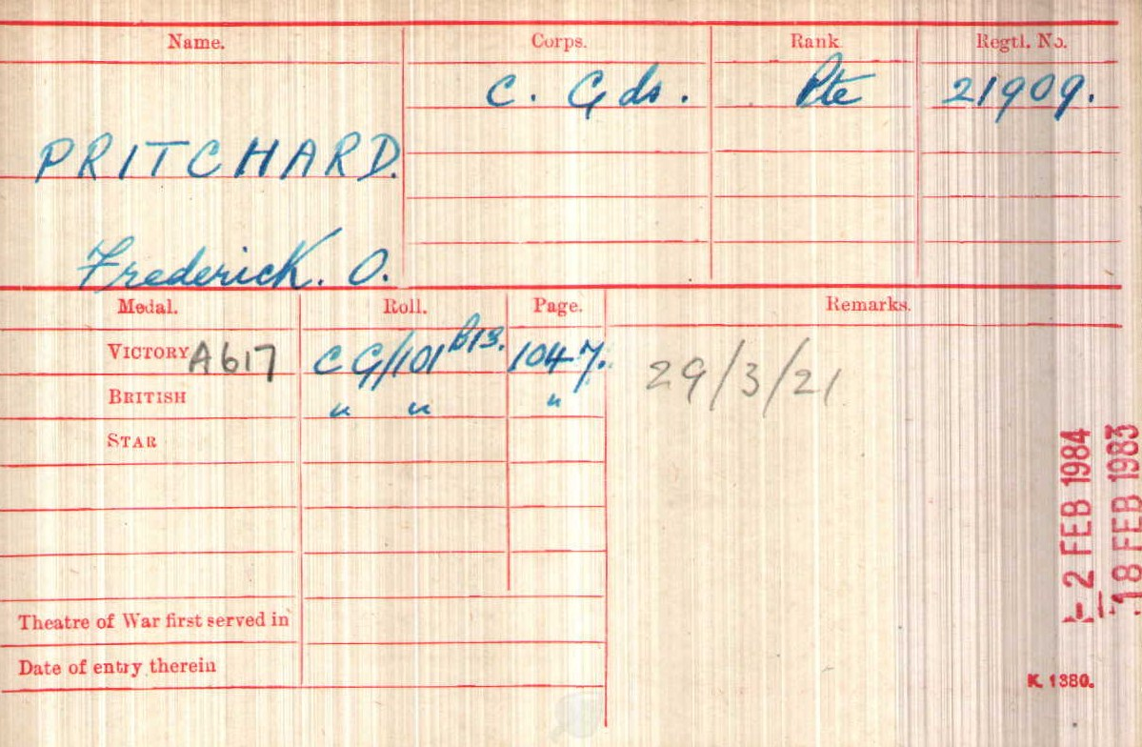

Police Service History
Frederick joined the Birmingham City Police on 1st March 1915 as a labourer and served on the ‘D’ Division with the warrant number 8602 and collar number D157. He resigned to enlist in the army in Birmingham.
Birmingham City Police Records states that PC D157 Fred O Pritchard along with 42 other officers was to join the Army and they were to report on Monday 5th March 1917 at 0930 at Curzon Street
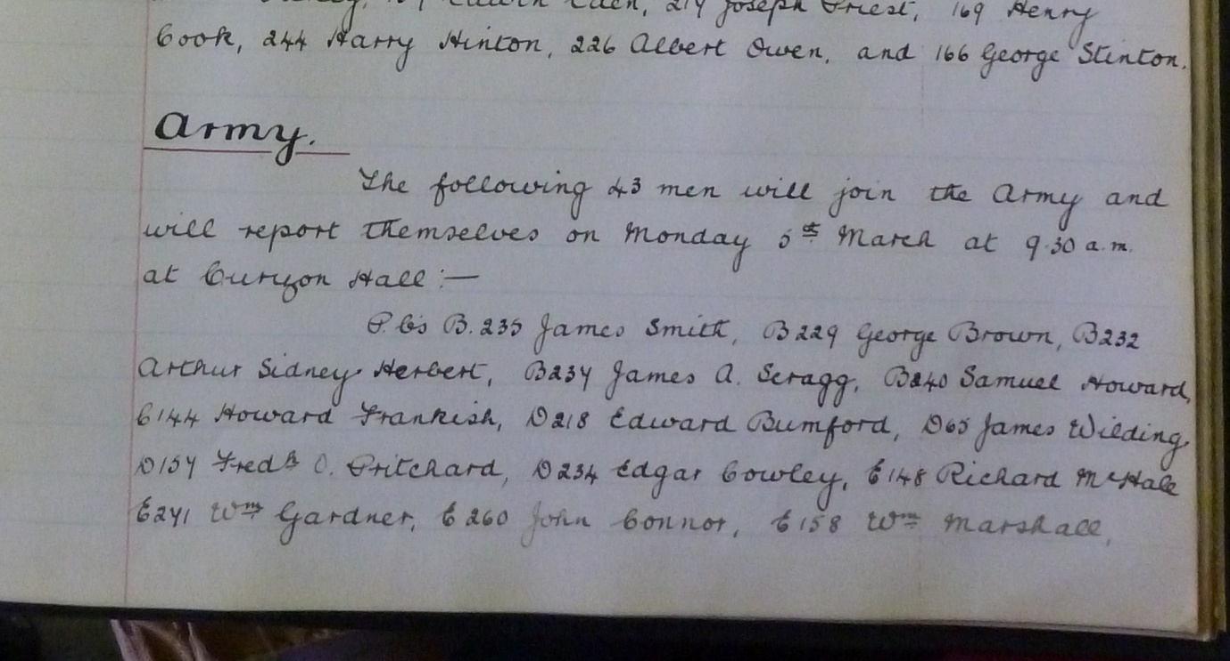

1918 Absent voters list shows Frederick residing at Duke Street Police station as 21909 Coldstream Guards, and he also worked at Duke Street.

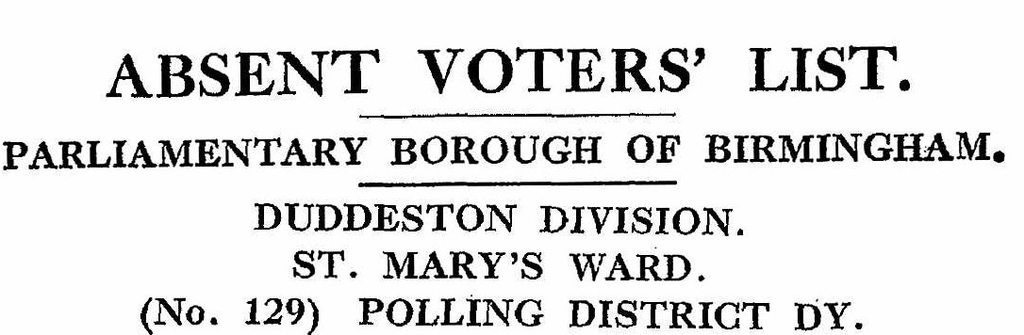
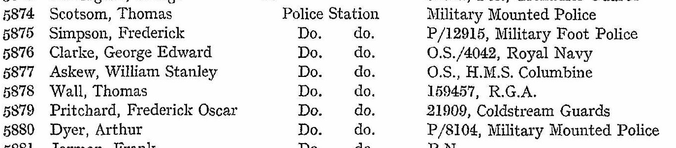

War Service History
At 6.20 am on the day of Frederick's death his battalion, together with the 3rd Battalion, Grenadier Guards and 2nd Battalion, Irish Guards, attacked Fontaine-Notre Dame, the battalion's objective being to seize the railway line from the northern edge of the village to the eastern edge of Bourlon Wood. Initially the battalion made a good headway but encountered enfilading machine gun fire from Bourlon Wood.
They then encountered determined resistance from Germans posted in a quarry just outside the village and lost all their officers overcoming the obstacle by 'bombing' their way along the trench system. Elements from the battalion gained access from the village and the railway line but found that, due to the excessive casualties, they did not have the manpower to consolidate the gains. As the Germans developed counter attacks the battalion was forced to retire with casualties of 75 men killed and hundreds wounded.
Frederick’s unit, commanded by Major General Evelyn Thomas Boscawen, 7th Viscount Falmouth, was part of the 2nd Guards Brigade, commanded by Brigadier-General B.N. Sergison-Brooke; it too formed part of the Guards Division, whose commanding officer was Major-General G.P.T. Feilding; and they were part of IV Corps, who formed part of the 3rd Army, commanded by General Sir Julian Byng.
The 1st battalion were in the centre of the advance on the wood, and though they had the support of the tanks they suffered heavy losses, with two companies almost wiped out. The action was part of the overall battle of Cambrai that lasted until 3 December.
Initially a brilliant tactical success which tore a wide gap in the German defence line, unfortunately the Cavalry Corps could not be brought forward quickly enough and the Germans were able to seal off the penetration, using tactics as developed at Caporetto, Italy October 1917

It would appear that Frederick was reported missing as an article dated January 1918 appeared in the ‘Police Review and Parade Gossip’ from Frederick’s mother appealing for news of her son
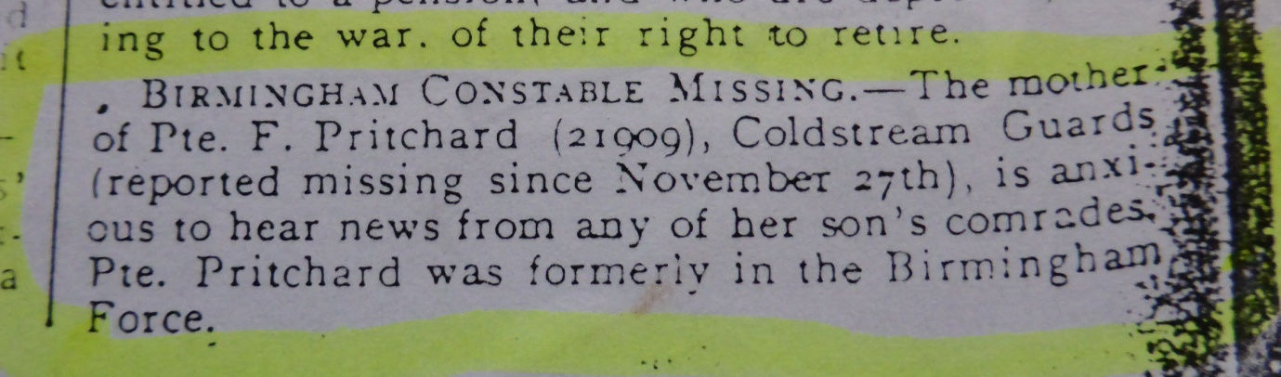

A Service was held at The Parish Church, Birmingham
Sunday 5th December 1920 3.30pm
Remembering those police constables killed in action, those who died on active service and those who died from illness due to war service

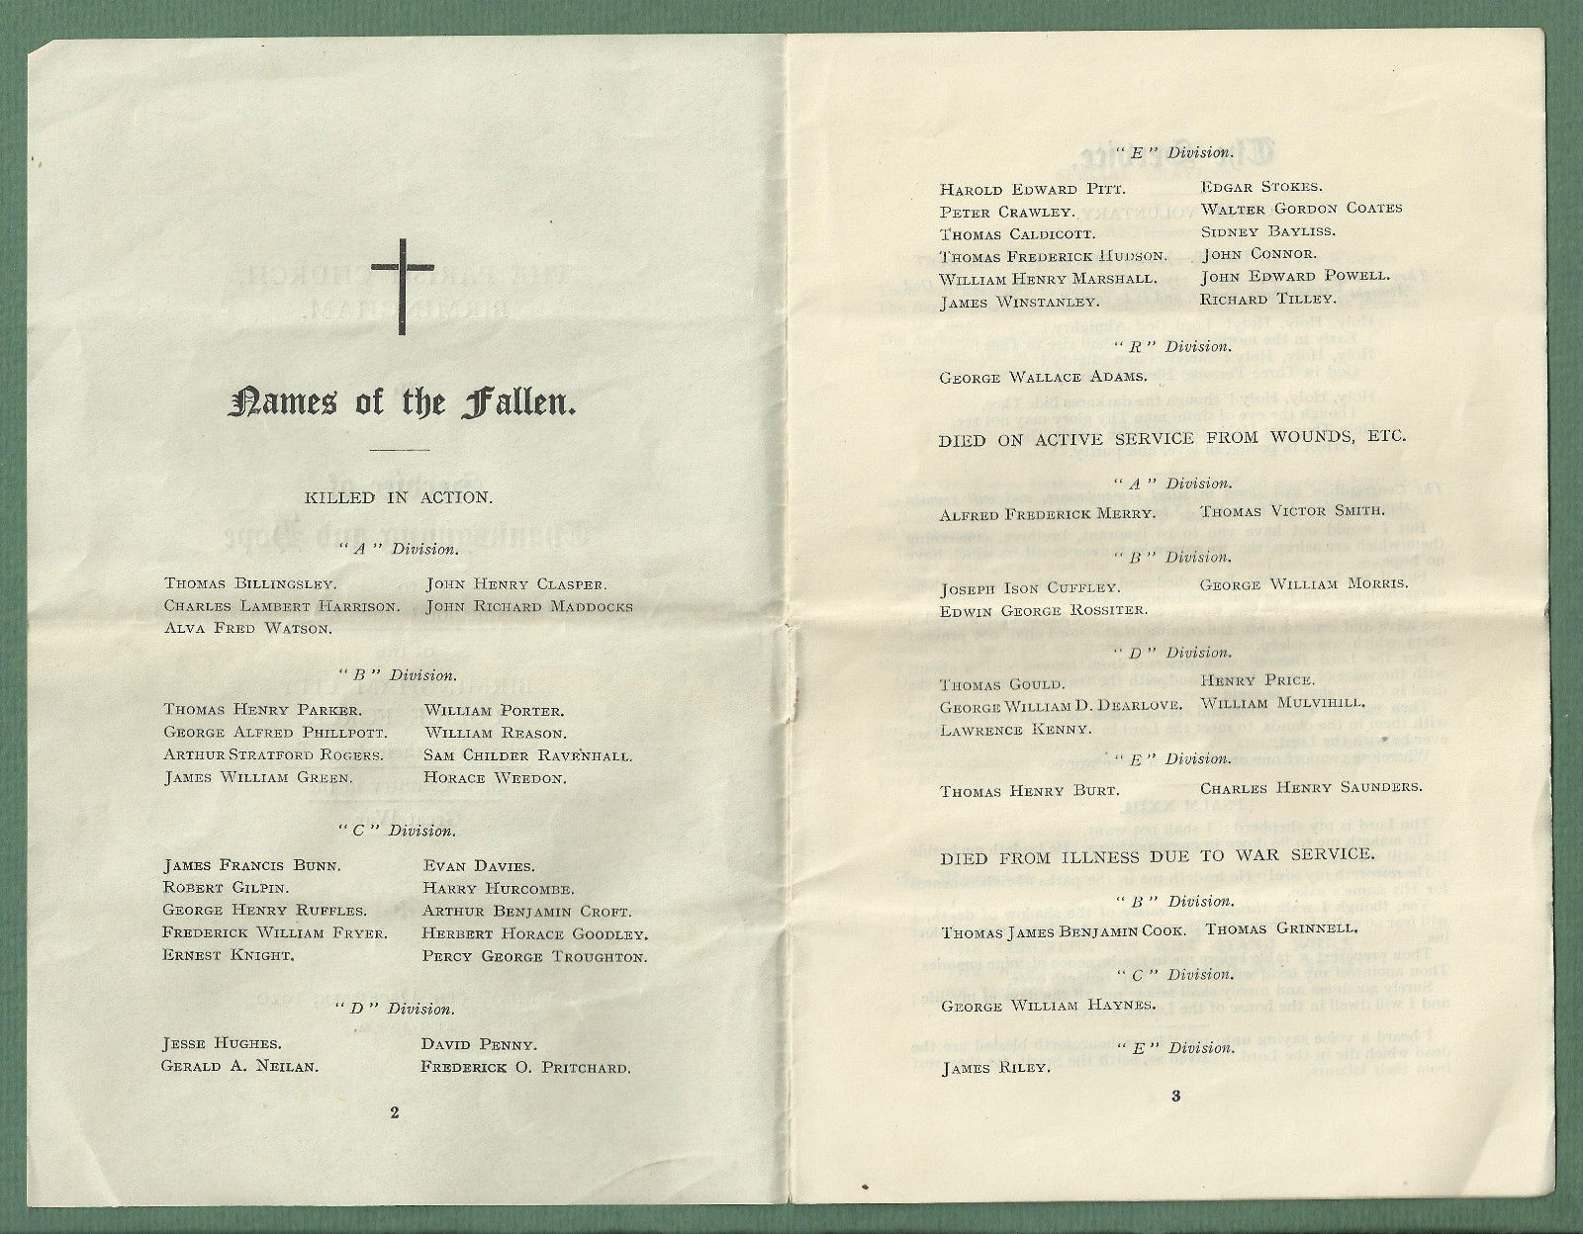

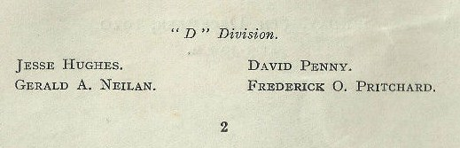

Frederick is commemorated Panel 2
Cambrai Memorial, Louveral, Nord-Pas-de-Calais
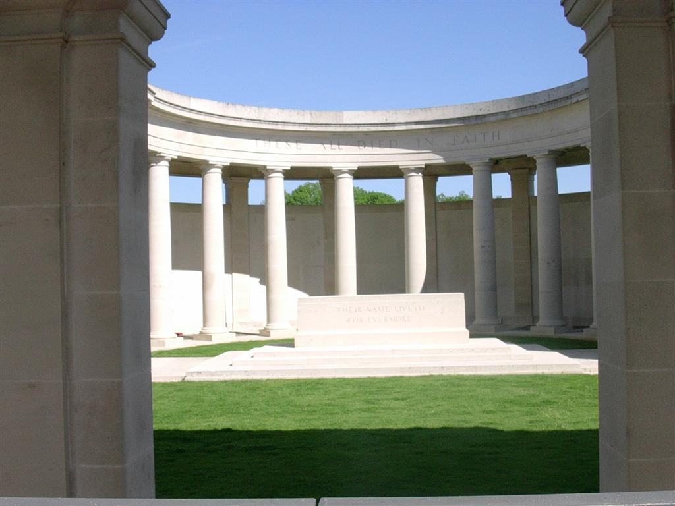

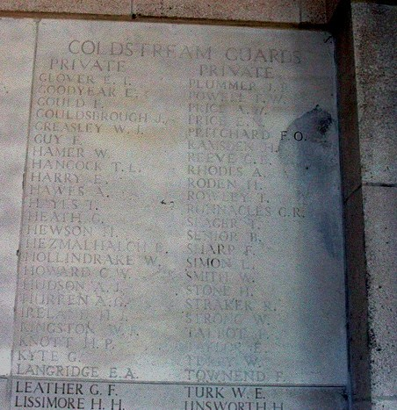
Findagrave.com
Frederick is remembered on the WW1 memorials at Pensax Church

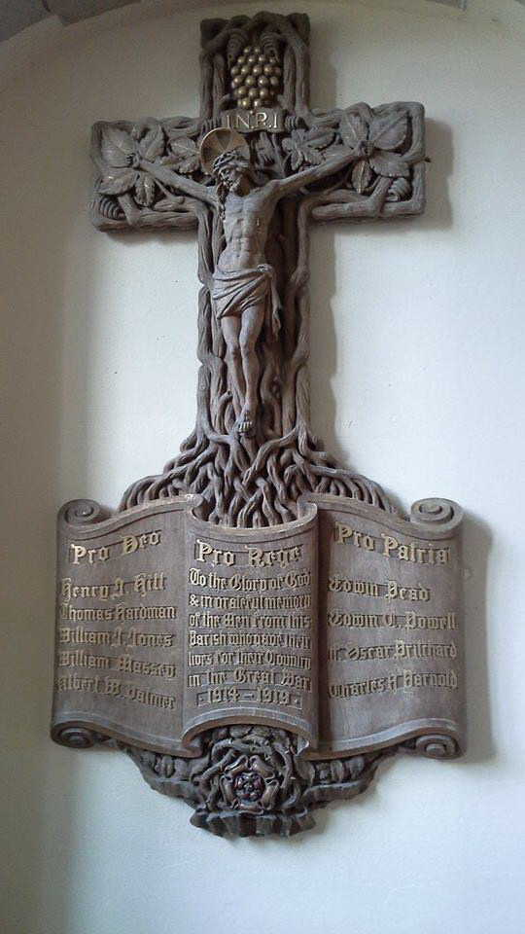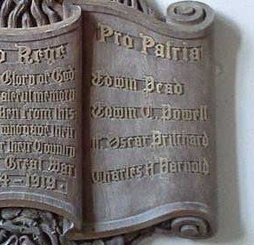

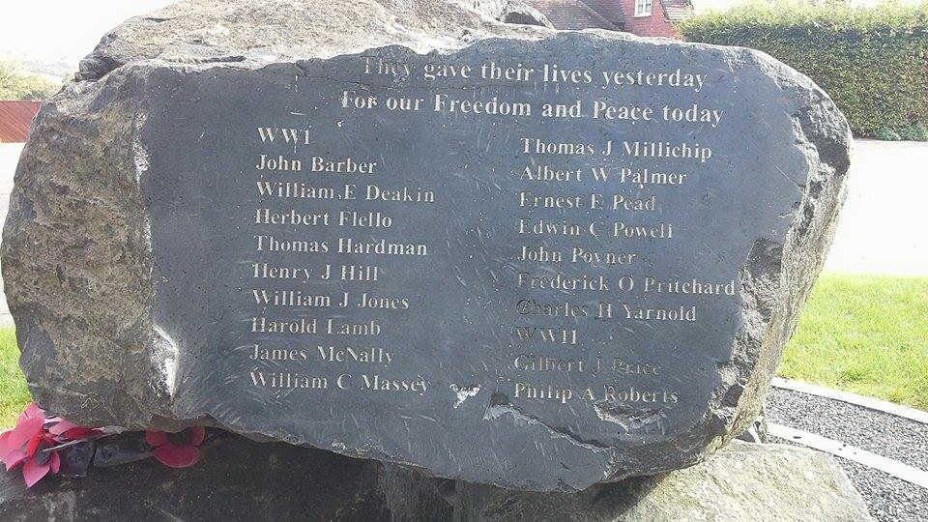

Frederick is also remembered on the memorial of Pensax C of E School but as reported missing
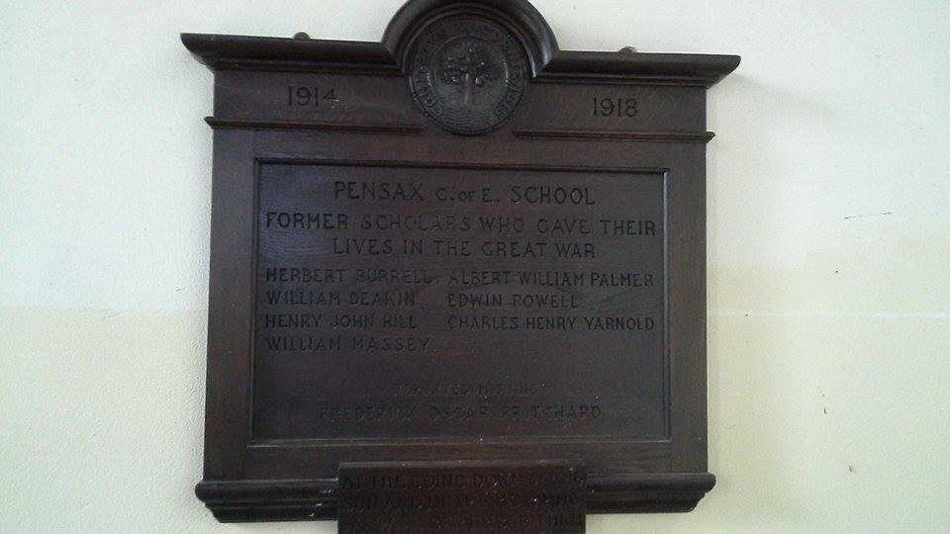

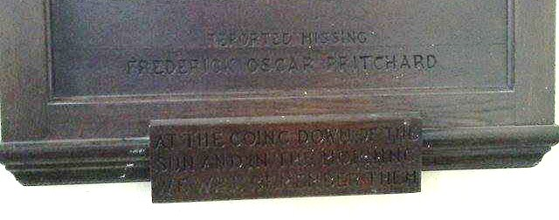

Antecedents of Frederick Oscar PRITCHARD
Photographs courtesy of Janice Hunt and Sue Walley creators of family trees of Frederick Oscar Pritchard via ancestry.com

Frederick Oscar PRITCHARD
- Frederick was born on 26th October 1894 in Pensax, Wolverhampton and resided in Hawkstone, Shropshire
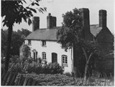
- The photo shows cottages at Pensax Common the one on the left is where Frederick Oscar Pritchard was born (ancestry.com family tree roydavies46)
- Frederick was baptised in the parish church on 1 November 1894
- His mother Eva Pritchard was a domestic servant
- 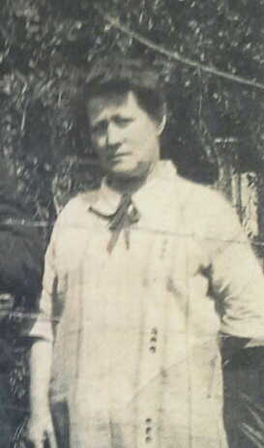 Eva Pritchard
- He was named Oscar by the family he was brought up by his grandparents.
- In 1901 he was living at Pensax Common with his grandfather and grandmother, William and Sarah, and his uncles Vincent (38), William (36) and Sidney (33)
- In 1911 he was still living with his grandmother, Vincent and Sidney. His grandmother was a widow. Oscar was working as a collier draw boy
- Frederick married his wife Lillian Beatrice Jane Yeomans in February 1917
- 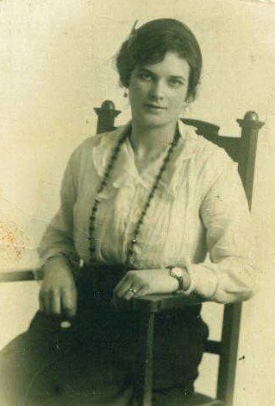 Lillian Beatrice Jane Yeomans 1896-1981

- Frederick and Lillian’s daughter Dorothea Mary was born 11th February 1918 who died 13th January 2007
- 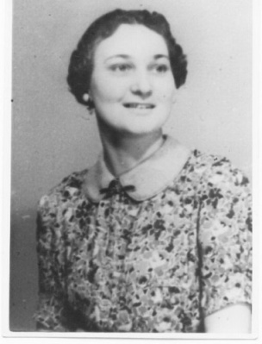 Dorothea

