March 2017
Private 7664 Henry PRICE
1st battalion King’s Shropshire Light Infantry
Birmingham City Police ‘D’ Division
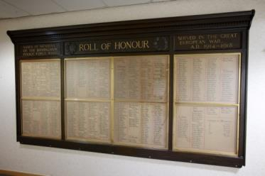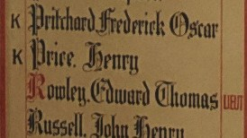
Died France 29th October 1914 aged 27
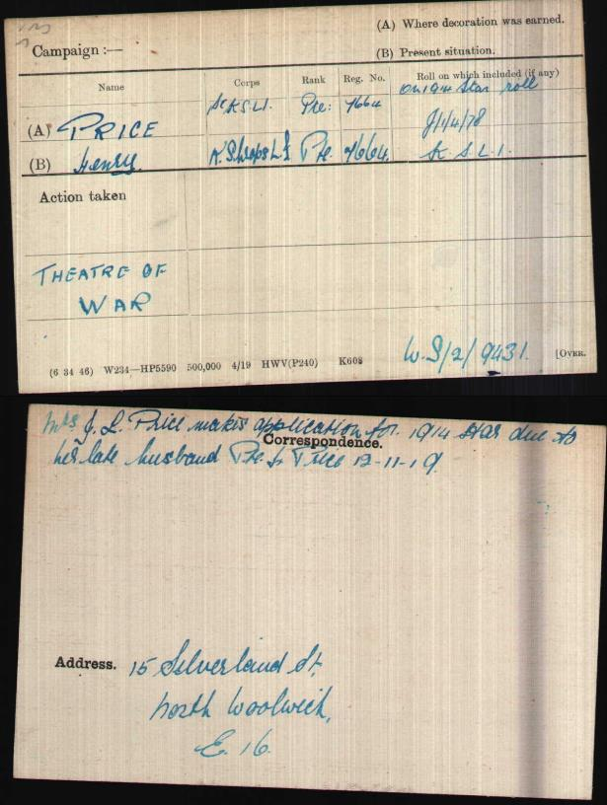
British Army WW1 Medal Rolls Index cards 1914-1920

Police Service History
10th March 1913 Henry joined Birmingham City Police as a 26 year old car-man and with previous military service. He served on the ‘D’ Division his warrant number was 8276.
4th August 1914 Henry was recalled to military service
3rd May 1915 Birmingham City Police records dated, show a report of the Chief Constable as to the late PC Henry PRICE, was resolved that pending the decision of the Government as to allowances to dependants of men killed on active service, the Chief Constable be authorised to continue the Watch Committee Allowances.
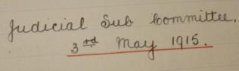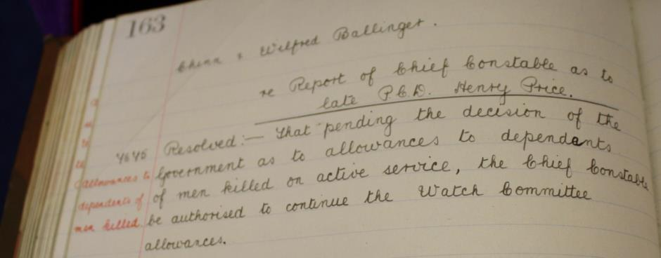

4th October 1915 Birmingham City Police Records states the Chief Constable reported with reference to the army pensions which had been granted to the relatives of PC Henry Price and others killed in the war was approved.
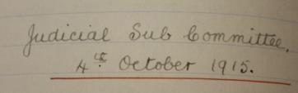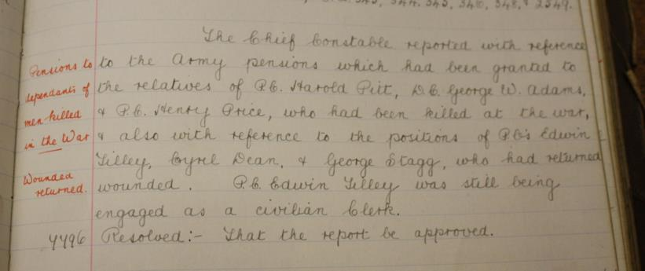

War service History
Henry was recalled to military service on 4th August 1914, his battalion landing at St Nazaire on 10th September 1914. They then moved by stages to Courcelles and relieved the 1st Wiltshire Regiment in the front line trenches north east of Vailly during the night of 21st September 1914. They were themselves relieved to positions west of Vailly during 1st October 1914 by which time the battalion had suffered casualties of 1 officer and 2 other ranks killed and 1 officer and 7 other ranks wounded.
The battalion then moved from Cassel and marched to Sailly, digging in at Le Quesne Farm, Bois Grenier on 20th October 1914. The following day they relieved the 2nd Battalion, York and Lancaster Regiment and 1 company from 1st Battalion, Leicestershire Regiment in the front line.
From this time onward the battalion was shelled and attacked, the enemy making concerted efforts to enter the battalion’s lines. On 23rd October 1914, the Germans were repulsed after much hand-to-hand fighting had taken place leaving some 200 dead behind them.
The following day another attack was repulsed, however the Germans held positions within 50 yards of the battalion’s lines. On 25th October 1914, the Germans managed to break through the lines forcing a retirement to Bois Grenier during the night. Casualties since going into the line amounted to 3 officers and 81 other ranks killed, 8 officers and 133 other ranks wounded and 11 missing.
Wounded at some stage during the above, Henry was removed to the 3rd General Hospital at Boulogne where he succumbed to his injuries

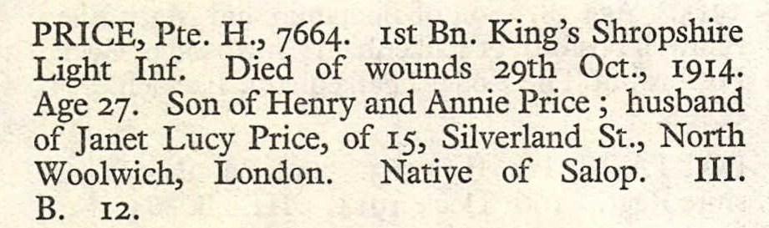
CWGC.com

Buried III B 12
Boulogne Eastern Cemetery, France
Visited and remembered 3rd May 2014
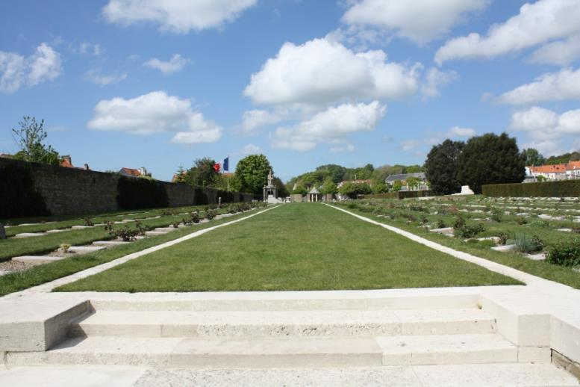
All photographs taken by Su Handford 3rd May 2014
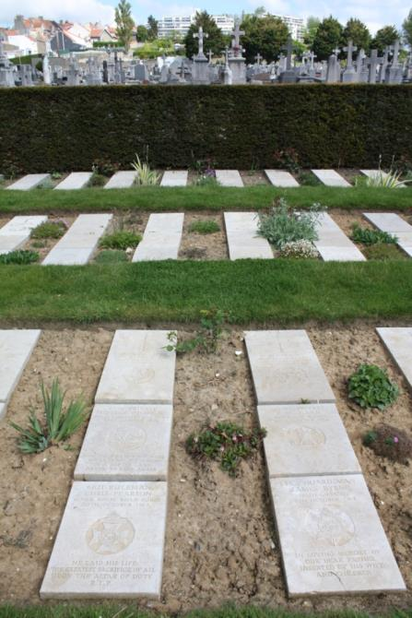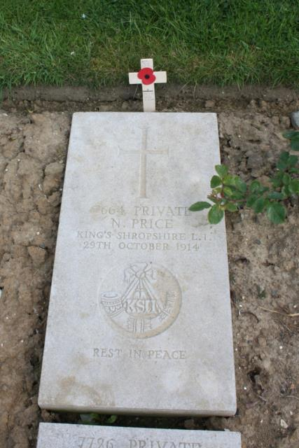
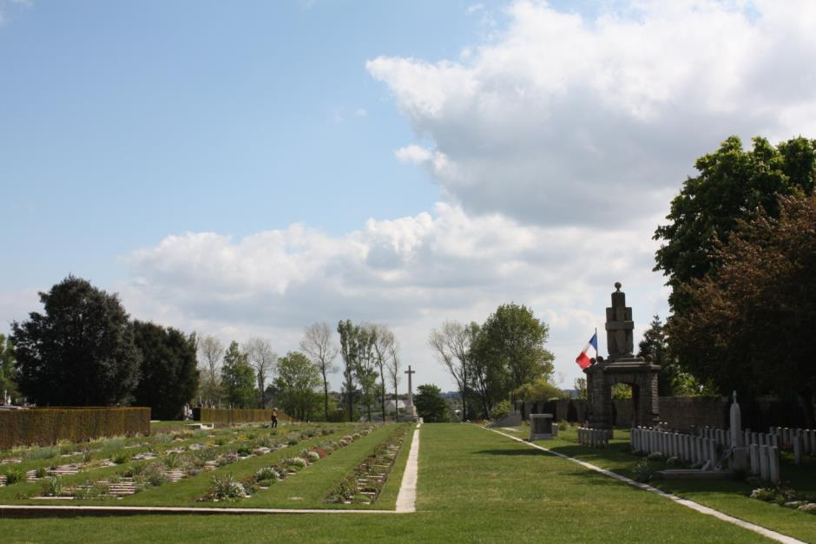

Antecedents of Henry PRICE
- Born 1887 Neen Savage, Cleobury Mortimer and resided Cleobury Mortimer, Salop
- Parents Henry and Annie Price, husband of Janet Lucy Price of 15 Silverland Street, North Woolwich, London. Native of Salop.
- In 1891 Henry was 4 years old and living with his parents and older siblings Martha (16), Emily (12), William (9), and John (6) at 55 Field House, Neen Savage, Cleobury Mortimer. His father was a general labourer.
- In 1901 Henry was living with his parents and younger brother Thomas (9) at 12 Stepple Lodge, Neen Savage, and his father was now working as a roadman.
- In 1911 Henry is listed as a private with the Infantry 2nd Battalion of The Kings (Shropshire Light Infantry) in India.
- Henry married Janet Lucy Pratley in Birmingham in September 1912. A later address for Janet Price was 15 Silverland Street, North Woolwich, London.

