Able seaman 224617 William PORTER
(RFR/PO/B/4493)
HMS ‘Princess Irene’ Royal Navy
Birmingham City Police ‘B’ Division

Died England 27th May 1915

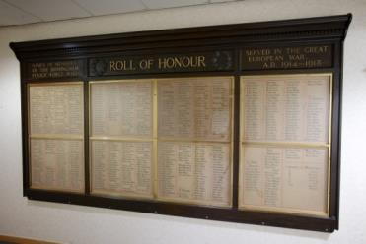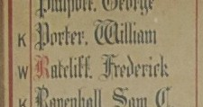

Birmingham City Police Records dated 20th November 1916, inform of his death

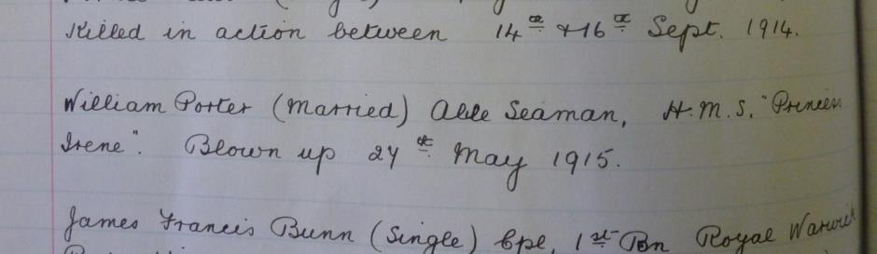

Police Service history

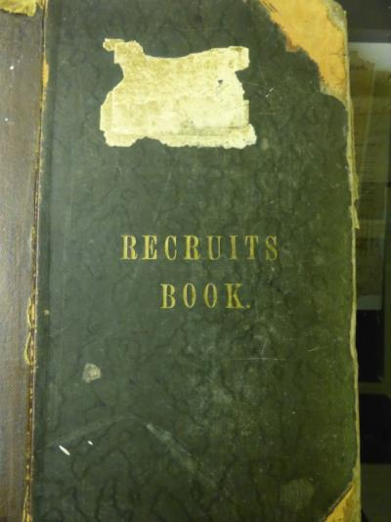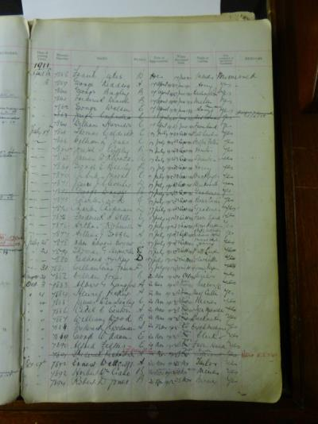

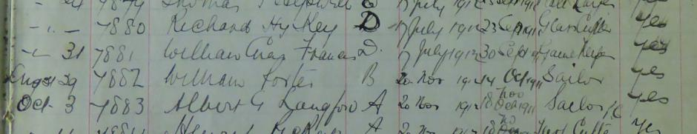

William joined Birmingham City Police 29th August 1911 aged 24 having just left the Royal Navy. He served on the ‘B’ Division with warrant number 7882. He was recalled to the Navy on 4th August 1914.
Birmingham City Police Records

War service history
William was recalled to the Navy on Tuesday 4th August 1914 and was killed aboard H.M.S. 'Princess Irene', a vessel built to the order of the Canadian Pacific Railway Company for the luxurious 'Triangle Route' linking Vancouver, Victoria and the American city of Seattle.
The ship was completed at Dumbarton, Scotland in 1914 but, before she was able to leave for the Pacific, was requisitioned by the Royal Navy and converted into a mine layer. Of 6,000 tons (gross) displacement, she was launched on Tuesday 20th October 1914, commissioned in January 1915 and was commanded by Captain M.H. Cole.
The' Princess Irene' had a compliment of 225 officers and men. At approximately 11.15 am on Thursday 27th May 1915, the 'Princess Irene' was anchored at Number 28 buoy off Port Victoria Pier in Salt Pan Reach, near Grain on the River Medway when she suddenly suffered a massive internal explosion. The explosion killed 51 crew and 77 civilian workers. At the time of the explosion mines were being primed on the ship's two mine decks prior to a planned departure on Saturday 29th May 1915. Also on board were a party of 80 or so Petty Officers from Chatham in addition to 76 Sheerness Dockyard workers who were completing various tasks.
The cause of the disaster was thought to have been due to a faulty primer (pistol) although evidence at the Official Enquiry showed that the work of priming the lethal mines was carried out in a hurry and by untrained personnel.
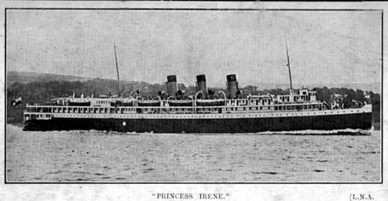
(ournewhaven.org)

A Service was held at The Parish Church, Birmingham
Sunday 5th December 1920 3.30pm
Remembering those police constables Killed in action, those who died on active service and those who died from illness due to war service

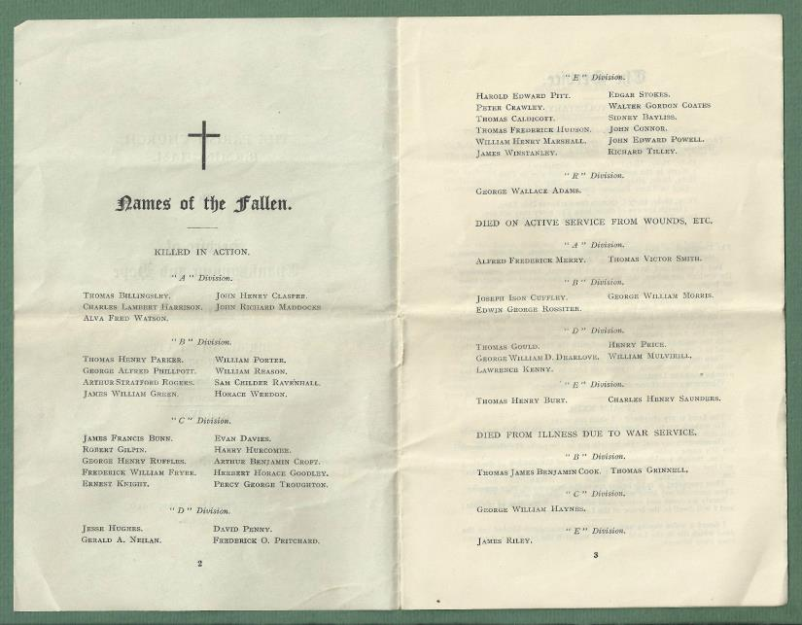

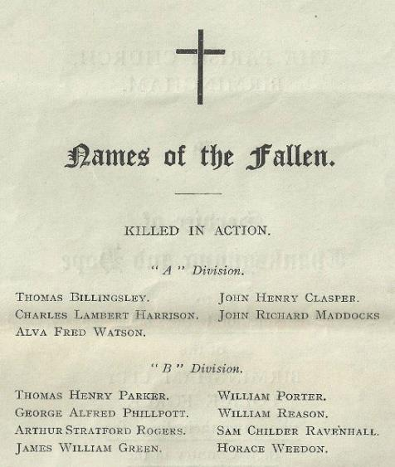
Commemorated Panel 8
Plymouth memorial
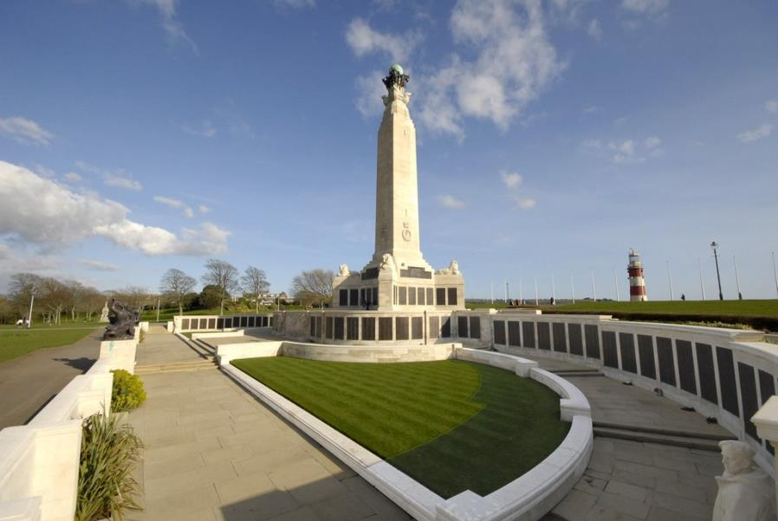
(drakesfamily2.webspace.com)
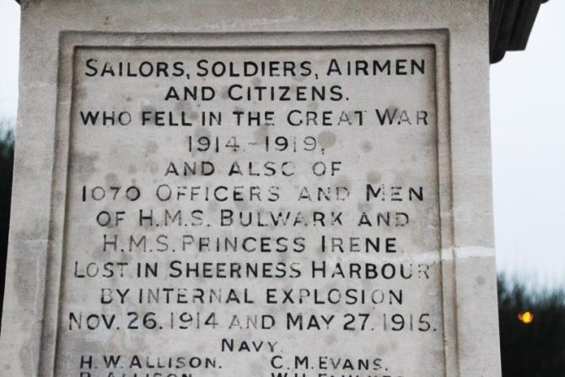
(drakesfamily2.webspace.com)

Antecedents of William Porter
- Born 19 Mar 1886 Barking In Essex,
- William’s body was not recovered for burial: His wife Amy was notified at 4, Ashburton Grove, Holloway, London
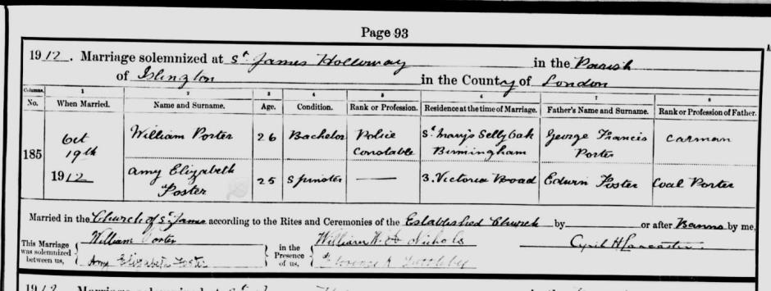
Marriage certificate dated 19th October 1912 of William Porter aged 26 a Police Constable of St Mary’s Selly Oak, whose father was George Francis Porter a car man, marrying Amy Elizabeth Foster, a 25 year old spinster from 3 Victoria Road, whose father was Edwin Foster a coal porter.
The wedding took place at St James Holloway, Islington, London.

1911 Census shows an Able Seaman William PORTER born in Barking, Essex, Church of England and as of midnight April 2nd 1911 he was 25 years of age, single and serving on His Majesty’s Ship Crescent.
