Lance Sergeant 5046 Harold Edward PITT
4th Company 2nd battalion Coldstream Guards
Birmingham City Police ‘E’ Division PC 210
Killed in action France 2nd February 1915

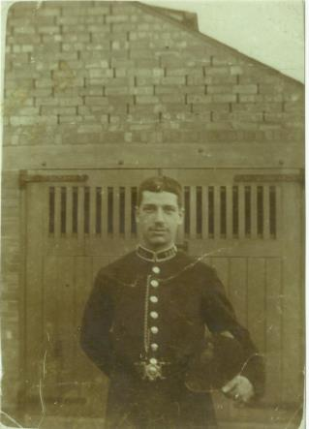
Harold at Sparkhill police Station in 1906

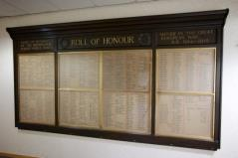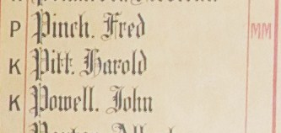
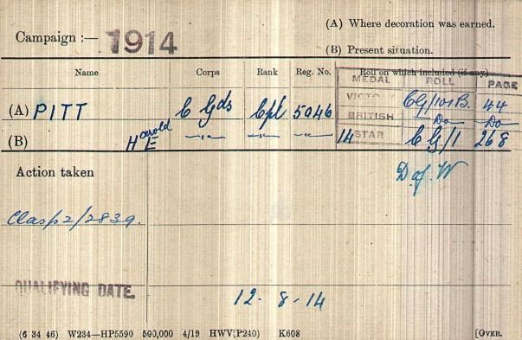
British Army WW1 Medal Rolls Index cards 1914-1920

Police service History
Harold joined Birmingham City Police, on 2nd April 1906, as a 21 year old edge tool worker, and served on the ‘E’ Division with warrant number 8004. He was a member of the E Division swimming club
Previously he was in the Worcestershire Police working in the Sparkhill and Sparkbrook area of Birmingham. In November, 1911 the areas of Sparkbrook and Hall Green were incorporated into the City of Birmingham Police and Harold opted to join The Birmingham City Police he was placed as a 2nd Class constable on a salary of 30 shillings per week

Whilst on reserve, he was recalled to the colours 4th August 1914.
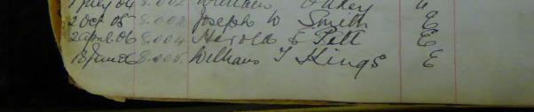Birmingham City Police Records

Police records show army pensions granted to dependants of men killed in the war, including PC Harold PITT
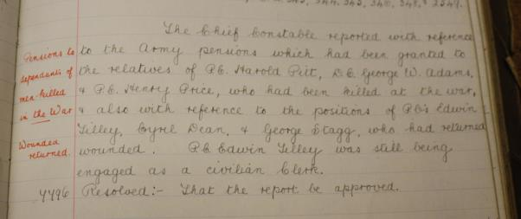
Birmingham City Police records

A service was held at The Parish Church, Birmingham
Sunday 5th December 1920 3.30pm
Remembering those police constables Killed in action, those who died on active service and those who died from illness due to war service

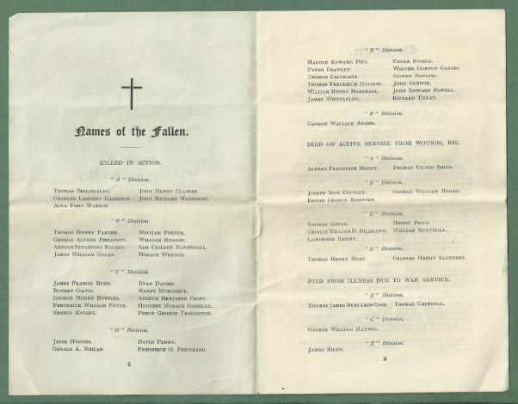
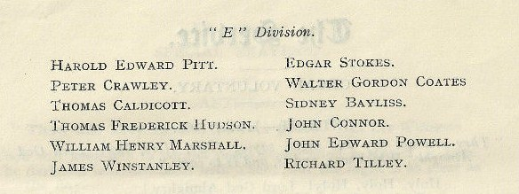

War service History
He enlisted in the army at Birmingham and served his time in the colours. He was wounded in action and taken to hospital in Lillers where he died of wounds.
It is probable that Harold was wounded in action at Givenchy on Monday 1st February 1915 when, at 2.30 am this day, his battalion's position near the La Bassee-Bethune road was attacked. The Germans made their attack via an old communication trench and forced the battalion to retire from their trenches. A stand was made 20 yards east of their original positions, the battalion fighting off further attacks during the morning. A counter attack was launched by a company from the Irish Guards with half a company from the Coldstream Guards at 3.15 am, but this was unsuccessful due to the volume of rifle fire encountered.
At 10.15 am a ten-minute bombardment was made on the lost ground, this being followed by an attack at bayonet point which recovered all lost ground. Casualties of 110 men were taken by the battalion during the day. Lance Corporal Ball from his battalion, also a police officer from Birmingham City Police, informed the news papers that "Harold was wounded when a grenade, thrown by the enemy, had burst under him." Other newspaper reports, however, stated that "Harold had both his arms blown off by the explosion of a grenade he was in the act of throwing out of a trench" as can be seen from the below newspaper article.

UK Army Registers of Soldier’s effects 1901 – 1929 via ancestry via National Army Museum
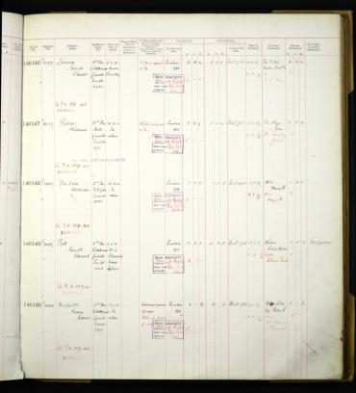
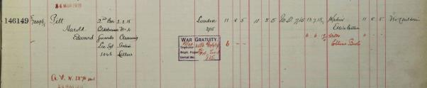
Harold Edward Pitt
It also confirms his place of death at No 4 (casualty) clearing station in Lillers and shows the recipient as his widow Ellice Bertha.

Buried III G 45
Lillers Communal Cemetery, Pas de Calais, France
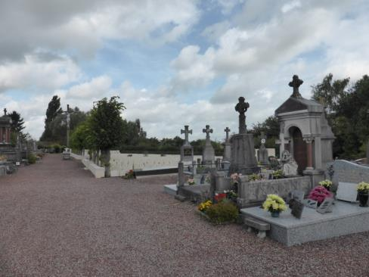
All photographs taken by Su Handford 29th August 2014
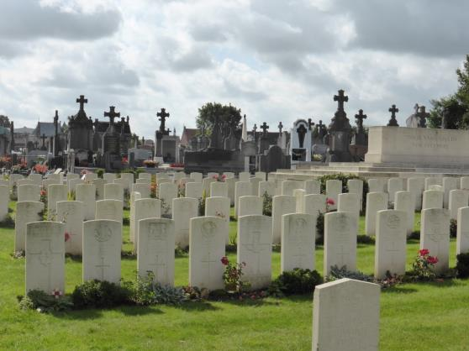
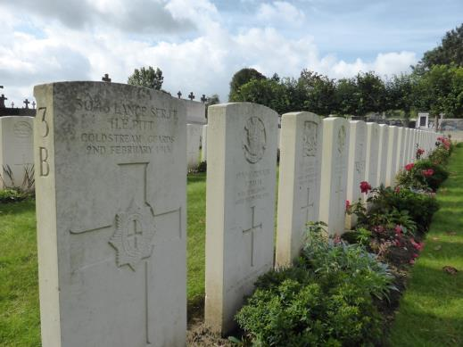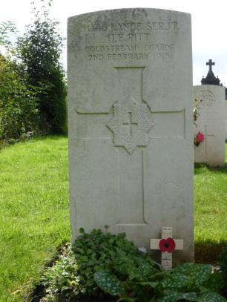

His name also appeared on the war memorial at St Barnabas Church in Erdington, Birmingham until it was destroyed by fire in October 2007.

Full antecedents of Harold Edward Pitt as told by his great nephew Anthony G Schuck

Harold Edward Pitt

Harold Edward Pitt, my Great Uncle, was born on 8 September 1884, in Erdington, Warwickshire. The site is now occupied by Colliers Garage, High Street, Erdington in the Northern suburbs of The City. He was the son of Francis John Pitt (1856-1924) and Lillian Mary Ann Pitt (1859-1919), my paternal Great Grandparents. Harold, or Hal as he was known by the family, was one of six children including my paternal grandmother, Lillian Pitt, (nee Turner) (1886-1977).

Little is known of his early life in this Georgian Cottage which was demolished in the 1950s. Hal was educated in Nechells and by 1891 the family had moved to 262, Long Acre, Nechells (1891 Census Return, 5th April, 1891). By1900 the family had again moved to Wainwright Street, Aston, where his younger sister was born on August 5, 1900 at No.107. At one point in his younger days he was fined 5 shillings for playing football in an Aston Street. It is known that he was particularly close to my grandmother who used to mention him a lot when I was a child.

There are however several snippets of information from my father passed to him by my grandmother which shed a little light into his early life. Hal's family were a closely knit unit as was often the case in the late Victorian period, when circumstances were somewhat straightened. Hal's parents both came from what could be considered by today's standards a “middle class” background . At Christmas and New Year times the family would sit around the fireside and sing together “The Miners Dream of Home”. An extraction of this Victorian song goes as follows; “ I saw the faces and homestead I loved, I saw England’s valleys and dales, And I listened with pride as I did when a boy, To the sound of the old village bells. The chorus followed. The log was burning brightly, It was the night to banish all sin, For the bells were ringing the old year out, and the New Year In.”
This perhaps gives an insight into the cohesive nature of Hal's family.

Hal became an Edge tool worker upon leaving school but his main calling had always been the army. In 1903 he joined the Coldstream Guards. He was a member of the Second Battalion and he had the Regimental No. 5046. Many of his duties during his three years “with the colours” were of a ceremonial nature both at Windsor and Buckingham Palace.
He is known on a number of occasions to have come into contact with King Edward V11 when the Monarch was returning home after an excessive consumption of intoxicants!

His qualifications accrued during the period 1903 to 1906 are documented in my copy of Army Form B217. It is of note that his next of kin address was given as 12, Park Street, Aston, Birmingham at this time. At this time Hal is described as being 5 feet 9 inches tall with sallow complexion and hazel eyes. He recruited in Birmingham on 9th March, 1903. Contemporary photographs indicated that he was particularly handsome, especially in full dress uniform.. My second cousin Kay, (Whose mother was Ada, Hal's youngest sister, born in 1900) relates her mother’s memories of how Hal and his brother Fred, (also a Coldstream Guardsman), would visit her at home when on leave, bringing with them their bearskins which had to be kept in a damp cloth to preserve their shape and substance. No doubt my grandmother would also have seen Hal whilst on leave during the period 1903-1906. In fact my grandmother has spoken of occasions when she saw them off back to London from Snow Hill Station, they in their dress uniforms.

Upon leaving the army in 1906 as a reservist he joined the Worcestershire Police as Police Constable 196. He served, after initial training at H.Q. Worcester, at Sparkhill and Hall Green Police Stations. At the time of joining the Force he is described as 5ft 10 inches tall with grey eyes and dark brown hair, and being tattooed on both arms. The tattoos were probably a legacy from his army days. His place of residence by this time was No. 1 Back of 35 Sandy Lane, Aston. This road was just off Lichfield Road opposite Victoria Road.

It was at this point whilst on patrol in Sparkhill that he met my Great Aunt, Ellice Bertha Boyllin, who was in service as a nanny in the area. Family legend has it that Hal and Ella met whilst she was out walking her employer's child in a pram. It must be remembered that at this time Sparkbrook was considered to be a prosperous area which was (until the boundary revisions of 1911) still in Worcestershire. Hal was himself at this time (by Christmas 1906) at 3,Thornhill Road, Sparkbrook, a terraced Victorian House that still stands today.

On April 12 1908 Hal and Ella married at St. Johns Church, Sparkbrook. A postcard of the Church in my possession is annotated by Ella as follows; “Hal and Ella wed at this church, April 12 1908, on a Sunday morning, 9a.m.. Carriage and pair of horses to take us—we all in white dress Nan made in London, my step brother Walters wife that is.” At this time Hal had again moved to 143, Ivor Road, Sparkbrook, which can only be presumed as their first matrimonial home.

Upon the aforementioned boundary revisions of November, 1911 the areas of Sparkbrook and Hall Green were incorporated into the City Of Birmingham.
Hal opted to join The Birmingham City Police and became P.C. E 210, (Warrant No. 8004), on 9th November, 1911. He was placed as a 2nd Class constable on a salary of 30 shillings per week.

Little is known of his postings during the period 1911 to 1914 and there is at present no known picture of him in City Police uniform. His personal record was destroyed along with others of a similar age some years ago. His discipline record states, however that on 5th June, 1912 Hal was complained about by one Martha Gilbert, wife of George Edwin Gilbert, Bootmaker, Market Place, Hall Green for “Highly improper conduct by seizing her round the waist and kissing her on the neck and face whilst in her husband’s shop at Hall Green about 10.00p.m. on Tuesday 21May,1912.” For this demeanour he was moved to another part of the Division and reduced from 2nd to 3rd Class Constable. One gets the impression that Hal could be somewhat of a “Jack The Lad!”

On 18 June, 1913 he was reinstated as 2nd Class and promoted to 1st Class at a salary of 31 shillings per week. On 13 October, 1913 he was awarded a gratuity of a guinea and complimented in Police Orders for skill in rendering first aid to a member of the public suffering from convulsions. In fact I am in possession of a silver medallion issued by St John Ambulance (No. 128158) in 1908 to Hal. This would indicate he probably had some skill in First Aid. Additionally Hal is known to have been a strong swimmer as I also have a cloth badge which he wore as a member of the E Division Swimming Club. It is worthy of note that my grandfather Edwin Schuck was also a good swimmer. In fact Hal and my grandfather were friends and it was through this relationship that my grandmother and grandfather met.

By this time Hal and Ella were living at a more substantial property at 131 Oldknow Road, in Small Heath which, once again is still standing. The couple had no children.

It is believed that just prior to the outbreak of the Great War that Hal was working in plain clothes at Moseley Street Police Station. There is nothing to indicate that Hal ever took the promotion examination.

On 4 August, 1914 War was declared against Germany and Hal as a reservist was immediately called up to join his old Regiment, the Coldstream Guards.

Things moved rapidly and by 6 August, 1914 he was at Wellington Barracks, London. These days are clearly documented in The Battalion War Diary.

On 8 August, 1914 Hal was promoted to the rank of corporal, no doubt recognising his previous army service. On 12 August 1914 The Battalion embarked upon S.S. Olympia from Southampton to Le Havre arriving the following day. He was part of the first contingent of “the Old Contemptibles” to arrive in France on that hot, stormy, August Day. He would never again return to England.

The long, arduous march to Mons is well described in the aforementioned war diary and the private diaries of Sergeant 7291 Lane, Private, 8430 Hatton and Captain W.J. Cook. Lane was in the first company and Cook in the second. Hal was in the fourth company.

Following the retreat from Mons on 25 August, 1914 Hal was involved in the actions at Villers Cotterets (1st September, 1914) and the counter attack across the Aisne during mid September, 1914.On Hal's 30th birthday, which was to be his last, 8 September, 1914 was spent engaged in a severe action at “holding the wooded slopes south of the village of Boitron with infantry and machineguns. Thee brigade attacked and after considerable opposition the village gained…towards evening the battalion had a sharp engagement with a number of machine-guns which with their infantry escort attempted to break through- and about 70 Germans and 7 machine-guns with 8 limbers were captured. Casualties; Captain Handy and Lt. Lloyd wounded. Other ranks; 3 killed and 7 wounded, all in No. 1 company.”

After more severe fighting, The British Expeditionary Force crossed the River Aisne during Mid September. The conflict was centred on Soupir and Chavonne. The attack came to a standstill amidst heavy fighting and deteriorating weather conditions. The autumn had set in and with it came heavy rain. The Germans also held the high ground north of The Aisne, known as Chemin de Dames. The conditions in the trenches became unbearable, many men becoming ill with enteric fever. German artillery bombardment was heavy and to obtain relief the Battalion operated a system of 2 companies in the firing line and 2 companies in reserve in billets in Chavonne. The strategy had now changed. Trench warfare began to succeed open warfare. It is of note that during this engagement Pte. Dobson was awarded the Victoria Cross and Cpl. Brown The Distinguished Conduct Medal following brave actions in rescuing two members of a patrol wounded in No Mans Land after being surprised by a German Patrol.

The stalemate continued until October 13 1914 when the Battalion was relieved by the 332nd French Regiment. The Coldstream Guards were subsequently transferred to Hazebrouck, Belgium, by rail. They were in a position some 15 miles to the South West of Ypres on Flanders Battlefield. The Battalion moved through Ypres on 20 October to Wietje where they occupied a position along with the French. They then advanced on Zonnebecke where the Battalion was subjected to heavy fire.

Casualties were heavy from October 22 to 23. Killed; 2 officers and 15 other ranks. Wounded;34.Missing;4.By October 25 they had moved to the east of the Ypres salient supporting the Irish Guards and the Grenadiers in Polygon Wood. The Battalion advanced through the dense woods in single file in the early hours of October 26. They were under heavy fire and greatly outnumbered by the enemy. The position was held by The Battalion until November 17 when it was relieved by the French. The conditions once again were atrocious as autumn surrendered to Winter. Heavy rain inevitably turned the ground to mud. This was exacerbated by the fact that natural springs were common in the area. During this time there was no relief for the British soldiers who heroically held the salient in what has now become known as The First Ypres. Casualties were high during this period; Officers Wounded; 5. Other Ranks Killed or Wounded; 151 .Missing; 1. It was at this point that Hal was promoted to Lance Sergeant, on 14 November.

The remarkable achievement was given just tribute in an open letter to the troops by Brigadier Cavan on 20 November 1914. He describes their staunchness under fire and in particular the privations they suffered during this heroic stand.

Unfortunately I do not know exactly what part Hal played in this action, but I have no doubt that he would have accounted for himself in a manner our family would be proud of. It is prophetic to note that Cavan mentions, “Hand grenades thrown at them were one occasion when they did not explode picked up and hurled back again.” This practice was within a few months to prove fatal to Hal.

After a period of rest and refitment in Reserve at Meteren on December 22 The Battalion marched to Bethune. This area was some 25 miles south west of Ypres. These trenches were in a particularly bad state filled with icy mud and water. Several times men had to be rescued from waist high mud. Christmas Day, 1914 bought no truce on this part of the Western Front.
The Battalion War Diary reads, “Very Cold, freezing hard, snipers caused a few casualties, otherwise quiet. Defence arranged.2 companies in trenches, 1 company in support, 1 company in billet, relief taking place nightly.” After a period of relief at the beginning of January, 1915 , the Battalion moved position on a couple of occasions in the locality of Bethune. On 30 January, 1915 they marched to “The Brickstacks” trenches about 2 miles to the east of Bethune. These trenches were adjacent to a wide canal known as The La Bassee Canal just to the East of Cuinchy. They arrived here at 7.30p.m. and took over the trenches from the Sussex and Northampton Regiments. No.. 1 company was on the right of the line, on the La Bassee Road. Then no. 2 and No. 3 were with Hal's company on the left adjacent to the Canal

At about 2.30 am on Monday 1 February the Germans attacked the British Line with a superior force and Hal's Company retreated from their line of trenches. A comrade who was with Hal at this time, Private B.C. Nightingale later wrote a letter to Ella describing exactly what had happened at that fateful time. “Dear Mrs Pitt…..I feel it is my duty to let you know how my brave chum fell. We went into this position on Saturday night, January 30 , things were rather quiet, just the usual, a little sniping and bombing…Sunday was the same until 2.30 am. Monday morning, February 1 when the Germans started sending bombs into our trenches from their trench mortar…they attacked us and succeeded in taking 10 yards of our trench which we had to get back. We tried and succeeded when the Germans started throwing hand grenades at us and as they dropped and before they exploded, Sgt. Pitt, always as brave as a lion, and without hesitation picked them up and threw them back in the Germans faces, a plucky act that none of us will forget as long as we live. Sgt. Pitt threw four or five when one exploded as it left my chums hand…..I can assure you Mrs Pitt that had this brave fellow had got over his wounds he would have had the D.C.M. (Distinguished Conduct Medal). I don’t know whether this will be any consolation to you but his gallant acts were the cause of a lot of my comrades being alive today…..

Obviously Hal had been mortally wounded Later reports contradicted each other in respect of his exact injuries but it appears that he was injured in his left leg, left arm and head. He was taken to Bethune Hospital on 1 February where he was visited by Pte. Nightingale. A letter (a copy of which I have), dated 8 February, 1915 by Pte Nightingale to his father at 67, Grange Road, Small Heath, Birmingham, indicates that he thought Hal would recover from his wounds and be returning to Birmingham shortly. In fact in his letter to Ella of 17 April, 1915, he states that he visited Hal on the night of February 1st and left with the opinion that he would make a full recovery, hence his despatch to his father a few days later.

Hal however died on 2 February at No. 4 Clearing Hospital, Lillers. He lies in Plot B III 45, amongst his comrades who fell in the same theatre of war in Flanders Field.

One can imagine the heartache that his family endured when initially receiving the detail from Pte Nightingale’s letter to his father. Family legend has it that there was bunting out in the streets in expectation of his arrival home. His mother, my Great Grandmother, Lillian refused to believe he was dead for some considerable time, believing a mistake had been made. She would wait tirelessly at Snow Hill station for the hospital trains to arrive hoping that Hal would one day arrive home. The official notification of his death was in fact not despatched from the Coldstream Guards Headquarters until 13 February 1915.

The final action Hal was involved in clearly was quite costly in terms of lives. The Battalion War Diary summarises to casualties for the period 8.00p.m. 30 .1.15 until 9.00p.m. 1.2.15 as; Killed; Officers;2 Capt. Lord Northland and 2nd Lt J.A. Carter Wood. Other ranks; 20. Wounded; Other ranks; 52.

Hal's bravery was later recognised by the press, the army and for evermore by his family. His photograph appeared in The Picture World on the front page on Wednesday 24th February, 1915 along with a description of how he died. This in fact was the first time I had seen Hal's photograph when the micro fiche was discovered at Birmingham Reference Library. The London Gazette of 18 June, 1915 mentions his name and the fact that he died of wounds. His name also appears on the Roll Of Honour at West Midlands Police H.Q., Lloyd House, Colmore Circus, Birmingham with the synonymous letter K by his name.

Ella never forgot her husband, although she later married another Great War veteran, John Coulson, who had also heroically served in the Gloucestershire Regiment at Gallipoli. She remarried in 1921 and had four children, John, Mary, Margaret and Barbara .Ella died on 28 February, 1976 at the ripe old age of 89. She was cremated at Redditch, Worcestershire.

However the story of Hal's memory and the tangible effects left behind did not start for me until almost 80 years after his death.

Anthony G Schuck,
Lichfield 5th March 2010.

‘The Quest’ of Anthony G Schuck as told by the Great Nephew of Harold Edward Pitt

My Quest

My first knowledge of Harold Edward Pitt, my Great Uncle, was imparted to me by his younger sister, my paternal grandmother, Lillian Schuck. She used to relate stories of his boisterous youth in the Nechells area of Birmingham (where they lived from about 1890), along with his brothers Jack and Fred. Also I had been told by my grandmother how he had died bravely trying to save the lives of his comrades whilst a soldier in the Guards in the Great War. At this time I was perhaps under 10 years old and did not understand the significance of this illustrious relative of mine. My gran died in April 1977, aged 90 years, the year I was getting married at the age of 22. There were then much more important things on my mind than my great uncle. But now as an amateur historian interested in my families genealogy it is to my eternal regret that I did not ask more questions and take more notice of this remarkable lady whose memory of late Victorian and Edwardian Birmingham was so vivid, as indeed were her memories of Hal to whom she was extremely close.

In another work I have attempted to describe in chronological fashion Hal’s life history using information, documents, letters, photographs and memorabilia accrued as a result of 4 years of interesting, rewarding, challenging and emotional historic research which took me as far as Canada and as near as Bromsgrove. All along the way I was assisted by people I have never met before in my life who were not members of my family, who treated me with unfailing kindness and generosity. I am now also a greater believer in fate than I was before this quest began.

It was not until 1993 when as an inspector on attachment to The West Midlands Police H.Q. at Lloyd House that I had an opportunity to research Hal. His name immortally appears on the Roll Of Honour in that building stating that he was killed in action whilst being a member of The “E” Division of The Birmingham City Police. I knew little else other than he was a Coldstream Guardsman. My objective was to discover his war medals and to gain as much knowledge of Hal as I possibly could. My colleague Rob Williams, a First World War medal collector and a keen enthusiast of that war was a great help.

My research began at the Central Library in Birmingham. Numerous lunchtime visits revealed his name in “Soldiers Died”, his place of burial in Lillers, Northern France, and more interestingly the fact that he was “Mentioned In Despatches” by Sir John French on 18th June, 1915. This latter piece of information was tantalising as it tended to support my gran’s story about the way he died.

Genealogical research established Hal’s marriage to Ellice Bertha Boyllin at St. John’s Church, Sparkbrook on 12th April, 1908. It was also established that he had no children. This fact was somewhat disappointing from a research context as it may have indicated that all tangible primary evidence of his life may have been lost.

Most of my family, (excluding my father, Ted, who like me “kept the faith”), thought the pursuit for his medals would prove fruitless in the light of the aforementioned information.

I established from The BMD Index that Ellice, or Ella, as she was known, had in fact remarried in late 1921 to another Great War veteran, John Coulson, who had served in the Gloucestershire Regiment (No. 11932). It was therefore sensible to predict that perhaps she would have wished to have started a new life after this marriage, perhaps wishing to put behind her the tragic past. My Great Aunt was to surprise us all.

Ella had four children by her second marriage, John, (1922-2009), Ellice Mary, (born 1924), Margaret Rose, (born 1931), and Barbara, (born 1933). I had no idea where any of these people were in the world, if indeed they were still alive.

I began to write to everybody in the Birmingham area with the surname Coulson in an effort to trace John Coulson, junior. In the interim time I discovered on microfilm a photograph of Hal in “The Picture World”, dated 24th February, 1915. I had no need to read the text to know it was him. His features were instantly recognisable as he looked like a younger version of my father, and I am proud to say that I too bear some resemblance to him. This was a major breakthrough. I had never seen his likeness previously, and additionally the text substantiated the family legend that Hal had died whilst throwing grenades out of the trenches in an effort to save his comrade’s lives. I became even more determined in my pursuit although I never imagined how successful I would be.

On November 13th, Remembrance Sunday, 1993 I made an appeal on West Midlands Radio, (the Ed Doolan Show) for Hal’s medals. This appeal met with no direct success; however it did lead to a telephone call from my second cousin, Kay, the daughter of Ada Katherine Pitt, Hal’s youngest sister, (born in 1900). A visit to Kay and John in Olton revealed more items connected with Hal and my family. Kay kindly gave me a photograph of Hal along with further photographs of his brothers Jack and Fred, and one interestingly taken of my Grandmother Lillian with her colleagues whilst working at Dunlop’s, Birmingham as a young woman. Kay also gave me a delightful Christmas card sent by my grandmother to her mother. In addition to this Kay allowed me to copy pictures of my Great Grandfather, Francis John, and my great –grand mother Lillian Mary Ann who is holding Ada Katherine as a baby. This must have been taken in 1900. More poignantly I was allowed to copy verse written by Francis John following his wife’s death in 1919. This work clearly illustrates his education, ability, intelligence and perhaps above all the love for his wife, whose death he never recovered from. I also was given a small piece of ribbon taken from a “1914 Star”………… this still has considerable significance.

At this time I employed the services of a researcher to confirm which medals Hal had been issued with. The confirmation arrived that he had in fact been awarded the “1914 Star”, War and Victory medals posthumously.

During the weekend of 4th to 5th March, 1994 along with colleagues and other friends I visited Lillers and saw Hal’s grave for the first time. This was a very emotional moment for me as I had been involved so much with his past that I felt almost part of him. I laid a fitting tribute to him from our family and spent a few minutes in silence and remembrance. I believe that this was the first occasion that a member of our family had visited his grave, although Ella had arranged for a photograph to be taken of it just after his burial. My friend filmed the grave and the cemetery which is a treasured possession.

Later that year I took my parents along with my son Adrian, my wife Lynne to visit Hal’s grave. A photograph was taken with myself, my father, and Adrian by his graveside. On that day we also visited Cuinchy the sight of Hal’s final action where he received his fatal wounds. There is little there today to remind us of the almost a century ago.

I also visited the Police Museum at Sparkbrook and extracted his discipline record from Standing Orders, and also obtained his collar number and warrant number details.

Although I had many replies from people in the Birmingham area who had the surname Coulson, they were fruitless, in fact some of were from West Indian families! Therefore in early January, 1995 my father and I visited Wolverhampton Central Library (which had at that time the best BMD index in The Midlands extending to 1980), in an effort to establish when my Great Aunt Ella died. We examined the microfilms for almost three and a half hours when we discovered that she had died in the first quarter of 1976 aged 89 years, in the Birmingham area. The following day on 6th January, 1995 I visited Birmingham Registry Office and purchased a copy of her death certificate which revealed that Ella had died on 28th February, 1976, in Sheldon Hospital, Rubery. The informant was Ellice Mary Oliver, her eldest daughter. I crossed the road to a telephone box in Broad Street, dialled 192 asking for Mary Oliver’s telephone number at the address on the certificate. There was no trace. Then I asked the operator the telephone number of anybody with the surname Oliver in Bromsgrove. I was then given Mary’s telephone number. I immediately phoned the number and it was answered by an elderly lady who confirmed her identity. I explained who I was and what my interest was in her mother’s first husband, and the fact that her mother was in fact my Great Aunt. She invited me to visit her and her husband at her home on Sunday 8th January.

Upon visiting Mary and Vic, a retired Birmingham Fireman, Mary went upstairs to the landing and came back down and presented me with Hal’s “death plaque” in a frame. It had been hanging up in the house for many years. I was speechless. She also gave me the letter written to Ella by B.C. Nightingale, a Private in The Coldstream Guards who was with Hal when he received his mortal wounds. Further to these priceless items Mary gave me photographs of Hal whilst in the Worcestershire Police, and Coldstream Guards uniform, along with a further photograph of him and Ella on their wedding day. Other items included a copy of a letter by B.C. Nightingale to his own father on 8th February, 1915, describing Hal’s final hours in hospital (This was scripted in Ella’s handwriting obviously copied from the original), a personalised Christmas card from Hal dated 1906, the whistle (A Hudson), he had with him upon his death, a postcard of St. John’s Church, Sparkhill annotated by Ella on the rear, a picture of Princess Mary ( Extracted from 1914 “Mary Box”), and a couple of postcard sized photographs of Ella. I also had given to me the only postcard known to have been written by Hal on 16th August, 1914 on his way to The Western Front. This is a time I will never forget. I had never dreamed of possessing such items and was amazed that they had survived 80 years with people who were not related to Hal. Why were they kept? Mary explained to me that when her mother remarried, her husband, John, (who was as previously mentioned, a First World War veteran), wanted her to keep everything as he understood that she had loved Hal.
John Coulson must have been a particularly understanding man realising himself how Ella must have felt after the loss of Hal in such tragic circumstances in a war which he had had a direct experience of with all it's tragedy and loss. He himself was badly wounded at Gallipoli whilst serving in The Gloucesters. Hence nothing seemed to have been lost in terms of items relating to Hal. The medals received by Ella were kept, according to Mary, in a tin box.

Mary informed me that her brother John had possessed Hal’s medals since the date of his mother’s funeral in 1976. John lived in Pontardulias, near Swansea in Wales. I telephoned him who immediately said he would sort them out. On 8th February, 1995 myself and my father made the journey to Wales and met John and his wife Megan. Once again we were met with kindness and hospitality. John turned out his drawers in an old sideboard and immediately discovered 2 of the 3 medals. A third item was a Coldstream Guards button which had been converted to a brooch, no doubt worn by Ella when Hal was overseas as a keepsake. A search for the third medal the 1914 Star, disappointedly proved fruitless. A week later, John sent me the letter that had been sent to Ella in January, 1919, accompanying the missing medal. Although somewhat disappointed I could not be too upset as what I had achieved was very positive in all respects. But I could not give up. I was sure that it was out there somwhere.

In April, 1995 I had published an article in the West Midlands Police “News Beat” magazine, copies of which I distributed to all those who had assisted me in my quest.

In August, 1995 we visited Canada for a holiday. Margaret Coulson-Bant, another of Ella’s daughters lived in Missassauga, just outside Toronto. My many correspondences with her over the preceding few months revealed that she had in her possession other treasured items which included; Hal’s “Dog Tags”, the letter confirming Hal being “Mentioned in Despatches,” the original photograph of Hal in Coldstream Guards uniform (my favourite which had appeared in “The Picture World” following his death), a photograph of Jack Pitt (Hal’s eldest brother), taken in Montreal in 1906, whilst a member of a Territorial Regiment. Margaret also possessed the army form B104-82 formally notifying Ella of his death, along with a letter from the Birmingham City Police, Moseley Street Police Station sending condolences to Ella upon receipt of the news of his death. Additional items included a letter from The Director Of Graves Registration with an accompanying photograph of his grave taken shortly after his burial. These along with various contemporary newspaper cuttings were freely given to me by Margaret.
She stated that she was somewhat of a psychic and always knew that “some young man” would one day be in search of these items. She had lovingly therefore always treasured them. Once more I had been met with outstanding generosity from people whom I had never met before. Needless to say I never let these possessions out of my sight for the rest of the holiday!

I have to date explored every known avenue to locate this elusive “1914 Star”. Medal Magazine advertisements, The Great War Forum, missing medal websites, the internet in general, newspaper adverts, and numerous telephone calls to dealers throughout the U.K.

In July 1997 I had published a further article about my quest in “The Sutton News” concerning my search but met with a zero response. The circulation was perhaps too low. I also additionally had published an article in the “Old Brum” Magazine on 13th October, 1997. This was kindly arranged by the Birmingham Historian Carl Chinn.

An appearance on the Carl Chinn Show on 2nd November, 1997 on Radio West Midlands was very opportune and a great experience but did not produce any tangible results in respect of the medal.

I am still today in search of this illusive 1914 Star!

The letter to Mrs Pitt from B.C. Nightingale in France 17th April 1915

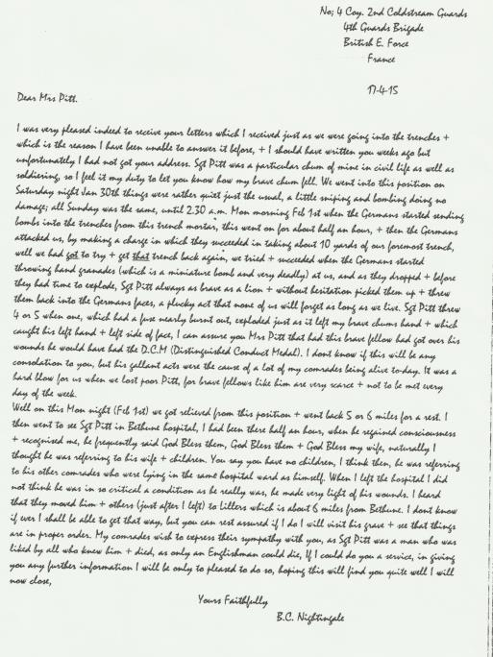

The notification letter of Harold’s death

