1st May 2017
Sergeant 36875 David Ernest PENNY
2nd battalion Royal Welsh (Welch) Fusiliers
Birmingham City Police ‘D’ Division PC 248

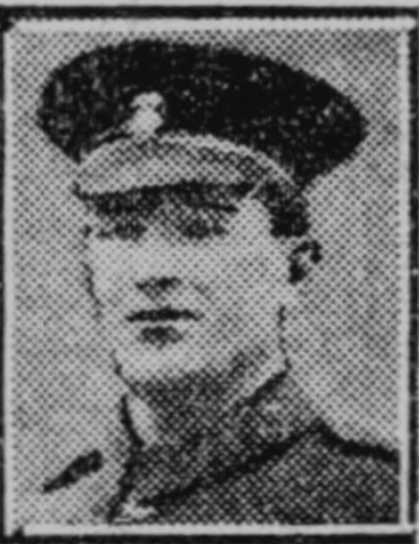
Western Mail Newspaper June 13th 1917

Died France 27th May 1917 aged 24

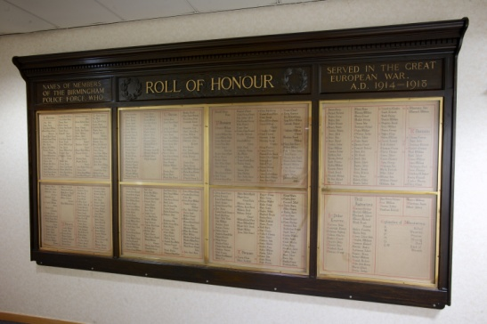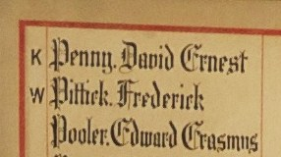

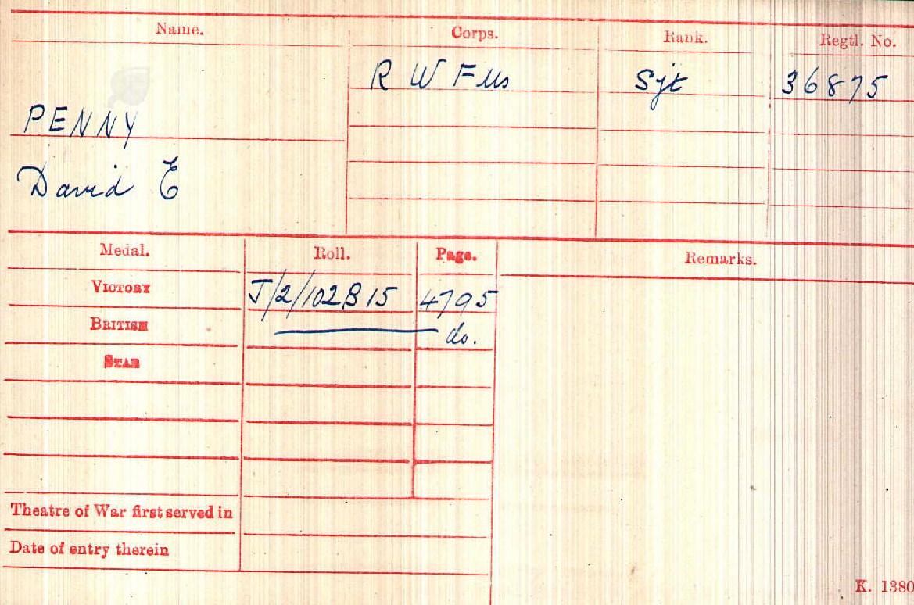
British Army WW1 Medal Rolls Index Cards 1914-1920

Police Service History

David joined Birmingham City Police on 3rd June 1914 as a 21 year old gardener. He served on the ‘D’ Division with warrant number 8498. He resigned and enlisted in the Army in Birmingham.

War Service history
Killed in the same attack where David Ernest PENNY lost his life was PC George MORRIS.

David's battalion moved from camp at St Leger into the front line trenches on Saturday 26th May 1917 relieving the 6th battalion, Northumberland Fusiliers. At 1.55pm the following day the battalion made an attack on the Hindenburg support line between Plumb Lane and Oldenburg Lane. The objective of 'A' and 'C' Companies was to cross the Hindenburg Line and establish a line of posts about 100 yards beyond, with the remaining companies following. The war Diary records the attack as follows; "The waves advanced extremely well until the wire was reached when there was a tendency to bunch. During the advance however a gap was caused between the Cameronians and the battalion on the left. The enemy worked round through this gap and this led to a retirement.
A few parties reached the Hindenburg Support on the left but the right appear to have encountered an intermediate line about 50 yards in front of it. An order to retire was given by someone unknown, and this was carried along the whole line from left to right and at 2.45 pm the whole were back in the old Hindenburg front line. Very heavy machine gun and rifle fire was met and casualties were heavy, only 2 2nd R.W. Fus. Officers returned unwounded.
Companies were quickly reorganised to meet a possible counter-attack. This appeared probable at about 7 pm but was apparently stopped by artillery fire. The back areas were heavily shelled during the attack the hostile barrage being extremely severe between the quarry and Croisilles." Casualties amounted to 6 officers killed and 4 wounded, 19 other ranks killed with 76 wounded and 59 missing. The following day at 1.10 pm the battalion was relieved to Moyenville.

The British Army Service Records for
Sergeant 36875 David Ernest Penny have survived
David attested 15th November 1915 and his occupation was a Police Constable aged 22 years and 10 months and he was single.

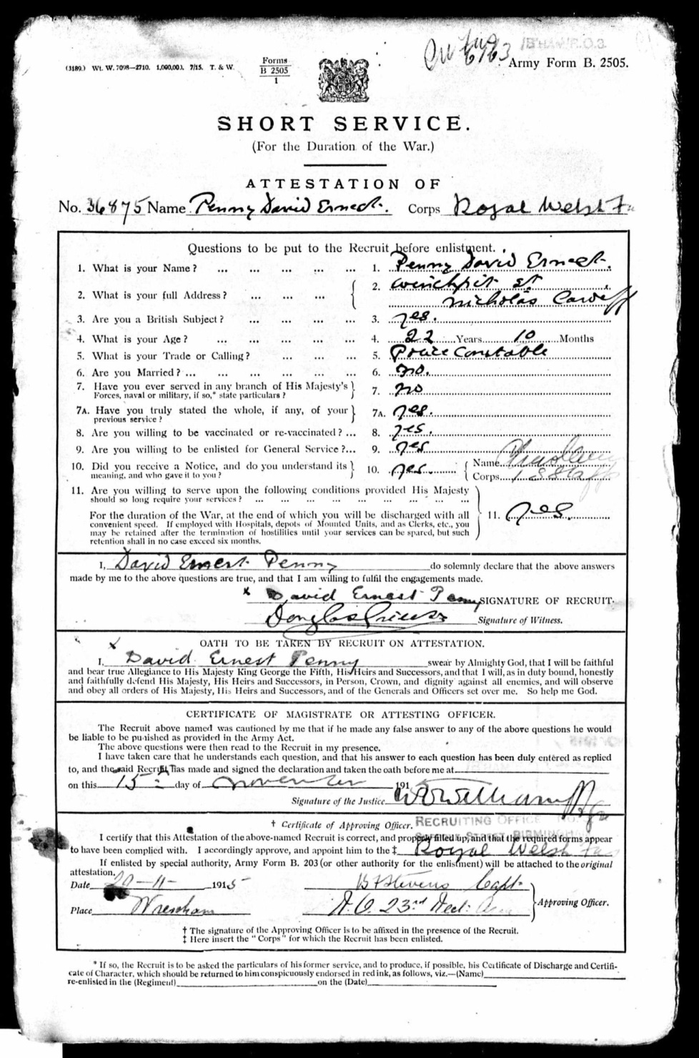

David’s form on enlistment and services
David’s next of kin was his mother Mary Ann. He was single and had no children
15th November 1915 Enlisted
24th November 1915 David was appointed Acting Corporal
3rd June 1916 David was appointed Acting Sergeant
10th September 1916 David reverted to Sergeant
27th May 1917 David was killed in action – Place not stated

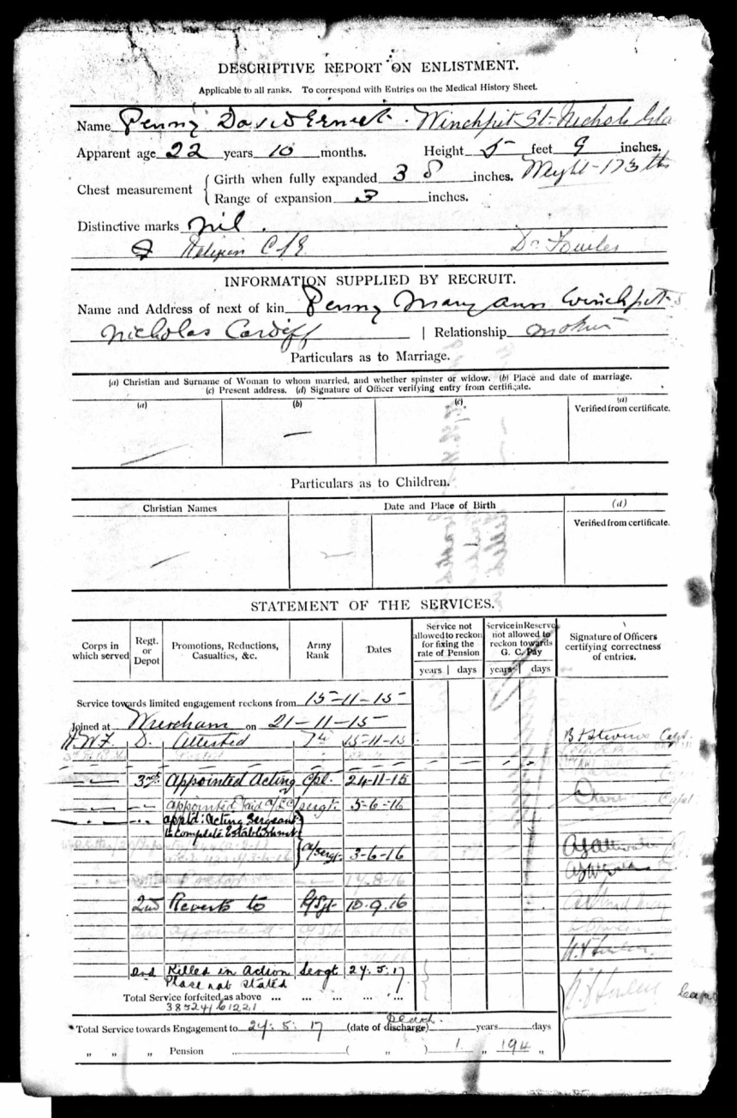

David’s medical history
15th november 1915 David was declared fit for field service at home or abroad by the nedical officer

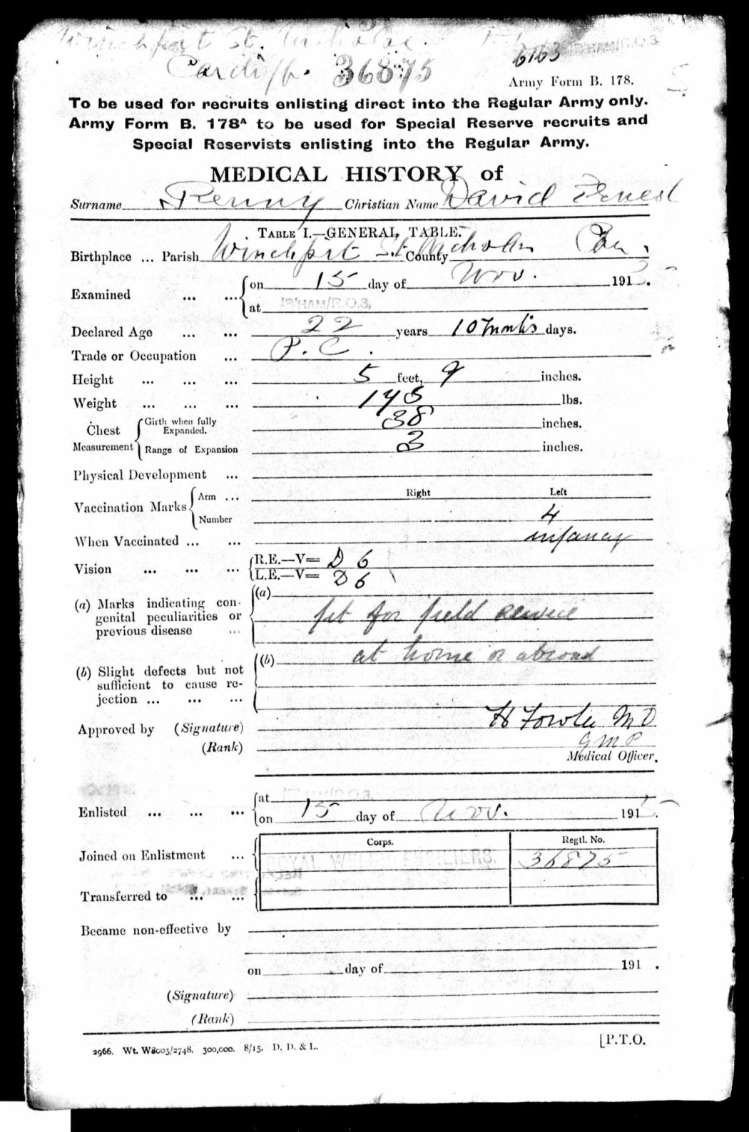

Squadron, Troop, Battery and Company Conduct Sheet
David was born in Cardiff and was Church of England by religion and it confirmed that David enlisted in Birmingham on 15th November 1915. He had not committed any offences and had not been in receipt of any punishment during his service with the Royal Welsh Fusiliers

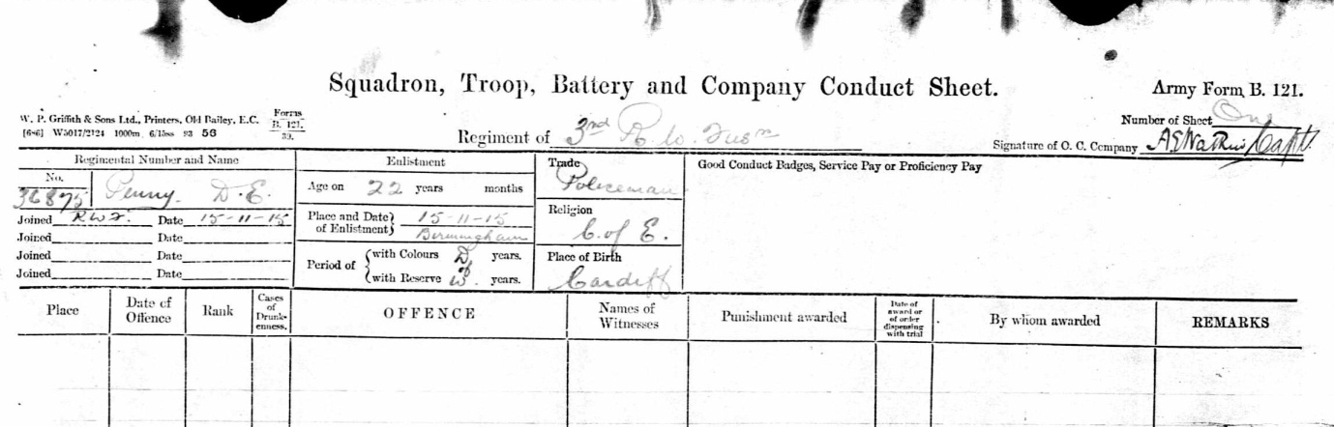

Commemorated Bay 6
Arras Memorial Pas de Calais, France
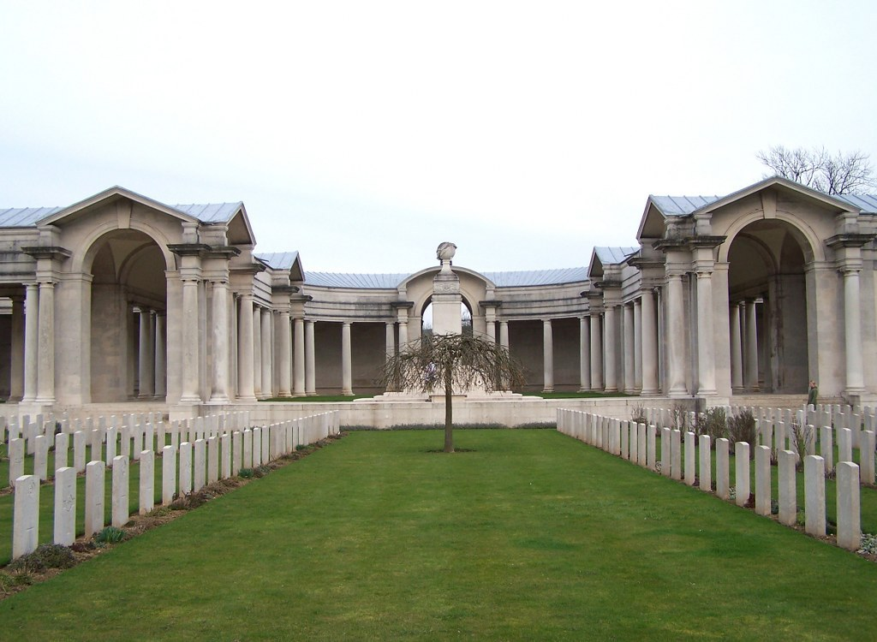

Antecedents of David Ernest PENNY
- David was born in Winchpit, St Nicholas, Cardiff in the spring of 1893
- David was the fourth child of John (1859) and Mary Ann Penny (1863) nee Donelly. The other family members were George (1886), William (1888), Helena (1890), Harriet (1895), Harold L. (1898) and John (1900)
- In the 1901 census the family are living at Winchpit, St Nicholas, just outside Cardiff, Glamorgan. His father was a shoemaker and his two older brothers were gardeners, a profession which David also took up.
- The 1911 census shows David living with his parents at the same address and working as a gardener. His two older brothers, George and William were married, and Helena, Harriet and Harold were all working and living in service. The youngest son John was living with his grandmother, Ellen Penny.

