April 2017

Corporal 36892 Thomas Henry PARKER
2nd Battalion Royal Welsh Fusiliers
Former territorial service with North Staffordshire Regiment No T958
Birmingham City Police ‘B’ Division PC 38
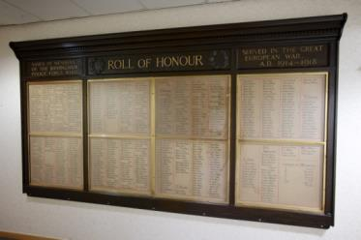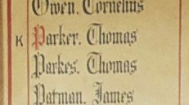
Died France 6th November 1916 Aged 26
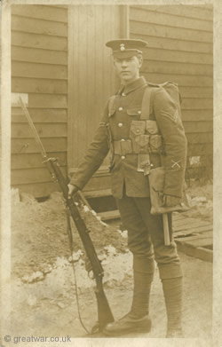
Courtesy of family member Joanna Legg greatwar.co.uk
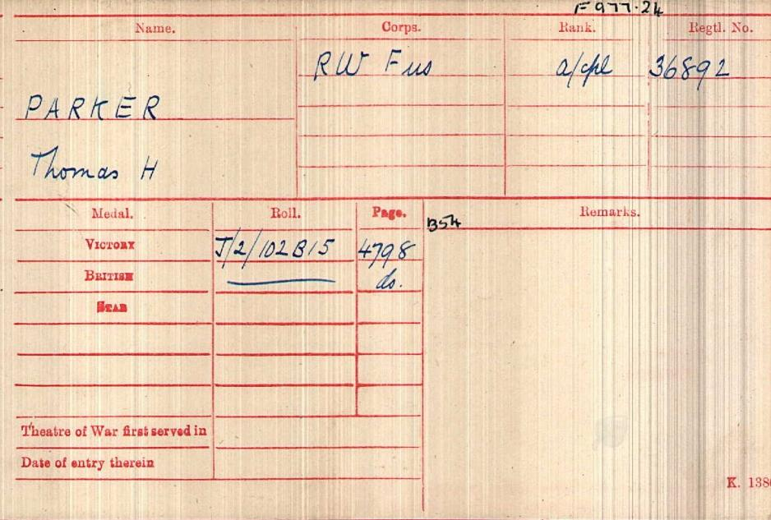
British Army WW1 Medal Rolls Index cards 1914-1920

Police Service History
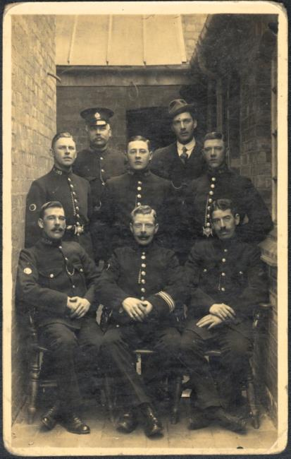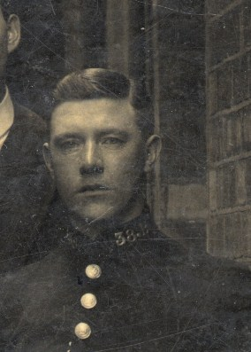
Thomas joined Birmingham City Police 2nd January 1912 as a 21 year old postman, and served on the ‘B’ Division with warrant number 8151.
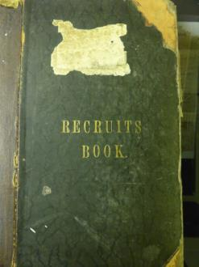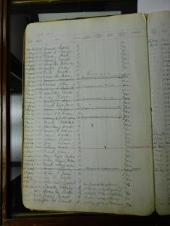
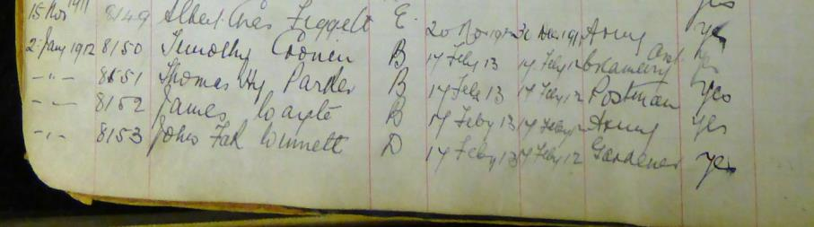
Birmingham City Police records dated 12th November 1915
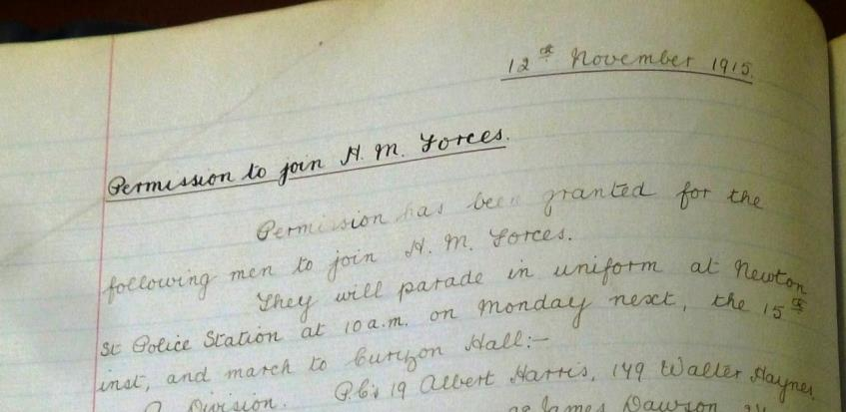
Permission to join H.M. Forces
Permission has been granted for the following men to join H.M. Forces. They will parade in uniform at Newton Street Police Station at 10 am on Monday next, the 15th inst and march to Curzon Hall
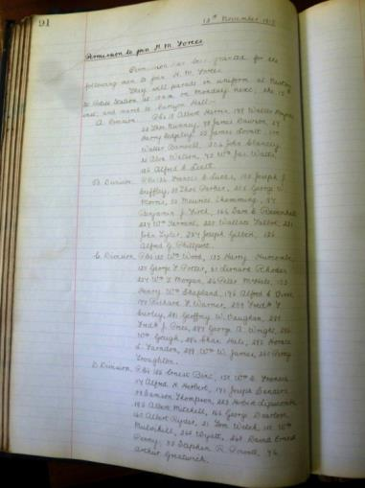

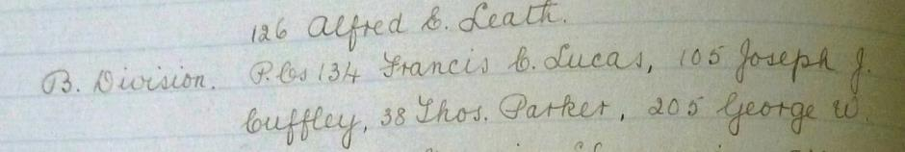
This is a photograph of Birmingham City Police Constables 15th November 1915 marching to Curzon Hall as mentioned above of which Thomas Henry Parker may very well be one of them
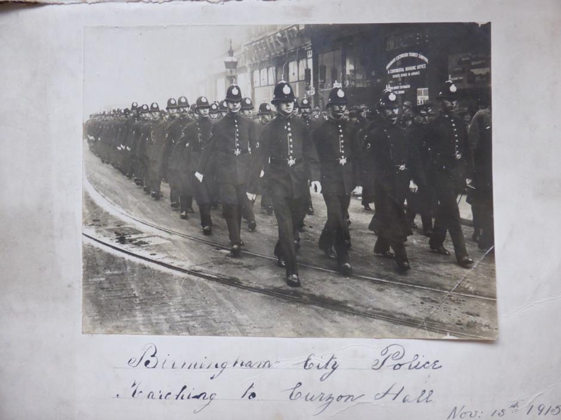

Birmingham City Police records dated 16th November 1915
The following officers have been allowed to join the Army as from the 15th November 1915
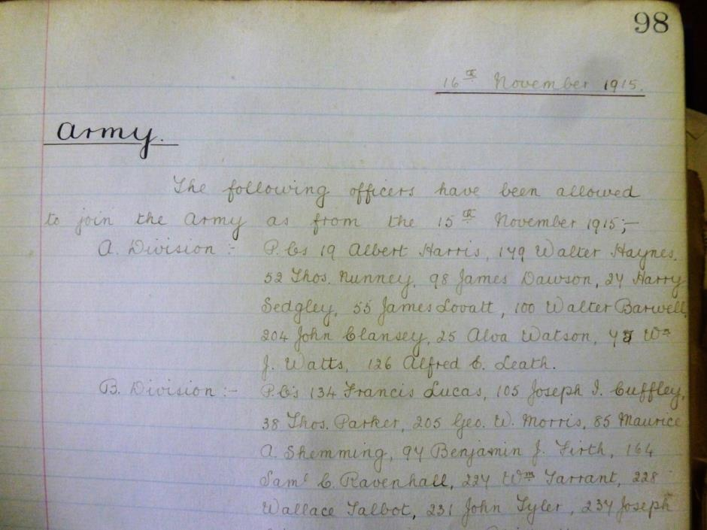

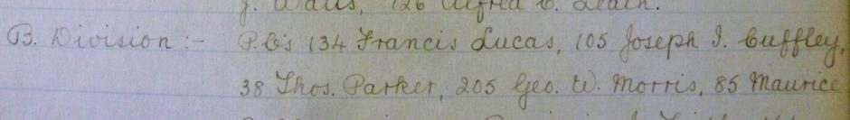

Thomas resigned from Birmingham City Police on 15th November 1915 and enlisted in the Army in Birmingham.

Birmingham City Police records dated 20th November 1916
Thomas Parker Cpl Welsh Fusiliers killed in action 6th November 1916
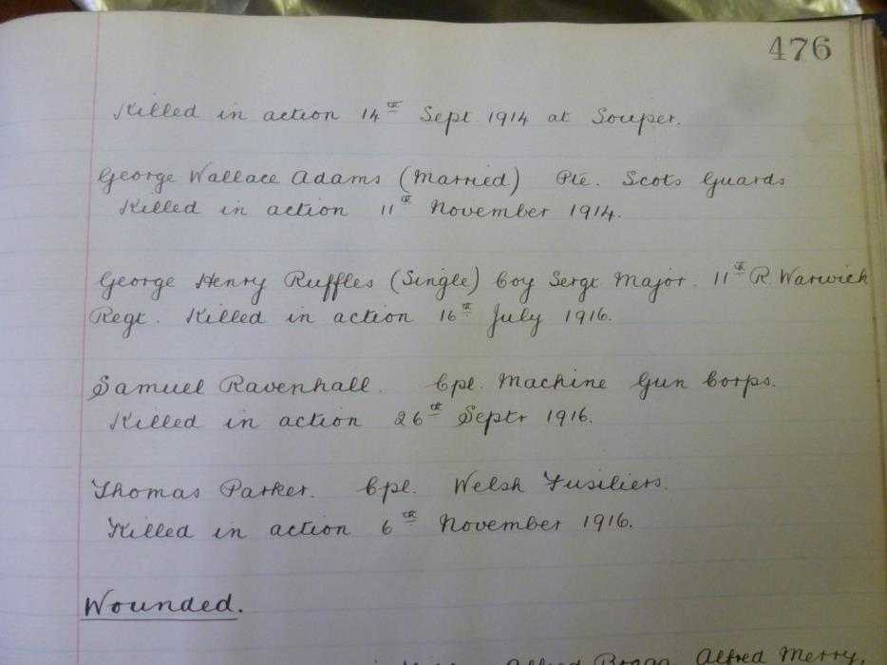

Thomas’ great niece, Joanna Legg, (www.greatwar.co.uk/whoweare) states that originally Thomas' family had received notification that Tom was missing in action in November 1916. Tom's name was inscribed on the Thiepval Memorial to the Missing. However, his body was found during the 1930s and he is now buried in London Cemetery and Extension, Longueval

Newspaper article reporting on the sad death of Thomas Parker
Corporal Thomas Parker Royal Welsh Fusiliers has been reported killed in action. He was the eldest son of Mr and Mrs Henry Parker, 11 Albion Street, Rugeley. He was formerly employed at the Rugeley Post Office as a telegraph messenger and later a postman. He was also a member of the local Territorial’s and later was a bandsman. In January 1913 he joined Birmingham City Police Force and in 1915 became a member of the Life Saving Society of the swimming club. In October 1915, he was one of 70 members of the Birmingham City Police Force who were marched to the recruiting office for enlistment when he joined the Welsh Fusiliers. He was drafted on to the front in June last. His Company Officer is expressing sympathy with deceased’s parents, stated that they has been through a serious charge and had been very fortunate having had only one man slightly wounded. Parker was serving out rations to the men in his section in a trench they had captured from the Germans when he was shot through the head, death being instantaneous. The officer further stated that Parker by his quiet, unassuming manner, his devotion to duty, and his willingness had endeared himself to all. He was a single man 28 [sic] years of age and was the eldest son of nine.
A Service was held at The Parish Church, Birmingham
Sunday 5th December 1920 3.30pm
Remembering those police constables killed in action, those who died on active service and those who died from illness due to war service

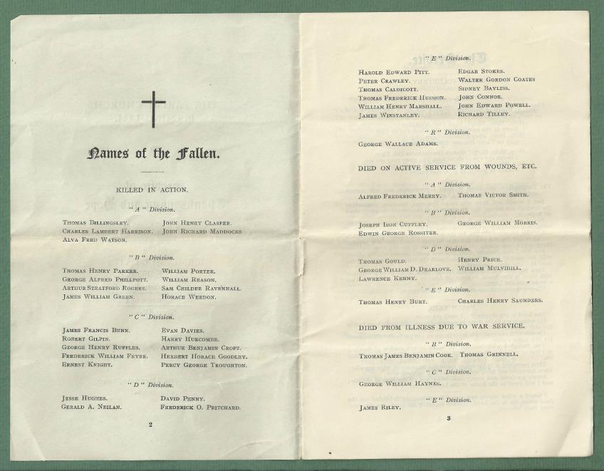

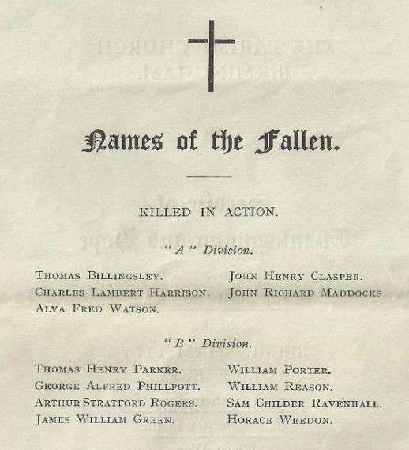
War Service History
On Friday 3th November 1916 Thomas's battalion moved into the front lines in the Lesboeufs sector.
On Sunday 5th November 1916 the battalion advanced, their objective being a cemetery in front of Le Transloy with orders to dig in about 20 yards beyond the crest of a ridge. The battalion moved forward up the Lesboeufs-Le Transloy Road, gaining some headway but were unable to make much progress due to the openness of the ground.
The new positions were held until the battalion was relieved to La Briqueterie on Tuesday 7th November 1916. Casualties amounted to 20 men killed during the attack and a further 5 men, including Thomas, killed during the holding action.
As can be seen from the newspaper article, it records the details of Thomas’ death.

British Army WW1 Service Records via ancestry.com
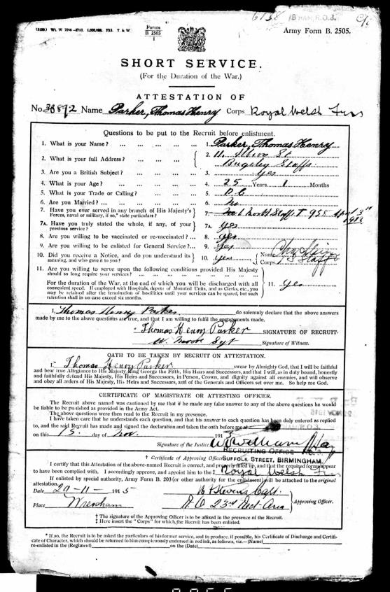
Thomas Attested in Birmingham: 15/11/15, aged 25 years 1 month as a policeman.

Description on enlistment
Thomas Henry Parker Rugeley Staffs
Enlisted aged 25 years 1 month. Next of kin listed as his mother Fanny Parker 11 Albion Street Rugeley Staffs
Engagement from November 1915 appointed acting Corporal 24th November 1915 and killed in action 6th November 1916

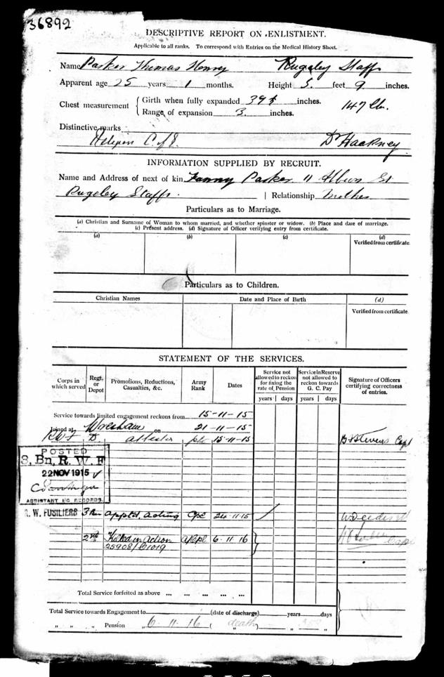

Casualty Form – Active service
Royal Welsh Fusiliers acting Corporal 36892 Thomas Henry Parker Church of England enlisted 15 November 1915 aged 25 years for duration of the war
16/8/1916 Embarked Southampton on SS Archangel and disembarked at Rouen the following day and joined No 5 I.B. Depot at Rouen and on 25th August 1916 joined 2nd bttn Royal Welsh Fusiliers and was killed in action in the field in France 6th November 1916

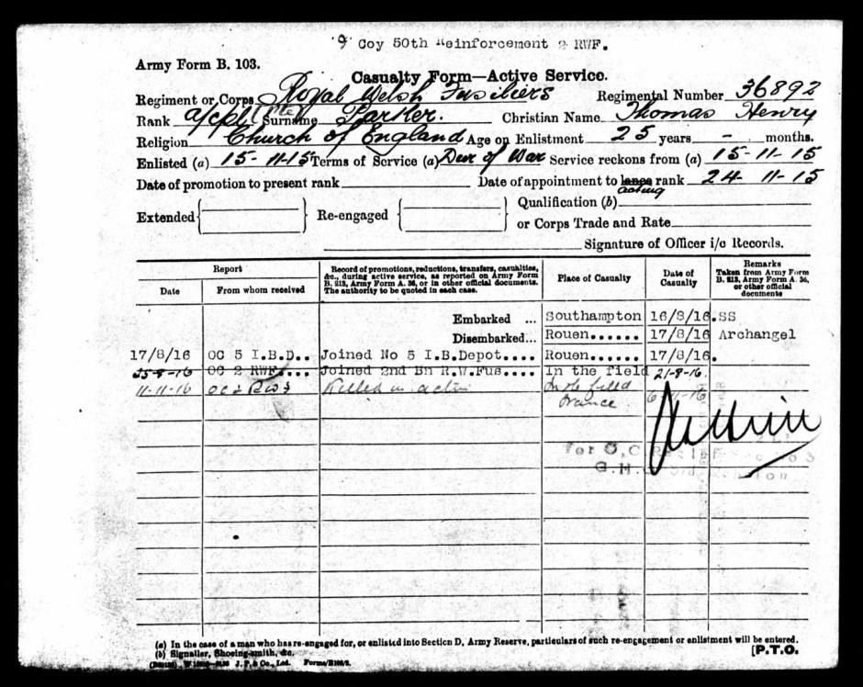

A letter from Thomas’s worried mother

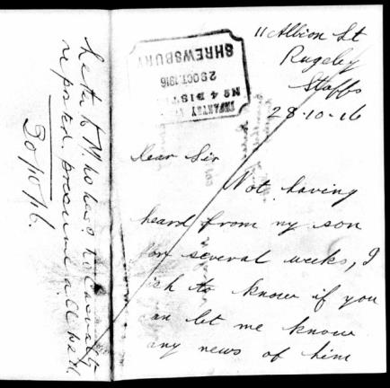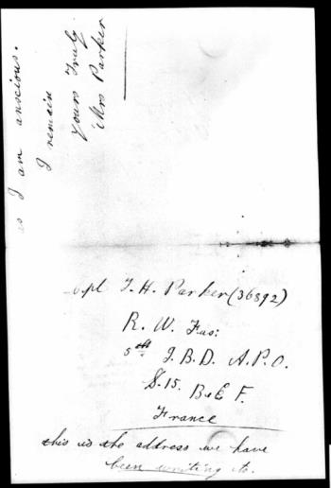

11 Albion Street
Rugeley
Staffs
28.10.1916
Dear Sir,
Not having heard from my son for several weeks, I wish to know if you can let me know any news of him as I am anxious.
I remain yours truly,
Mrs Parker
Cpl T H Parker (36892)
R W Fus:
5th J.B.D A.P.O
B.E.F. France
This is the address we have been writing to.

Thomas’s Victory Medal and British War Medal were signed for by Henry Parker, 27th December year not known. They were granted in respect of the service of 36892 T H Parker Royal Welsh Fusiliers

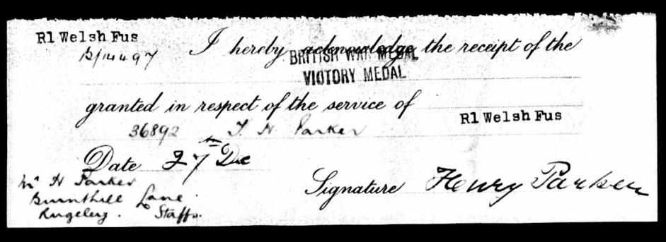
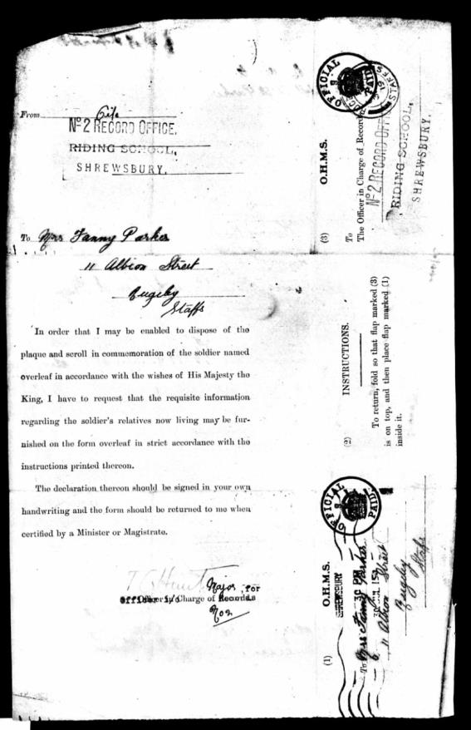
31st July 1919 a form completed by Thomas’ mother
Father of the soldier – Henry Parker
Mother of the soldier – Fanny Parker
Brothers of the soldier – William aged 19, Frederick aged 16 and Cecil
Sisters of the soldier – Francis, Mary, Connie aged 21 Gertrud aged 14 and Maggie aged 11. All of 11 Albion Street, Rugeley

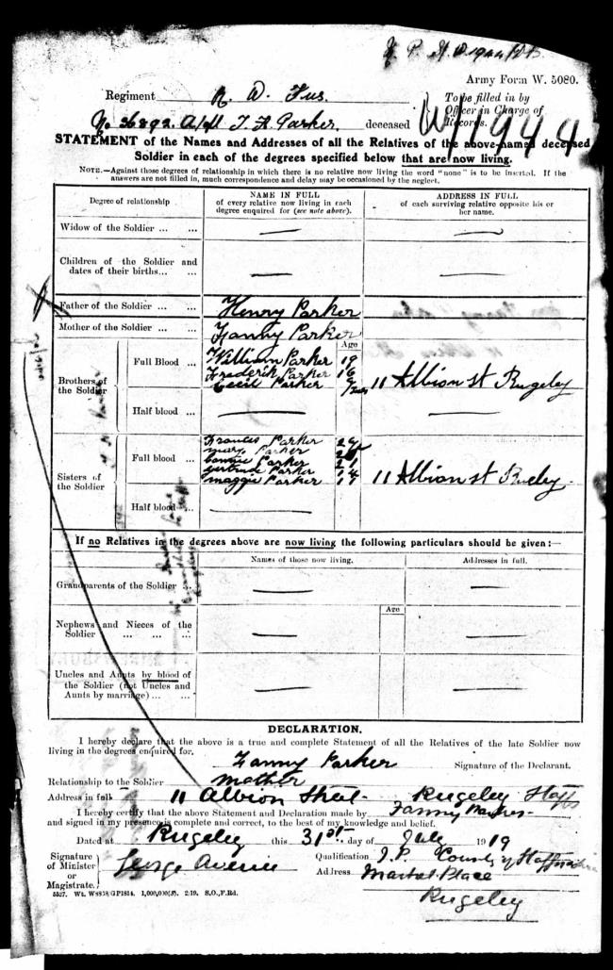

Squadron, Troop, Battery and Company Conduct sheet

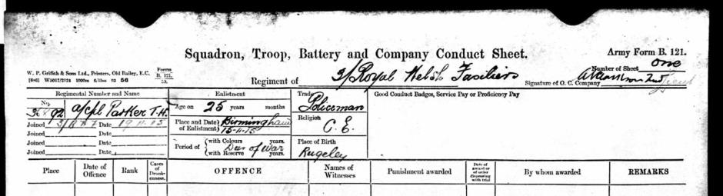

Medical History of Thomas Henry Parker on 15th November 1915
A police constable 5’ 09” weighing 147 lbs (10 stones 7lbs) and with a 37 and a half inch chest, he was of good physical development and had been vaccinated as a child and was classed as fit for service home and abroad.

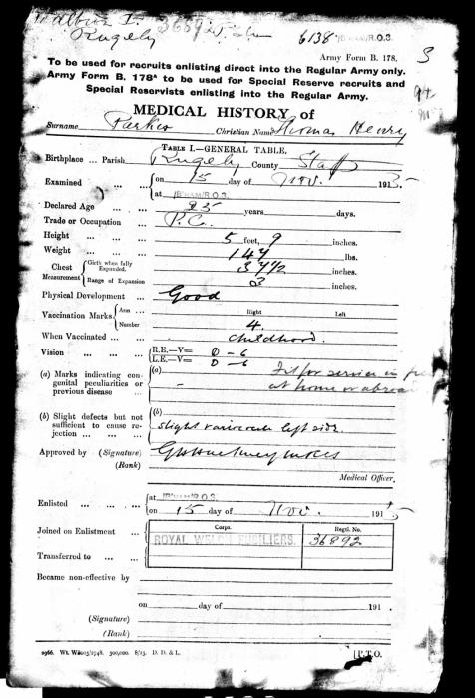

Buried Grave 1 A 1
London Cemetery and Extension,
Longueval, France.

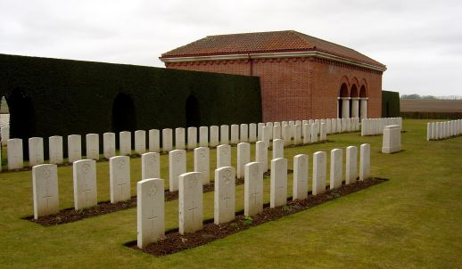
Inmemories.com
Thomas is also commemorated on Rugeley Town War Memorial

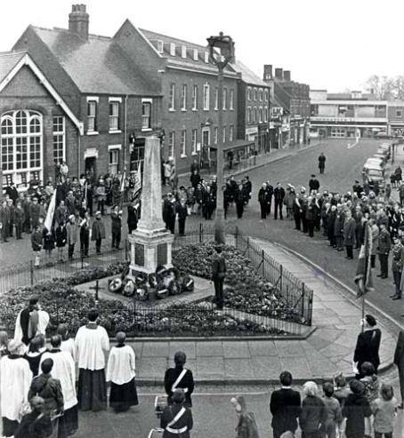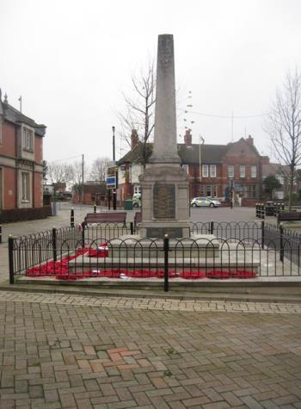

Antecedents of Thomas Henry PARKER
- Born in 1891 in Rugeley Staffordshire, Thomas was the son of Henry and Frances (Fanny) Elizabeth PARKER (nee Upton). 11 Burnt Hill Lane, Rugeley.
- In the 1891 census they were living at 68 Church Street, Rugeley. Thomas's father was a rural postman. Thomas had 3 brothers: Francis A (1895), William Arthur (1900), Fredrick Charles (1903); and 5 sisters: Frances Agnes (1982), Mary Elizabeth (1894), Constance Amelia (1899), Gertrude Alice (1905), and Margaret Ellen (1909).
- In the 1901 census Thomas is staying with his grandparents at no 5 Green Lane, Rugeley, while his parents, with Frances, Constance, Mary and William are living at no 6 Horse Fair, Rugeley. Thomas appears to have continued to live with his grandparents, George and Amelia Upton, as the 1911 census shows him living with them at Beech Cottage, no 7 Green Lane, Rugeley along with his sister Frances Agnes. His parents, along with Mary, Constance, William, Fredrick, Gertrude, and Margaret were living at 11 Albion Street Rugeley.
- All of the roads were quite close to one another. It was normal in this period for some of the children in a family to live with other family members, if the house was small and the family a large one.
- In 1911 Thomas was working as an assistant postman.

