Lieutenant Gerald Aloysius NEILAN
10th battalion Royal Dublin Fusiliers
Formerly served with Sherwood Foresters South African War
Birmingham City Police ‘D’ Division
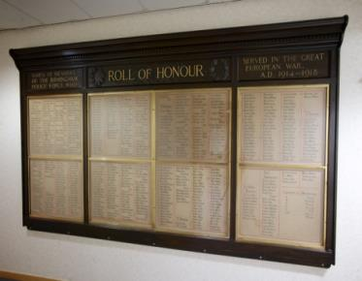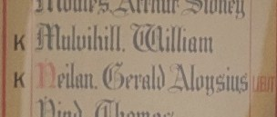
Died Republic of Ireland 24th April 1916
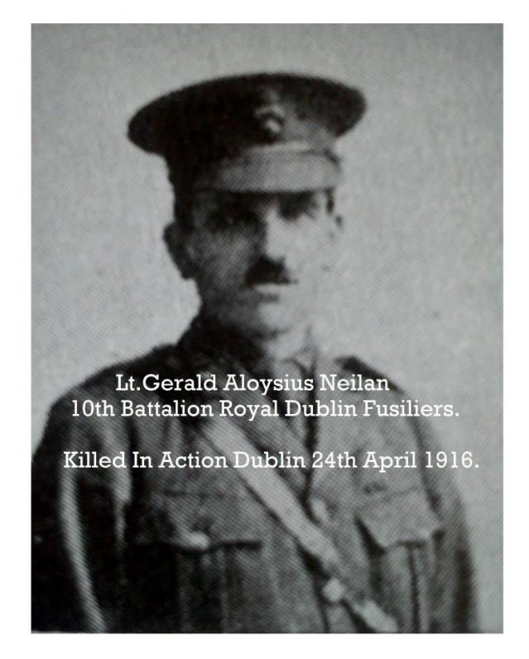
Courtesy of dublinandthegreatwar.com
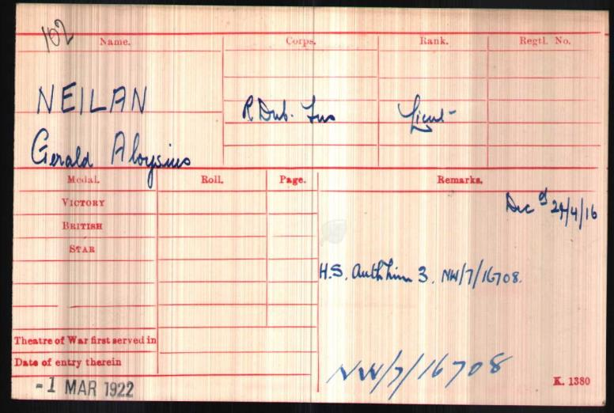
British Army WW1 Medal Rolls Index cards 1914-1920

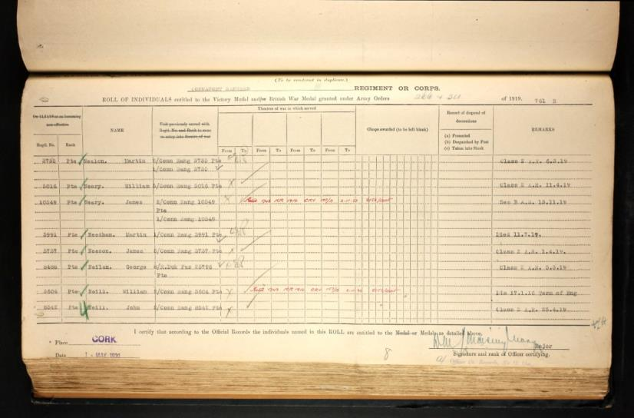
WW1 Service Medal and Award Rolls 1914-1918
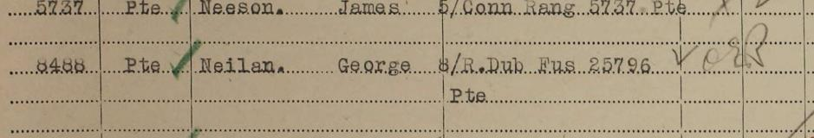

Killed in Dublin
Among the officers who were killed in The Dublin fighting was Lieut. Gerald Neilan of the Dublin Fusiliers who was formerly a member of the Birmingham Police Force attached to the D Division. Lieut. Neilan was the son of an Irish resident magistrate and for some years served in the Sherwood Foresters with which regiment he took part in the South African War

A Commission to second Lieutenant in the Durham Light Infantry has been accepted by Gerald Neilan who prior to the outbreak of war was a police constable in Birmingham. His resignation from the police force has been received. Neilan has acted as an instructor at Budbrook Barracks, since August.

Military Honours for Policeman
Edited after Gerald’s death on the last line of the text
His commission Lieutenant 10th Dublin Fusiliers

A Birmingham Officer Killed
It is reported that Lieut. Gerald Neilan, Dublin Fusiliers has met his death in the fighting at Dublin. Lieut Neilan was formerly Police Constable 24 D in the Birmingham Police Force and joined the Army in the early part of the War. He was a Swedish Drill expert. He was soon offered a commission which he accepted and he played an active part in raising the Irish Battalion of the Northumberland Fusiliers. When the battalion proceeded to the front he was drafted to Dublin where he had been engaged in recruiting duties for some months. Neilan’s death it is stated took place within half a mile of his mother’s house.

Police Service History
Gerald joined the Birmingham City Police on 18th January 1908, ex Army, and served on the ‘D’ Division with warrant number 7675.
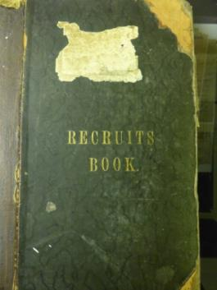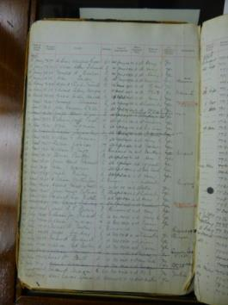

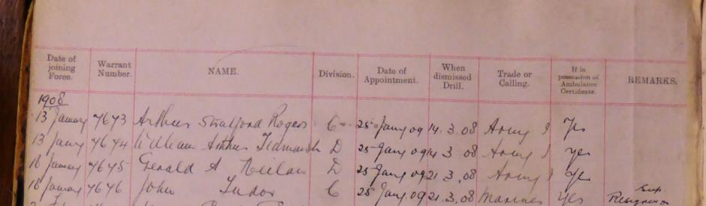

Gerald resigned on 20th December 1914 to rejoin the Army and was immediately given a commission being gazetted to the 24th Battalion, Northumberland Fusiliers, later transferring to the Royal Dublin Fusiliers. He was serving in Dublin engaged in recruitment duties when killed not half a mile from his parent’s house.
Birmingham City police Records

In 1911, Gerald was one of 32 police officers lodging at Duke Street Police Station, Birmingham.
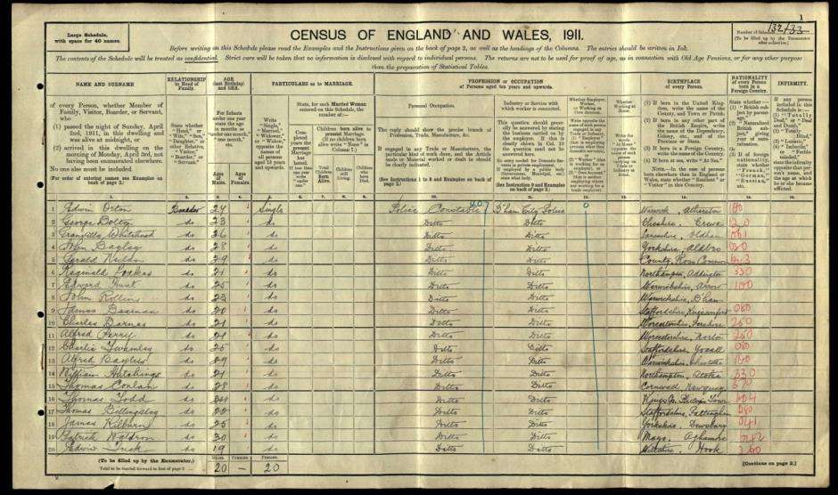

Birmingham City police Records dated 20th November 1916 detail Gerald’s death, Single Lt 10th Royal Dublin Fusiliers Killed in Irish Rebellion, Dublin 28th April 1916
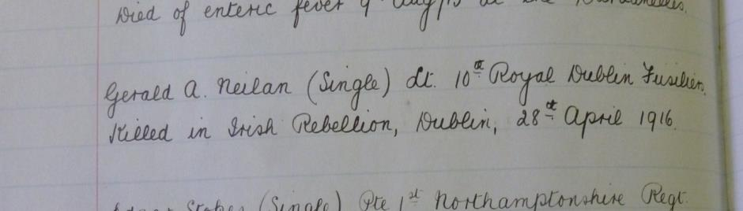

A Service was held at The Parish Church, Birmingham
Sunday 5th December 1920 3.30pm
Remembering those police constables Killed in action, those who died on active service and those who died from illness due to war service

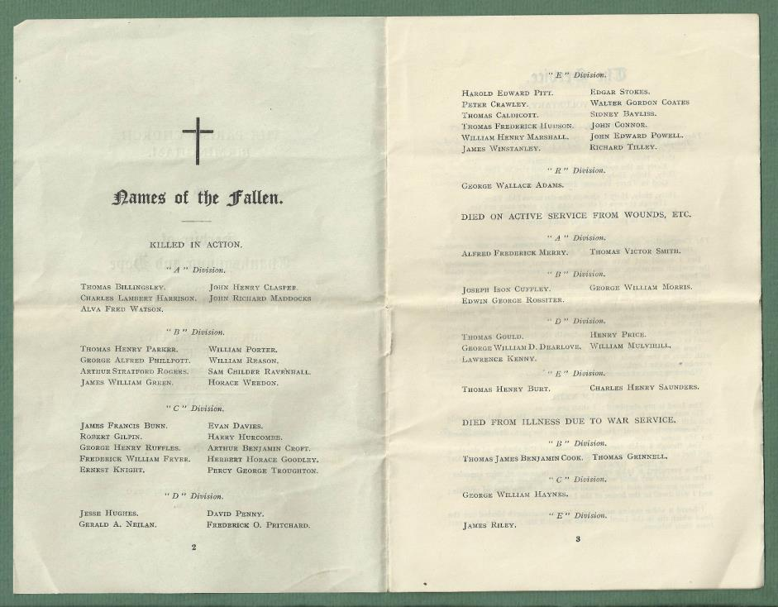

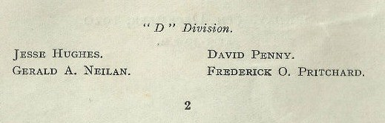

War service History
He was serving in Dublin engaged in recruitment duties when killed not half a mile from his parent’s house.
He was killed on the first day of the Irish Rebellion, Easter Monday 1916, a Republican insurrection against British government, planned to be a nationwide event. The British learned of the planned uprising and on Friday 21 April 1916 arrested the Irish nationalist Sir Roger Casement in County Kerry for running arms for the rebels. Although Eoin MacNeill, the leader of the Irish Volunteers, attempted to cancel the uprising, various factions mobilised resulting in about 1,560 Irish volunteers and a 200 man contingent of the Citizen Army seizing the Dublin General Post Office and other strategic points in Dublin's city centre. A proclamation announcing the birth of the Irish republic was read aloud. For nearly a week Dublin was paralysed by street fighting with British Artillery bombardments and fires compelling the Irish leaders to surrender on Saturday 29th April 1916. By this time casualties amounted to about 440 British troops and 75 Irish rebels.
Gerald was killed at the Mendicity Institute on Usher Island, this being a poorhouse on the Liffey quays, when it was attacked and seized by the Irish rebels. The attack was led by Sean Heuston who had orders to hold the building for 2 hours but, as it later transpired, he held it for 3 days. In a memorandum sent by General Sir John Maxwell to the Prime Minister, Herbert Asquith, he states of Heuston.
“This man was in command of the Mendicity Institute, Usher's Island. One British Officer and nine men were killed by the fire from the building which had to be carried by assault. Twenty-three rebels were captured in it amongst them this man, and large stores of revolver and rifle ammunitions and bombs were found. Orders and dispatches were also discovered showing that this man was in constant communication with the leaders. In all of these dispatches he described himself and was described as Captain.”
Once the uprising had been quelled, the ringleaders, Heuston, W. O’Dea, P. Kelly and J. Crenigan were tried together by Field General Courts Martial on Thursday 4 May 1916. The first witness, Captain A.W. MacDermot of the 7th Battalion, Royal Dublin Fusiliers stated.
“On 26 April I was present when the Mendicity Institution was taken by assault by a party of the 10th Royal Dublin Fusiliers. Twenty-three men surrendered on that occasion. I identify the four prisoners as having been in the body of men who surrendered. They left their arms except their revolvers in the Mendicity Institute when they surrendered. Some of them still wore revolvers. One officer of the 10th Royal Dublin Fusiliers was killed and 9 men wounded by fire from this Institute on the 24th April. I searched the building when they surrendered. I found several rifles, several thousand rounds of ammunition for both revolvers and rifles. I found 6 or 7 bombs charged and with fuses in them ready for use.”

The next witness was Lieutenant W.P. Connolly, 10th Battalion, Royal Dublin Fusiliers. He stated...
“I was present when 23 men surrendered on the 26th April at the Mendicity Institute. I identify the four prisoners before the court as being amongst them. The leader was J.J. Heuston. I was present when the troops were fired on from the Mendicity Institute on the 24th April, when Lieutenant G.A. Neilan was killed and 6 men wounded to my knowledge. Heuston was without a coat when he surrendered and also had no hat on. He was not in the uniform of the Irish Volunteers. I was present when the building was searched and found arms and ammunition in it and also the documents now before the court. Among the arms there were some old German Mausers. Among the ammunition there were two cardboard boxes of ‘Spange’ German ammunition.”
All four defendants were found guilty with Heuston being shot at 4.05am on Monday 8 May 1916 in the former stonebreaker’s yard at Kilmainham Prison. His remains were later buried in Arbour Lane Cemetery.
Gerald is buried in Glasnevin (Prospect) Cemetery, County Dublin in Grave St. Bridget’s. SH. 20.5.-21 and is also commemorated on the Birmingham City Police War Memorial, West Midlands Police, Lloyd House, Birmingham, on a memorial panel in the Abbey Presbyterian Church, Parnell Square, Dublin and at The Sacred Heart Church, Roscommon.
He was unmarried. His brothers Charles James and Alan Joseph saw service during the war as Doctors in the Royal Army Medical Corps in Mesopotamia and France.
Ironically another brother, Anthony, took part in the uprising against the British and was arrested and served a sentence in Knutsford Detention Barracks.

There is an account in a diary of the other Lieutenant alongside NEIALN. It was posted on the Great War Forum by his grandson April 4th 2011 who states...
I often reflect that such is the lottery of life, if my grandfather had been shot and not Gerald Neilan, then I would not be here writing this.
There were 2 Lieutenants in the column of the 10th Battallion RDF that left Royal Barracks to relieve Dublin Castle, Gerald Neilan was one, my grandfather was the other.
I have a first-hand account of Neilan's death from my grandfather's diary, and I also have a first-hand account of one of the men in the Mendicity Institute who shot at the column.
The essence from the IRA man is
..... Reflection of this kind came suddenly to an end when my eye caught signs of movement across the Liffey on the quays. Incredible to relate the Royal Dublin Fusiliers Regiment were coming out of the Royal Barracks headed by an officer carrying a drawn sword in columns of fours with their rifles at the slope. The column erupted suddenly on the quay and continued to pour its khaki bulk out like a sausage coming from a machine. No advance guard - no scouts thrown out in advance to give warning of enemy forces lying in wait. Stepping smartly in time as if on a ceremonial parade the column came nearer to us, and to add to the air of festivity a tram came running along the tracks from the Park.

The Tommies had reached halfway between Ellis's Street and Blackhall Place, when possibly the strain becoming too much, someone downstairs fired. At that reaction of the rest of us was instantaneous, and we all let go. If Sean Heuston blew his whistle its sound was lost in the thundering reverberations that beat about our ears as the echo of the rifle explosions came back across the river from the houses opposite. I fired with the rest at nothing in particular, and suddenly became aware that I was pulling on a trigger and there was no recoil. I had emptied the magazine of the Lee Enfield in a wild unaimed burst of firing quite automatically and unconsciously. I filled the magazine again, put one in the breech and bringing my eyes into focus I saw that the tram was stopped, and had emptied itself of its passengers. The khaki column had scattered. Here and there in the doorways the soldiers crouched, some could be seen taking cover behind the river wall, others were making sudden jumps for the cover of the tram. The corners still had their clumps of curious and interested civilian onlookers.
My grandfather wrote
I received orders to take B Company, about 50 men to the Castle. No further orders and there was no inkling that rebellion had broken out. I proceeded at the head of the party down a narrow street to the quays, where on turning a corner into Bridgeford Street, we received a volley of rifle shots which scattered our party.The officer following me, Lt Neilan, was killed,as were five or six men, and several more were wounded. I re-assembled the party, leaving the injured on the road, and sent out an advance party of six men. The party proceeded across Aran Street Bridge and up Winetarven Street to James Street, along Christchurch Place in the direction of the Castle, The rifle firing in the adjoining neighbourhood had become intense from the South Dublin Union which was being subject to heavy attack. A few shots passed over us without any effect.
Dublin-fusiliers.com

Attestation form
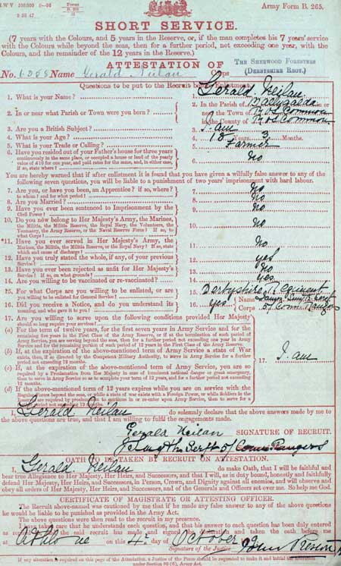
Dublin-fusiliers.com

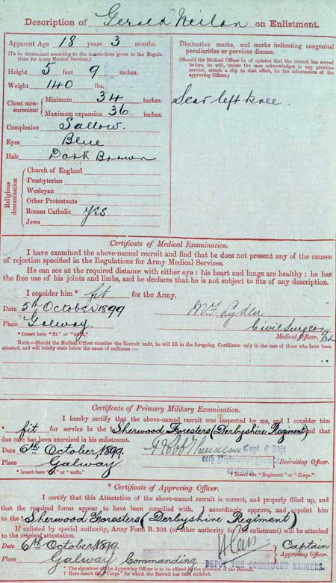
Dublin-fusiliers.com

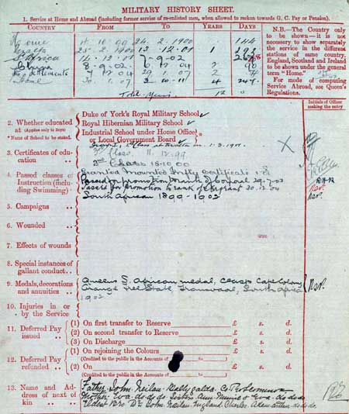
Dublin-fusiliers.com

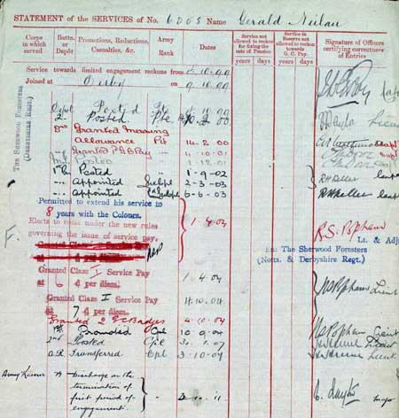
Dublin-fusiliers.com

Ireland’s casualties of World War One
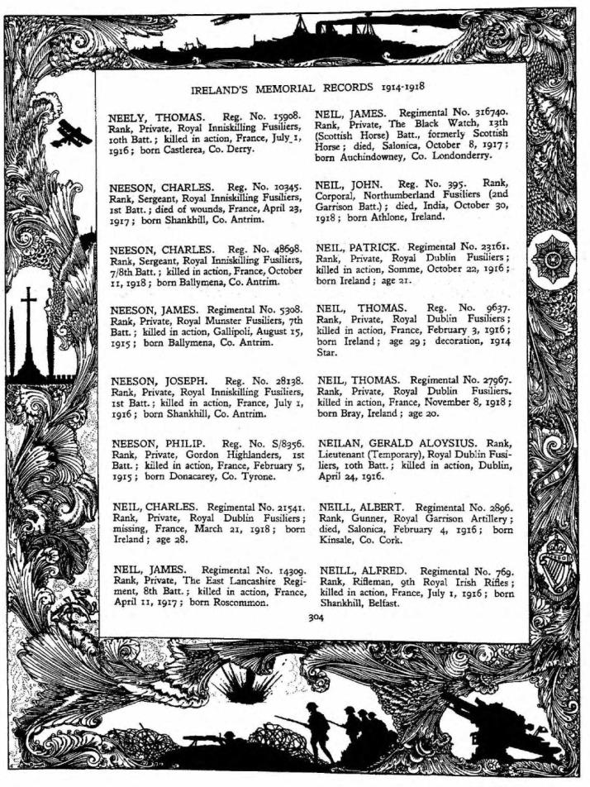

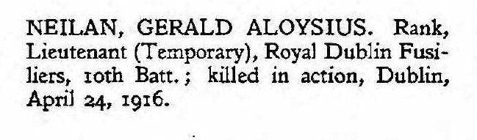

De Ruvigny’s Roll of Honour 1914-1919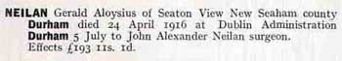

De Ruvigny’s Roll of Honour 1914-1919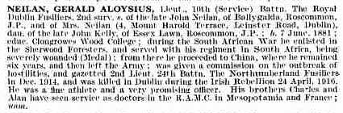
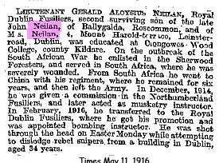
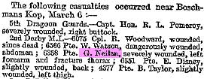

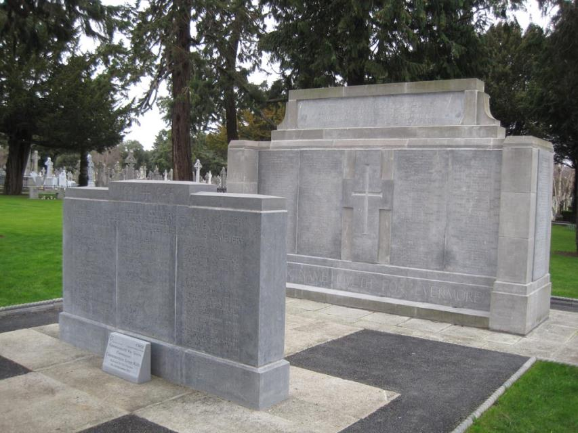

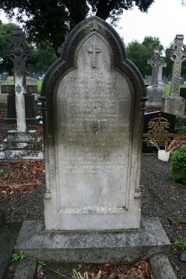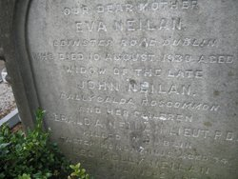
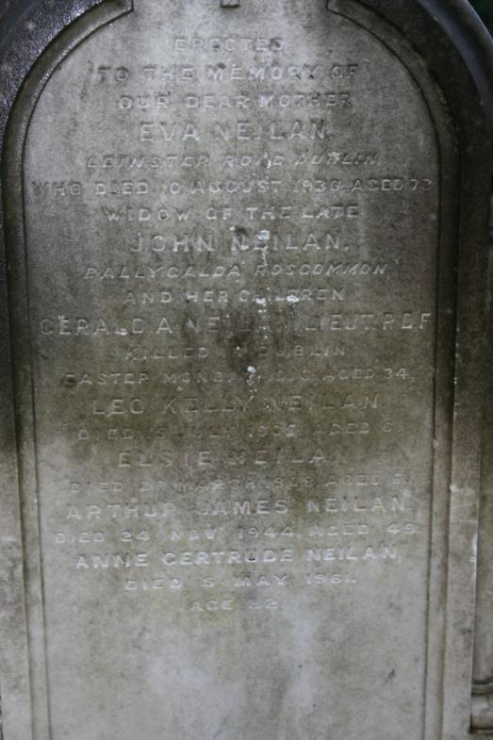
Findagrave.com

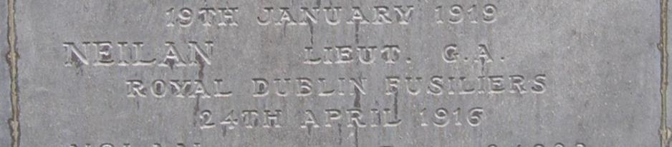

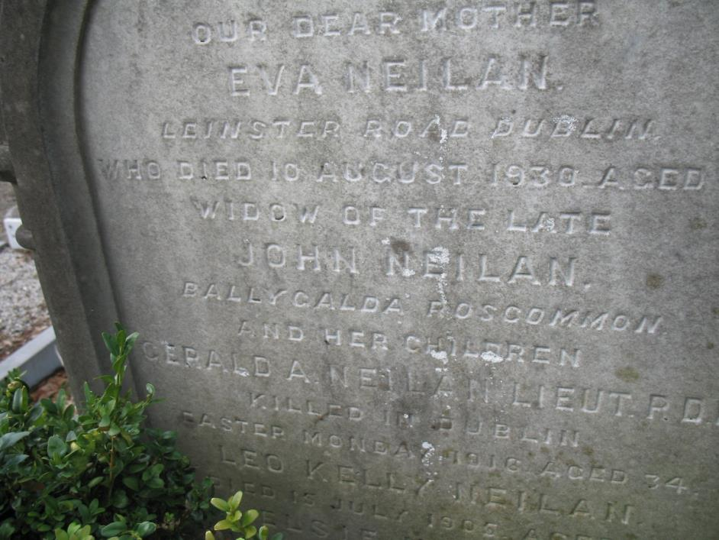
Findagrave.com

Antecedents of Gerald Aloysius NEILAN
- Gerald was born on 7th June 1881, the second son of John (of Ballygalda, Roscommon) and Eva (nee Kelly) Neilan of 4, Mount Harold Terrace, Leinster Road, Dublin. Second eldest of seven children. He has 5 brothers and two sisters.

- His father was a farmer and local Justice of the Peace and his mother was the daughter of the late John Kelly of Essex Lawn, Roscommon.

- He was educated at Clongrowes Wood College, County Kildare.

- Following her husband’s death some time before 1911 Eva resided at Mount Harold Terrace, Dublin.

- In 1911, Gerald was one of 32 police officers lodging at Duke Street Police Station, Birmingham.

- 1950 Census Gerald A NEILAN was recorded as residing at 119 College Road, Saltley along with James and Elizabeth REDDY
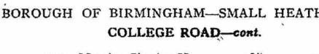
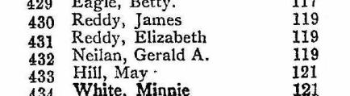

Probate 1916

