December 2017
Guardsman 11916 William MULVIHILL
1st battalion Irish Guards
Birmingham City Police ‘D’ Division PC D 110
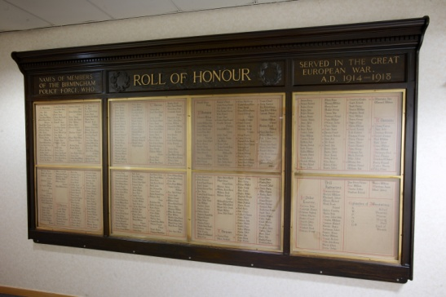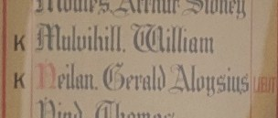

Died in France 3rd December 1917
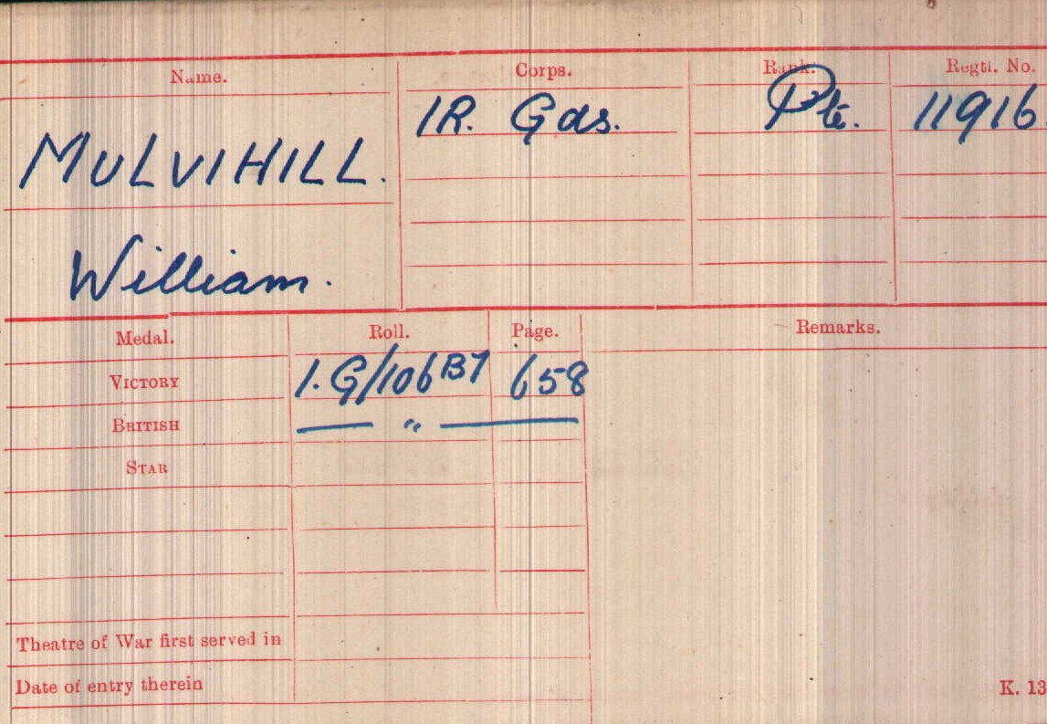
British Army WW1 Medal Rolls Index cards 1914-1920

Police Service History
William joined Birmingham City Police on 28th March 1914, as an 18 year old miner. He served on the ‘D’ division, with collar number D110 and warrant number 8465. He resigned 5th March 1917 to join the Army in Birmingham
Birmingham City Police records dated 13th April 1916 informs that William was cautioned for being under the influence of drink when parading for duty at Victoria Road Police Station at 9.45pm Saturday 1st April 1916
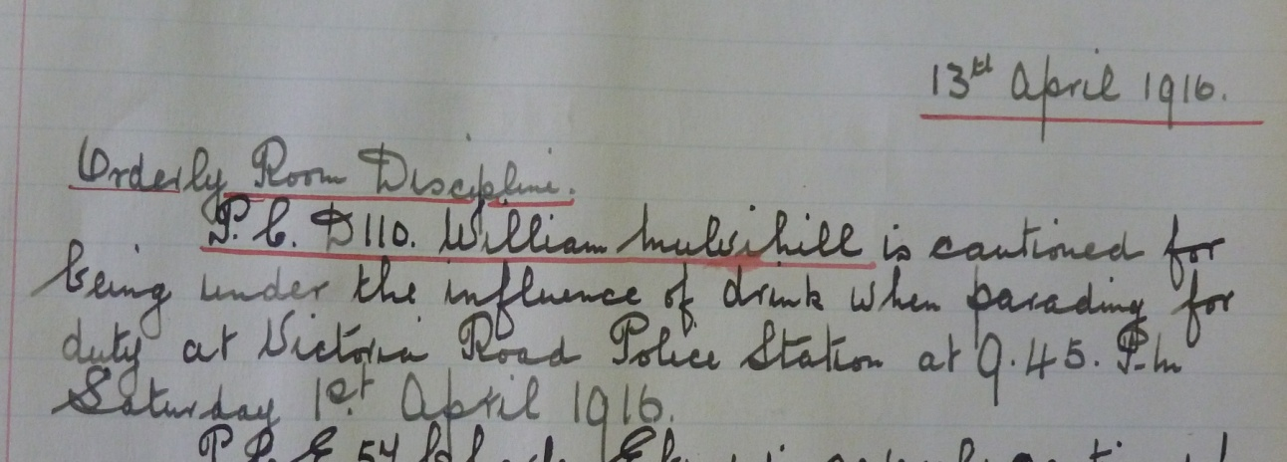

Birmingham City Police records dated 3rd March 1916 States William was suspended from 1st April 1916 for being under the influence of drink when parading for duty at 9.45pm
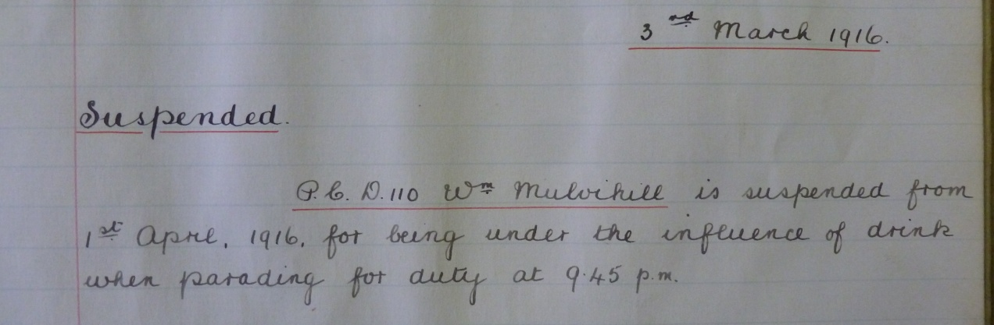
Birmingham City Police records dated 7th April 1916 shows William was reinstated on 7th April 1916
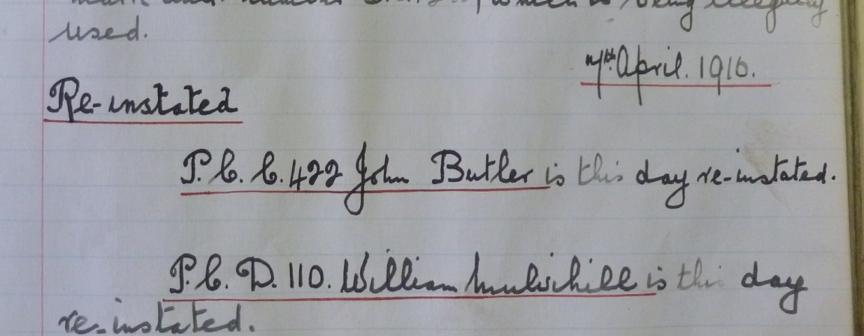
War service history
He was wounded in action and succumbed to his injuries at 21 Casualty Clearing Station in Ytres, France.
It is probable that William was wounded on Saturday 1st December 1917 during a Brigade attack on the Quentin Ridge and Gauche Wood, north of Epehy, the attack was led by 2nd Battalion, Grenadier Guards and the 3rd Battalion, Coldstream Guards at 6.20 am with William's battalion in support. By 7 am the woods had been seized and several counter attacks repulsed, however William's battalion was brought forward at some stage to fill a gap in the front lines. These positions were consolidated with the battalions being relieved the same night. Casualties in William's battalion amounted to 18 men killed and many more wounded.
Ireland Casualties of World War 1
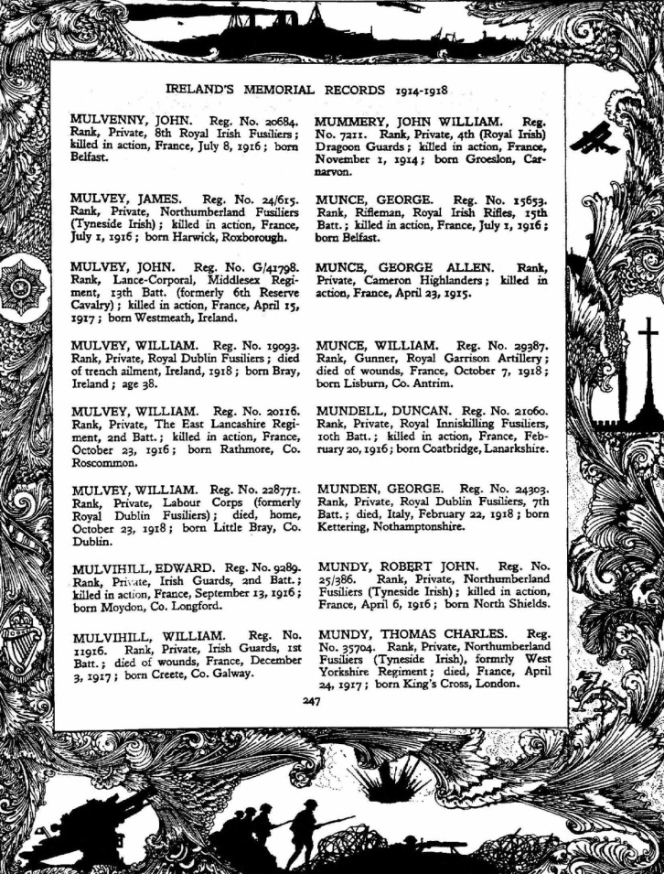

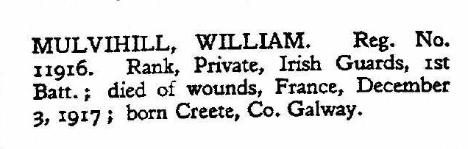

Buried VI E 6
Rocquigny-Equancourt Road British Cemetery,
Manancourt, France.
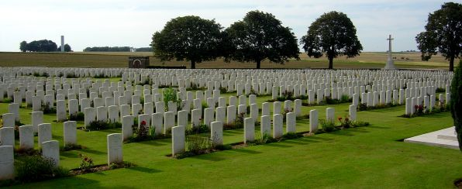
Inmemories.com

Antecedents of William MULVIHILL
- Born about 1895 Creete, Co Galway
- His mother was Mary Mulvihill who was the sole person to receive his effects on his death
- There is a Pat and Mary Mulvihill in the 1901 census, living at Creggs, Galway, with their 8 children: Kate 22, Patrick 20, Thomas 18, Martin 16, Michael 13, Mary Ann 11, James 9, William 6, and Margaret Hegarty (Mother)
- By the 1911 census Pat and Mary, Patrick, Mary Ann, James and William are living at Farranykelly (Athleague West, Roscommon). The father is a shepherd and the oldest sons were agricultural labourer
- William was a scholar in both census documents. In 1911 he was 16 years old. Possibly he came over to a Birmingham area to find work, as he was a miner when he enlisted age 18
William’s unit was part of the 1st Guards Brigade, led by Brigadier-General C.R. Champion de Crespigny; itself part of the Guards Division, commanded by Major-General G.P.T. Feilding; and they were part of IV Corps (Lieutenant-General Charles Woollcombe), who formed part of the 3rd Army, commanded by General Sir Julian Byng.

