1st May 2017
Lance Sgt 36732 George William MORRIS
2nd battalion Royal Welsh Fusiliers
Formerly 1st Cambridgeshire 28th January 1909
Birmingham City Police ‘B’ Division PC 205
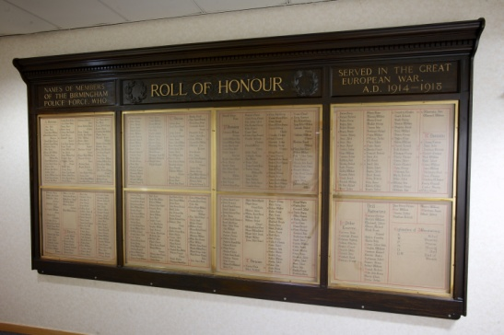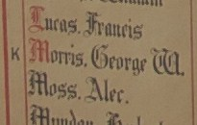
Died France 28th May 1917 aged 27
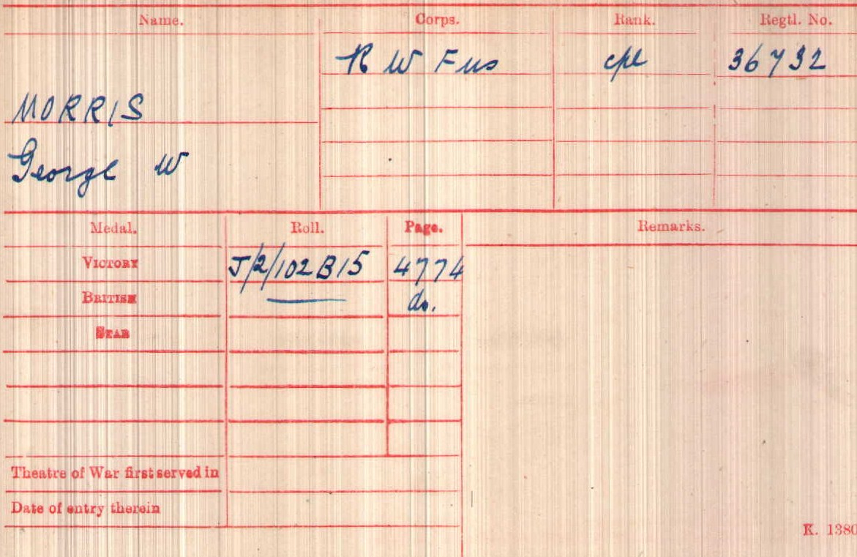
British Army WW1 Medal Rolls Index cards 1914-1920

Police Service History
George joined Birmingham City Police 3rd June 1912, as a 22 year old farm hand. He served on the ‘B’ Division with warrant number 8228 and collar number PC B205
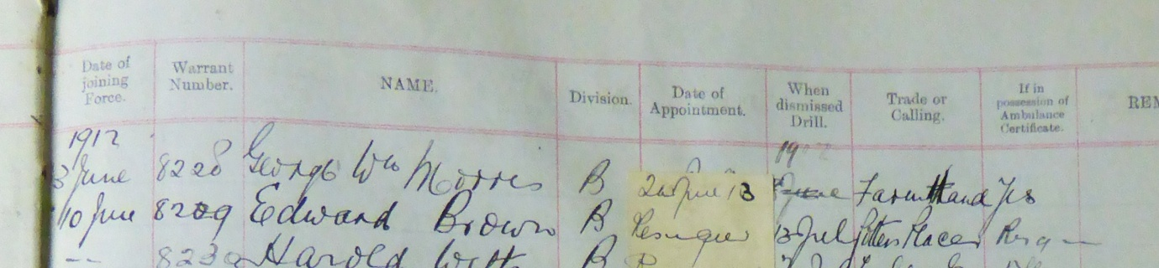

He resigned on 15th November 1915 and enlisted in the Army in Birmingham.
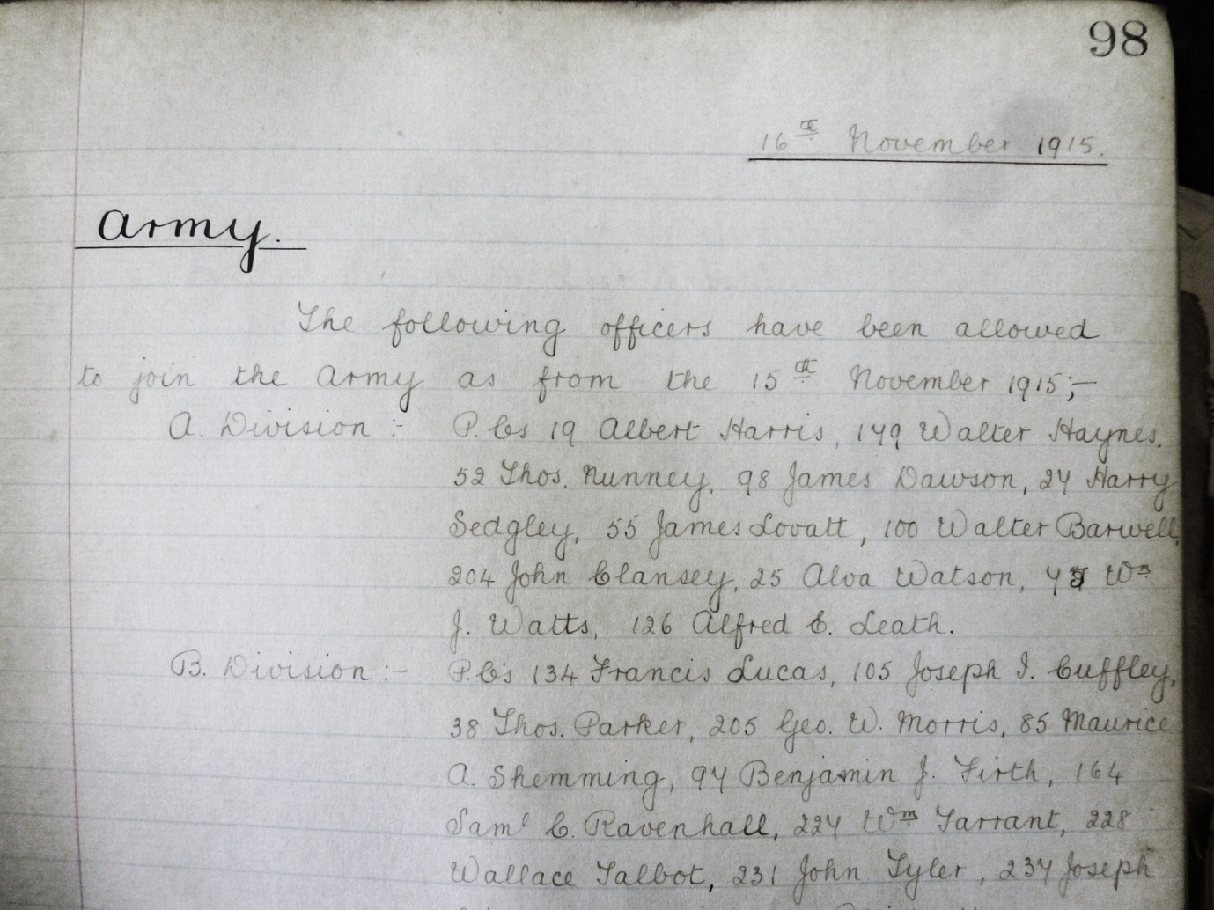

Birmingham City Police records dated 25th June 1917 inform officers of George’s death
George W Morris (single, Sergeant, Royal Welsh Fusiliers) died of wounds 28th May 1917
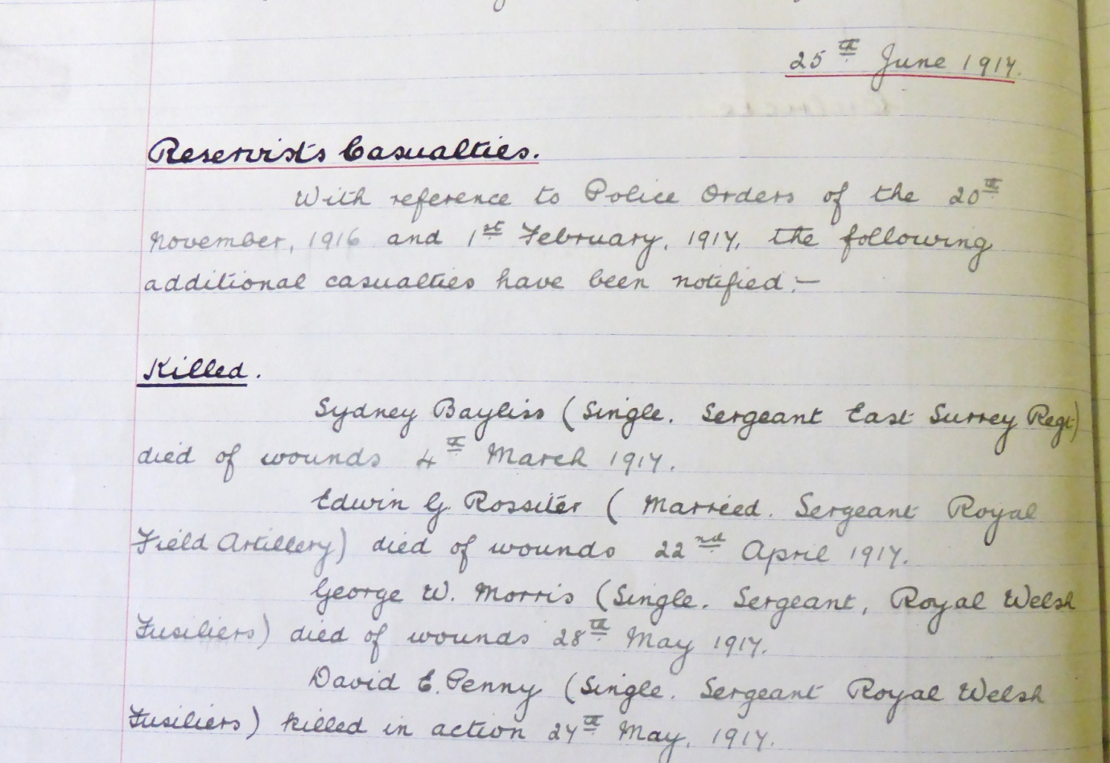

War service History
Wounded in Arras, on 27th May 1917, and died the following day at Boisleux-St Marc. Also killed in the same action was Birmingham City Policeman David Ernest PENNY.
In March 1917 the Germans withdrew to the Hindenburg Line in order to reduce their front by 25 miles and a major British offensive was launched in the area of Arras. At the time David's battalion was in training at camps in Basseux, Adinfer and Moyenville. On Tuesday 15th May 1917 the battalion moved forward into bivouacs in the support line at St Ledger-Henin, relieving a battalion of the Cameronians (Scottish Rifles) in the Croisilles sector in front of the Hindenburg Line on Friday 18th May 1917. There then followed a short period in which the battalion held the lines, being then relieved to St Ledger on the night of Tuesday 22th May 1917 where the battalion rested.
A return was made to the front line on Saturday 26th May 1917 when the battalion relieved the 6th Battalion, Northumberland Fusiliers in the front line trenches. The following day at 1.55pm the battalion made an attack on the Hindenburg Support Line between Plum Lane and Oldneburg Lane. The objective of 'A' and 'C' Companies was to cross the Hindenburg Line and establish a line of posts about 100 yards beyond, with the remaining companies following. The War Diary records the attack as follows: " The waves advanced extremely well until the wire was reached when there was a tendency to bunch. During the advance however a gap was caused between the Cameroonians and the battalion on the left. The enemy worked round through this gap and led to a retirement.
A few parties reached the Hindenburg Support on the left but right appeared to have encountered a intermediate line about 50 yards in front of it. An order to retire was given by someone unknown, as this was carried along the whole line from left to right and at 2.45pm the whole were back in the old Hindenburg front line. Very heavy machine gun and rifle fire was met and casualties were heavy, only 2 2nd R.W. Fusiliers Officers returned unwounded. Companies were quickly reorganised to meet a possible counter-attack.
This appeared probable at 7pm but was apparently stopped by artillery fire. The back areas were heavily shelled during the attack the hostile barrage being extremely severe between the quarry and Croisilles." Casualties amounted to 6 officers killed and 4 wounded, 19 other ranks killed with 76 wounded 59 missing. The following day at 1.10pm the battalion was relieved to Moyenville.

George’s pension service records have survived
Attestation Enlisting Form dated 15th November Suffolk Street, Birmingham, dated 15th November 1915.
Also shows him declaring he had previously served with 1st Cambridgeshire 28th Jan 1909

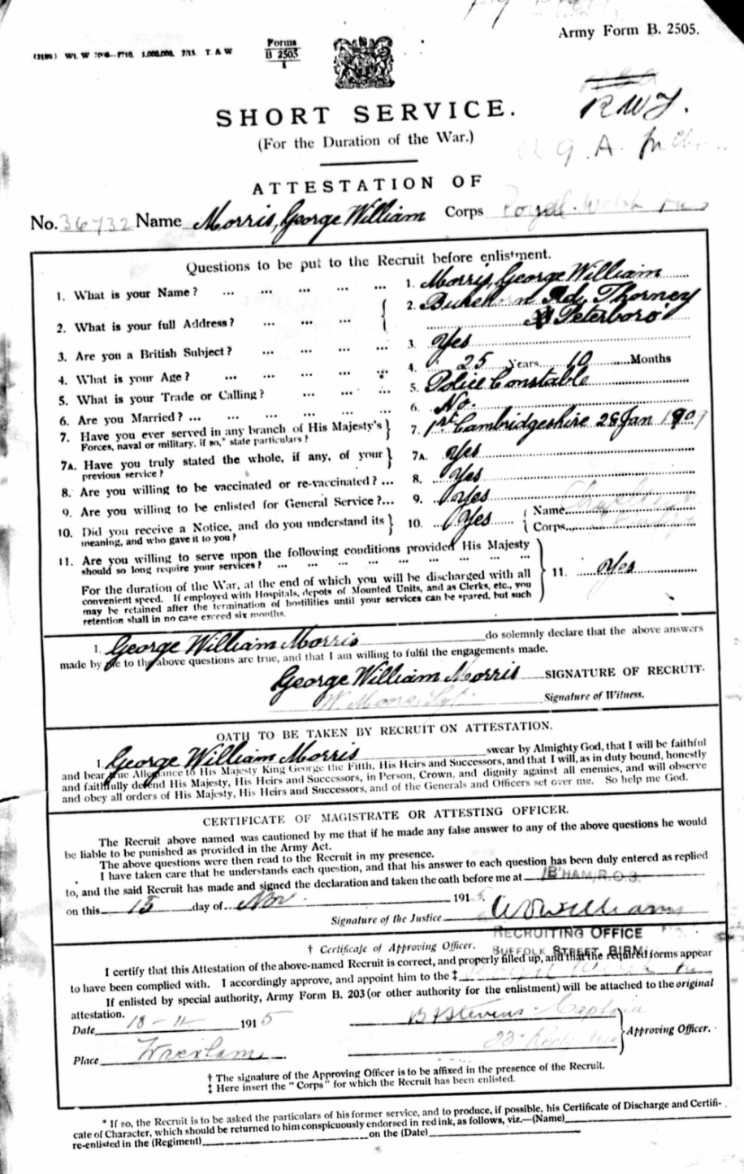

Enlistment descriptive form and Service statement
15.11.1915 – 24.04.1916 George served at home
24.11.1915 George was appointed Acting Corporal
26.04.1916 – 28.05.1917 George served in France, in the 2nd Battallion
14.06.1916 George was appointed to Lance Corporal unpaid
26.07.1916 George was promoted to Corporal
23.08.1916 George was appointed to Lance Sgt
28.05.1917 George died of wounds at 20 Casualty Clearing Station.

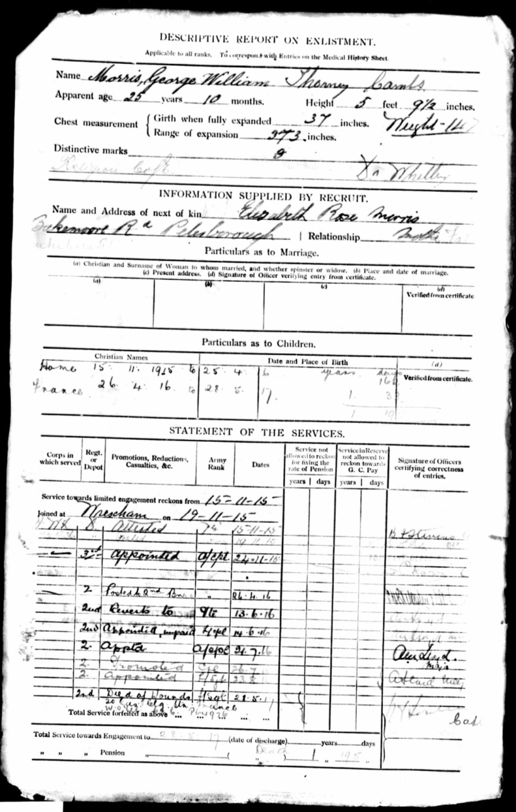

Conduct sheet for George William Morris
Shows no punishments, offences or good conduct awards

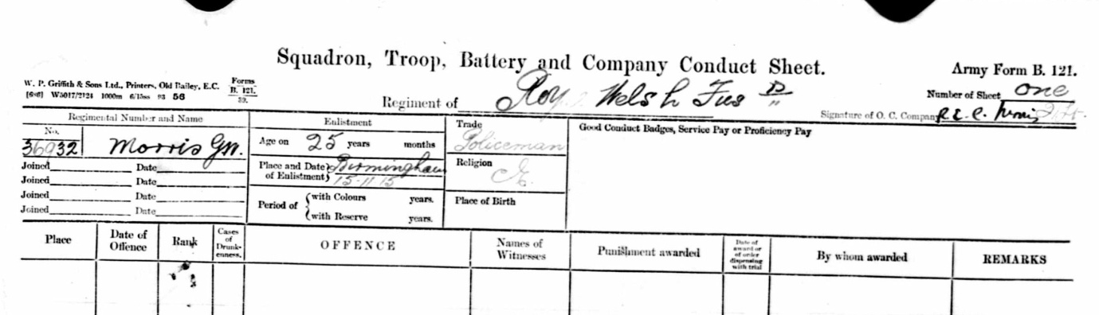

Buried Grave I C 6
Sunken Road Cemetery Boisleux-St Marc, France
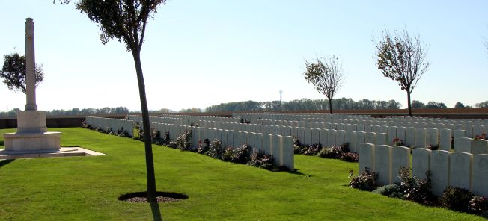
Inmemories.com

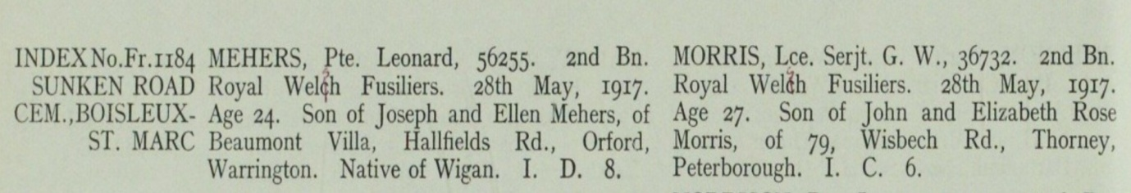

Antecedents of George William MORRIS
- George was born in the first quarter of 1890 in Thorney, Peterborough,
- His parents were John and Elizabeth Rose Morris of 79 Wisbech Road, Thorney, Peterborough
- In the 1891 census its confirms George was residing with his parents and older brother John Thomas (6) and his sister Lizzie (4) at Black Drove, Thorney, Peterborough
- His father was an agricultural labourer
- In 1901, the whole family, along with a younger sister, Edith Anne, were living at 39, Black Drove, Thorney (Isle of Ely), Peterborough
- George's father was now a foreman on a farm, his brother was a horse keeper and his older sister a domestic servant.
- In 1911 George and his younger sister Edith Annie were living with their parents at Small Holding Farm, Bukehorn Road, Thorney Peterborough. George was working on the farm

