Lance Corporal 9645 John Richard MADDOCKS
3rd Battalion Worcestershire Regiment
Birmingham City Police ‘A’ Division
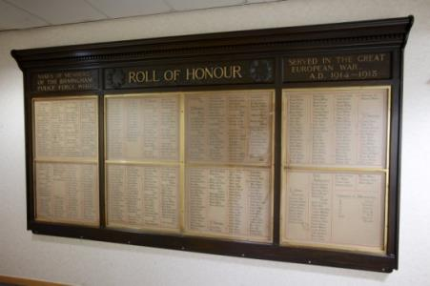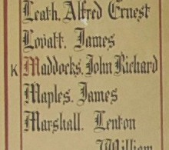
Died Belgium 13th January 1915 aged 27

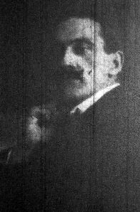
Inmemories.com
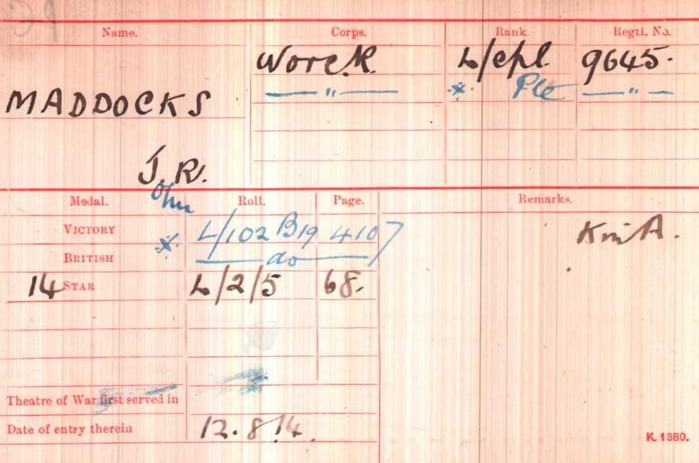
British Army WW1 Medal Rolls Index cards 1914-1920

Police Service History
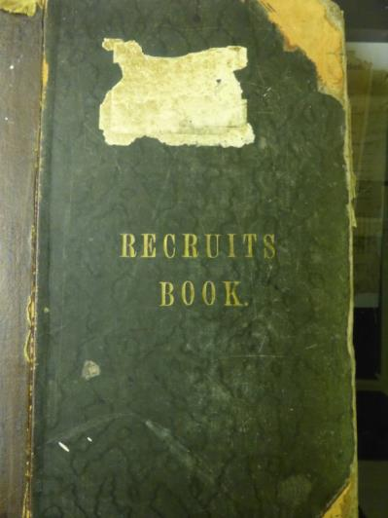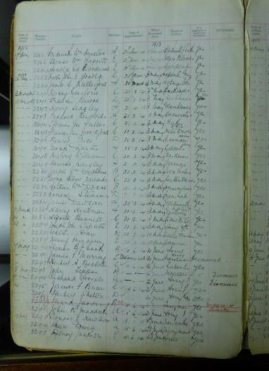

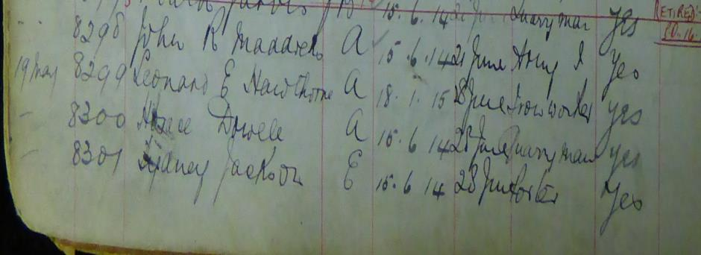
John joined Birmingham City Police on 14th May 1913 where his trade or calling was recorded as Army. He served on the ‘A’ Division with the warrant number 8298.
He was recalled to service on 4th August 1914.

War Service history
John joined the Worcester regiment in 1905, Regimental number 9645
John enlisted in the Army at Birmingham aged 17 and served seven years in Malta and India and left the Army and joined the police in 1913.
After being recalled to service 4th August 1914, he returned to his battalion and went to Belgium. He was promoted the day before his death, as a result of being shot in the head by a sniper whilst in the trenches.
John fell victim to a sniper whilst in the trenches at Spanbroekmolen near Kemmel. Company Sergeant Major P. Bland wrote to his family stating, "At about 8.30 on the morning of 13th January, your son, whilst in the trenches, was hit in the head by one of the enemy's snipers. The doctor was in attendance almost immediately and everything was done that was possible. However, he did not regain consciousness and died about 3pm. We removed him from the trenches after night fall and he is buried here, some way back out of the firing line".

Nick Beeching has provided further information: John was the only fatal casualty on that day. Stacke [H. Fitzm STACKE: ‘Worcestershire Regiment in the Great War’. 2 vols. 2002] has sketchy information for January to March 1915 (and therefore the War Diaries are too) but the 3rd Battalion was involved in line holding north of the River Lys from January to the beginning of March 1915. In January they were relieved every four days in the line, and in February every seven days in the line. Sniping and shelling took a steady toll of casualties with around a hundred killed and wounded over the period in question.
Stacke’s figures:
5 January – 1 February: 7 killed, 20 wounded
5 February – 4 March: 13 killed, 50 wounded
Total:20 killed, 70 wounded
Nick’s figures suggest fatal casualties based on SDGW [Soldiers Died in the Great War] and CWG [Commonwealth War Graves]:
January: 12 dead (included 3 DOW)
February: 18 dead (including 7 DOW)

Pension records ancestry.com show the following.

Casualty form showing John Richard Maddocks being
Killed in action at Kemmel 13th January 1915
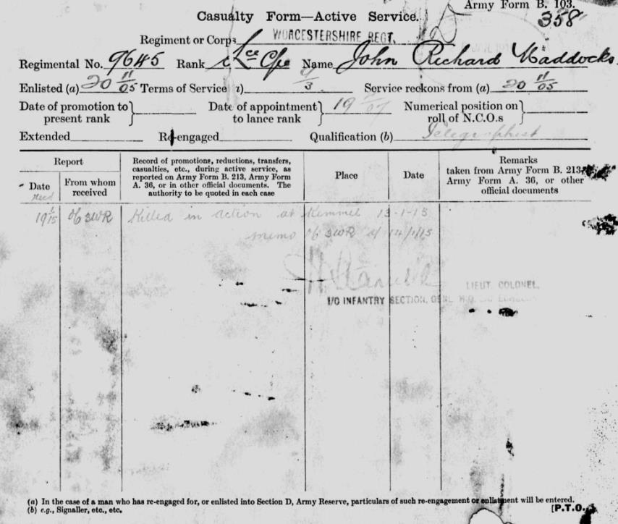

Enlistment form

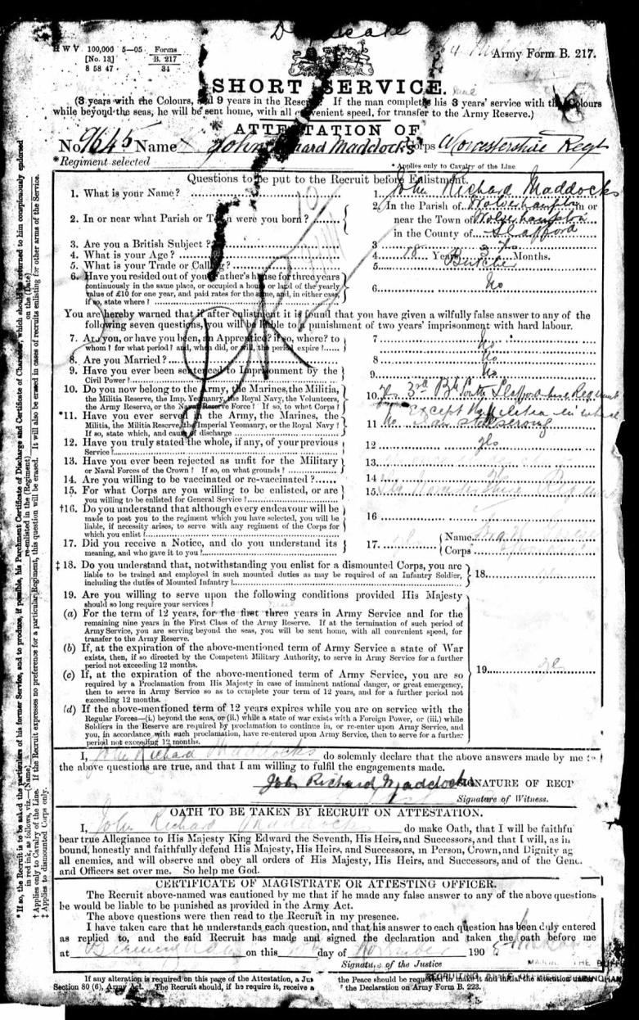

Description on enlistment

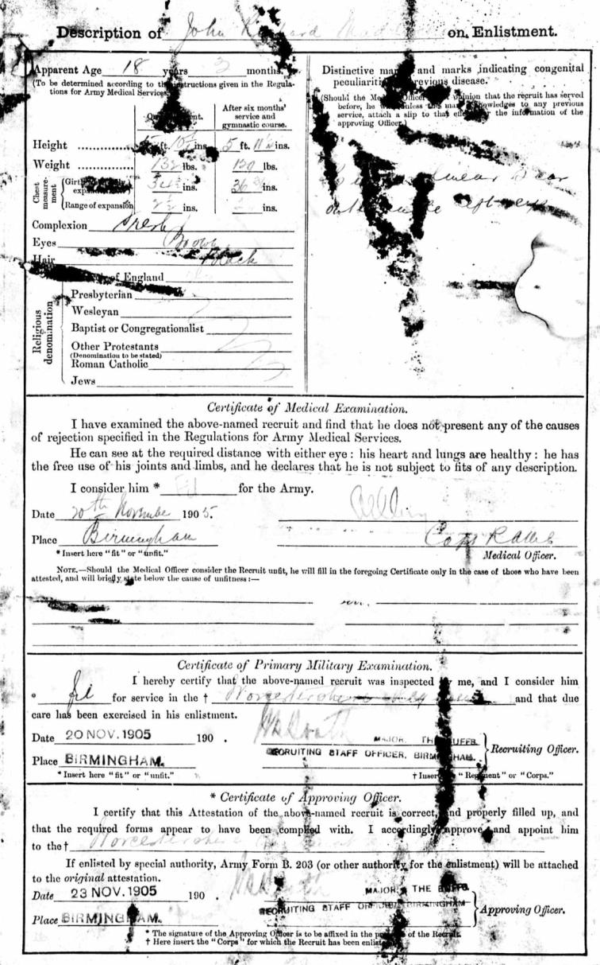

Medical history
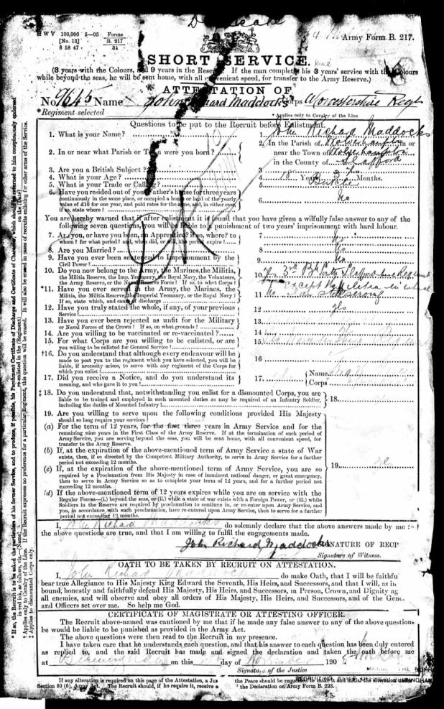

Copy of surviving relatives of the late John Maddocks
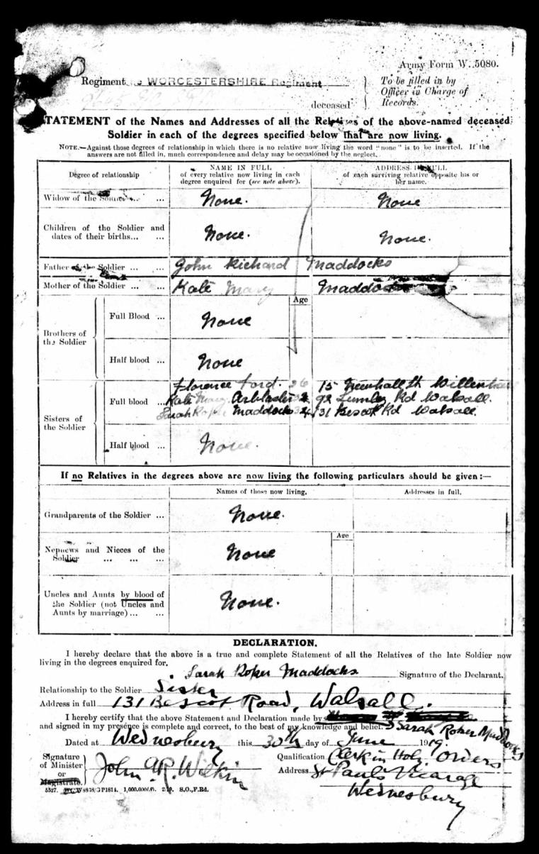

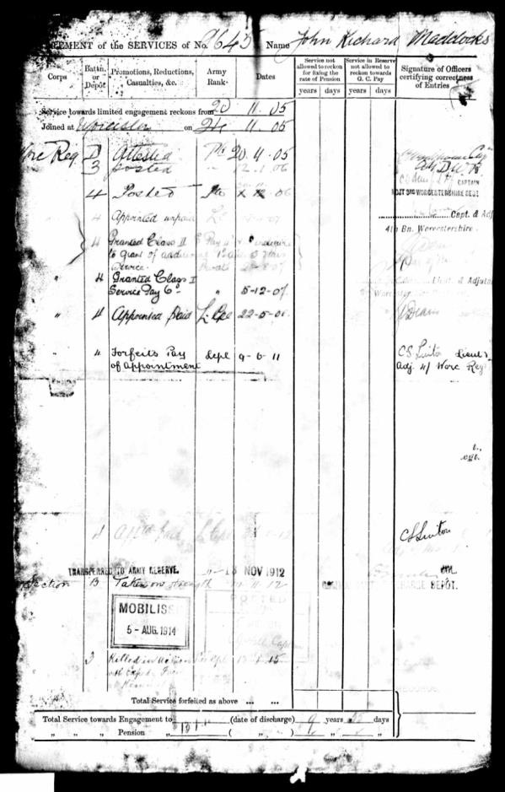

Military History Sheet
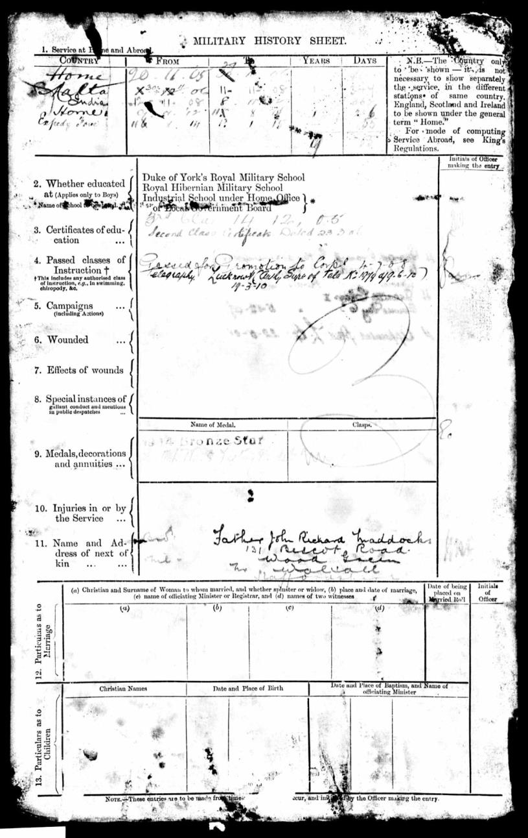

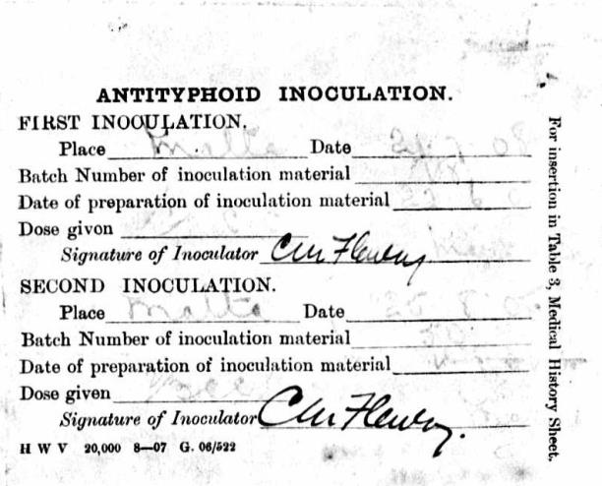

Receipt of BWM and VM by K M Maddocks
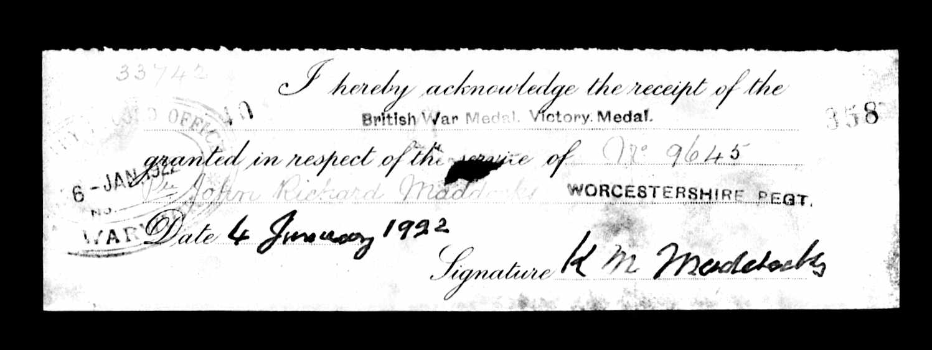

And receipt of 1914 Star by Kate M Maddocks
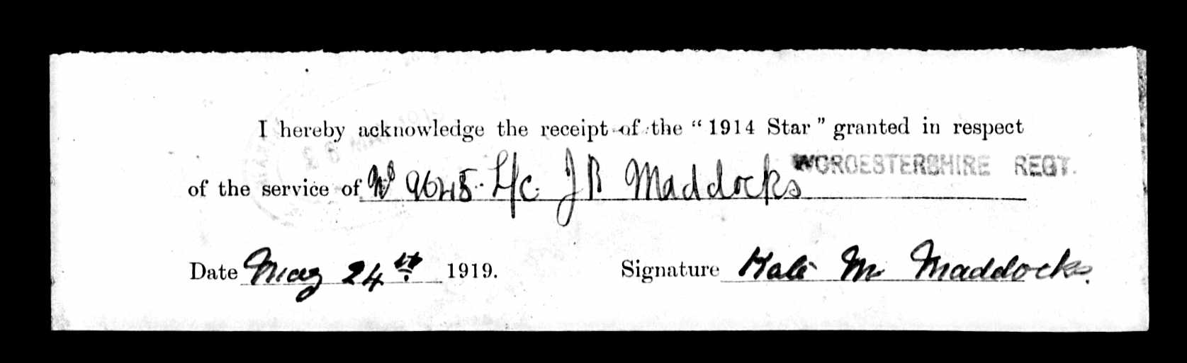

Buried Grave A 14
Kemmel Chateau Military Cemetery Ypres, Belgium.
He is also commemorated on Walsall Town Hall
and St John’s Church, Pleck, Walsall.
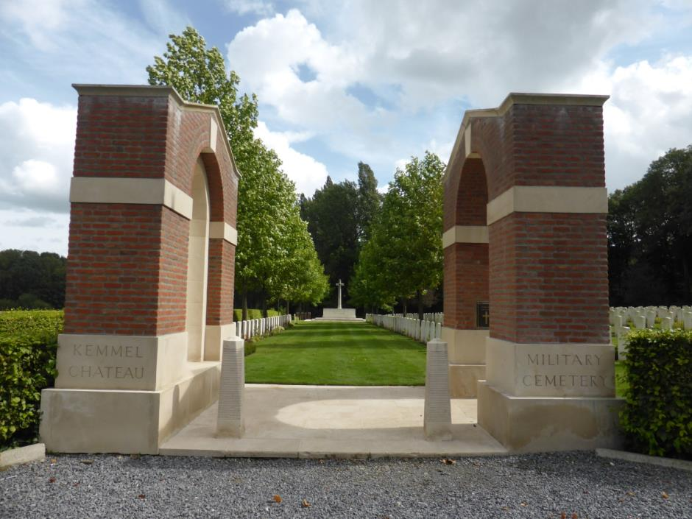
Photographs by permission of Su Handford taken 29th August 2014
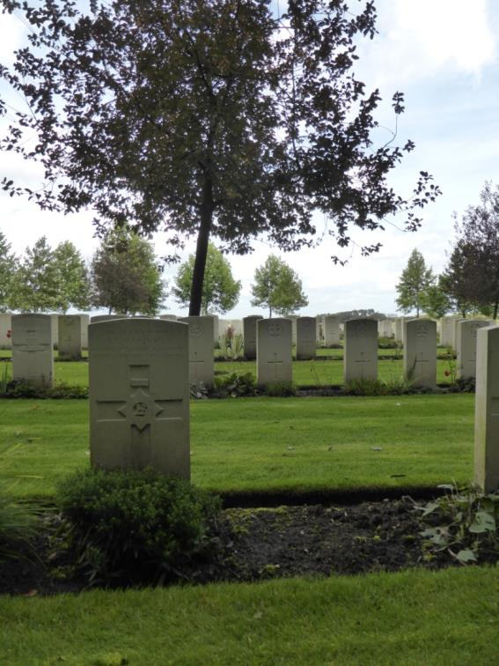

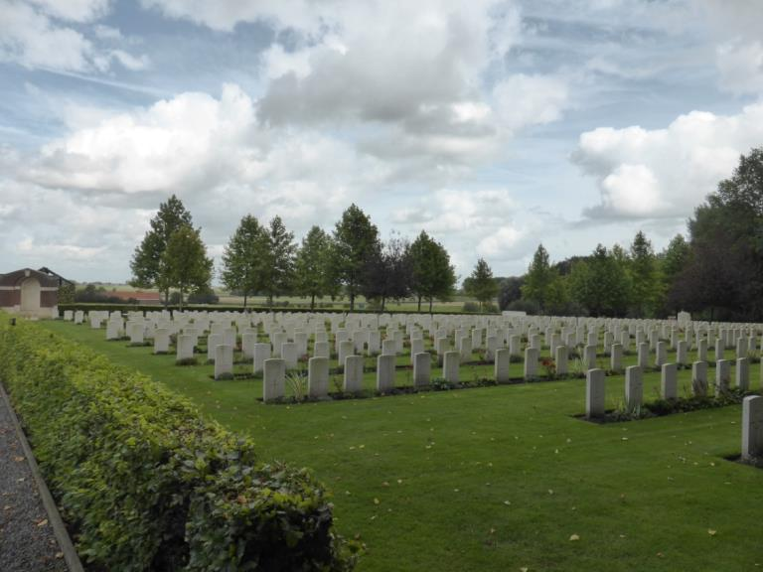

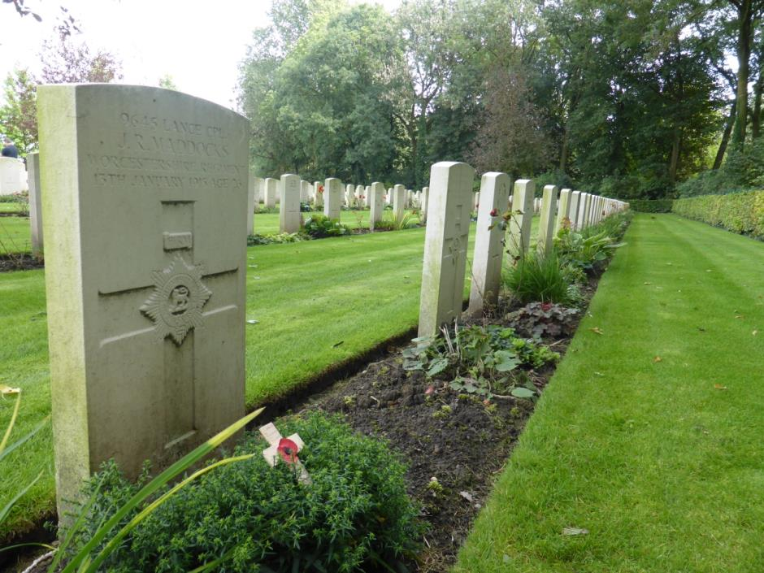

Antecedents of John Richard MADDOCKS
- John Richard Maddocks was born in the third quarter of 1888 in Wolverhampton, the only son of John Richard Maddocks and Kate Mary Maddocks.
- In the 1891 census the family were living at 32 Pond Lane Wolverhampton. John had 3 older sisters, Florence (8), Sarah (7) and Kate (4). His father was a blacksmith.
- In 1901 the family lived at 396 Pleck Road, Walsall. His father was still a blacksmith and his mother and three sisters worked as leather stitchers.
- On leaving school he worked at the offices of Richardson Ltd, Charles Street in Walsall.
- His British Army Pension record 30th June 1919 shows he has no widow, no brothers, no children but has three sisters one living in Willenhall and two in Walsall, one Sarah completing form 131 Bescott Road, Walsall.
- He joined the Worcester regiment in 1905, Regimental number 9645

