Compiled by Su Handford QPM on behalf of
West Midlands Police Military History Society
Lance Sergeant 5805 James William GREEN
2nd battalion Coldstream Guards
Birmingham City Police ‘B’ Division
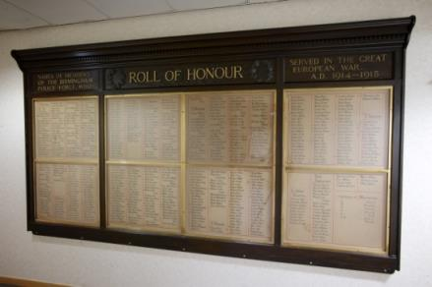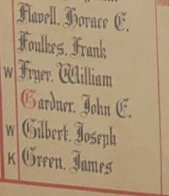

Died France 14th-16th September 1916

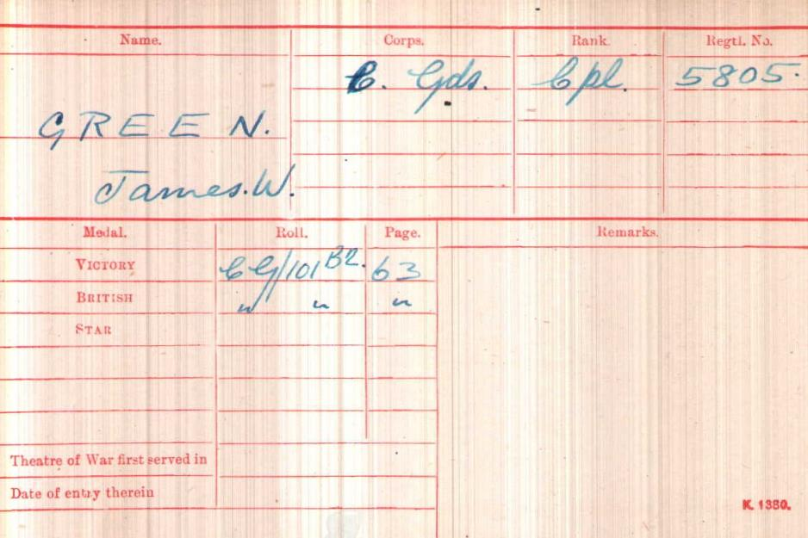
British Army WW1 Medal Rolls Index cards 1914-1920

Police Service History
James William Green joined Birmingham City Police 16th December 1907 as a 24 year old iron turner.
He served on the ‘B’ Division with warrant number 7963. He enlisted in the Army prior to joining the police. He was recalled as a reserve, on 4th August 1914.

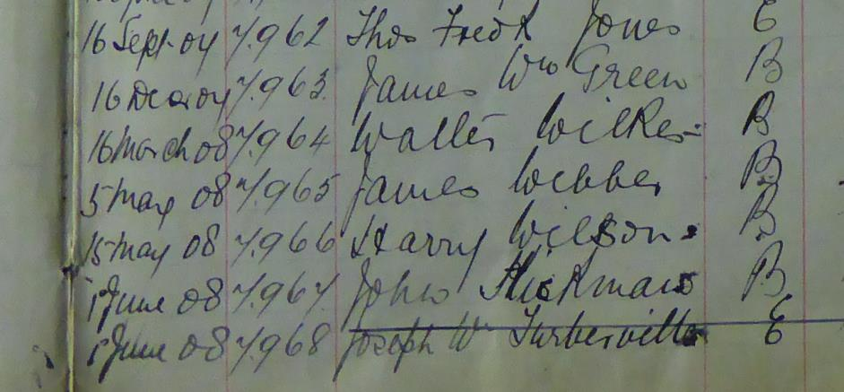

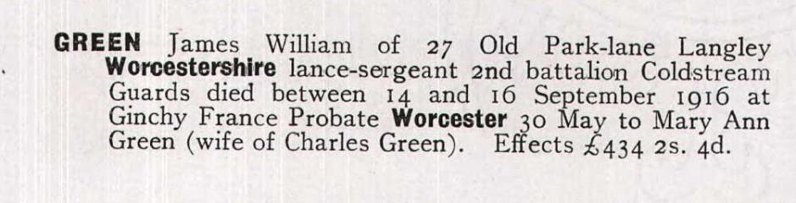

A Service was held at The Parish Church, Birmingham
Sunday 5th December 1920 3.30pm
Remembering those police constables Killed in action, those who died on active service and those who died from illness due to war service

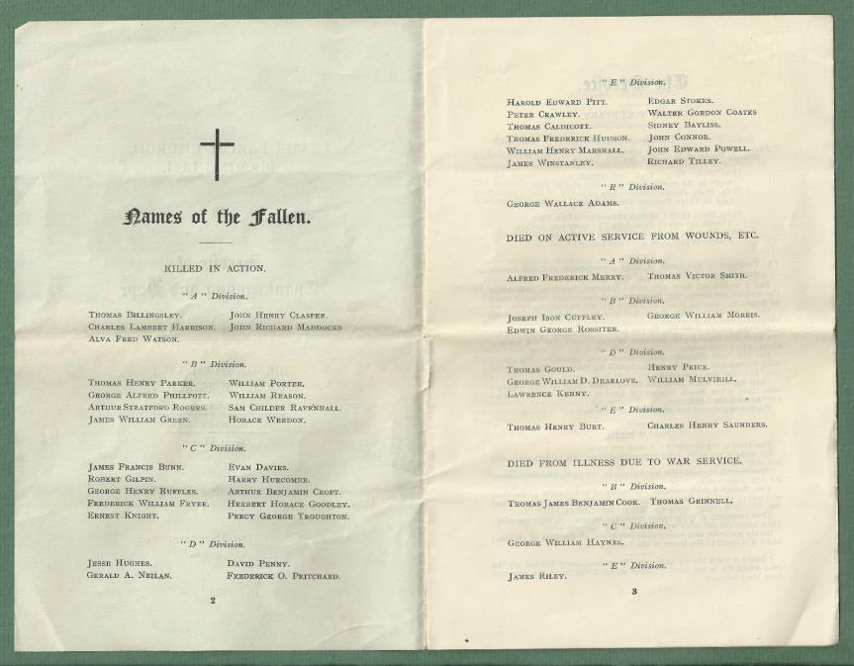

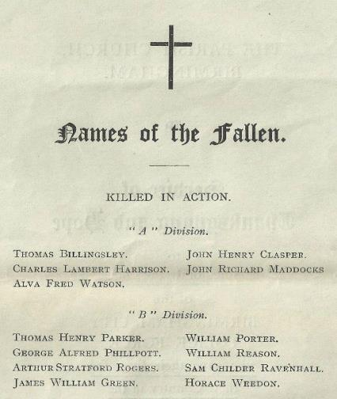
War Service history
On Tuesday 12th September 1916, during the Somme Offensive, James's battalion moved from Meaulte, via Bernafay Wood into the Givenchy sector. At 6.20 am on Friday 15th September 1916 the battalion made an attack towards Lesboeufs but received heavy casualties from withering German machine gun fire in the sunken Gincy-Flers Road.
Notwithstanding the casualties the battalion surged forward and entered the German front line at about 7.15 am. Further advances were then made and the positions successfully held against German counter attacks at 6.30 pm and 7.15 pm. The following day the Germans continually bombarded the battalion's positions, a relief not taking place until nightfall when the survivors were relieved to Citadel Camp. Casualties amounted to 440 men killed, wounded or missing.

Soldier’s effects records record James’ death as
Between 14th & 16th September
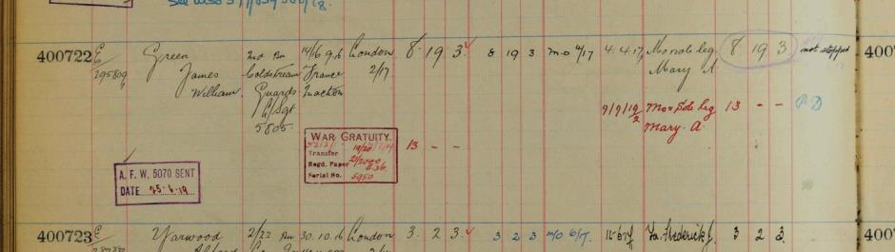

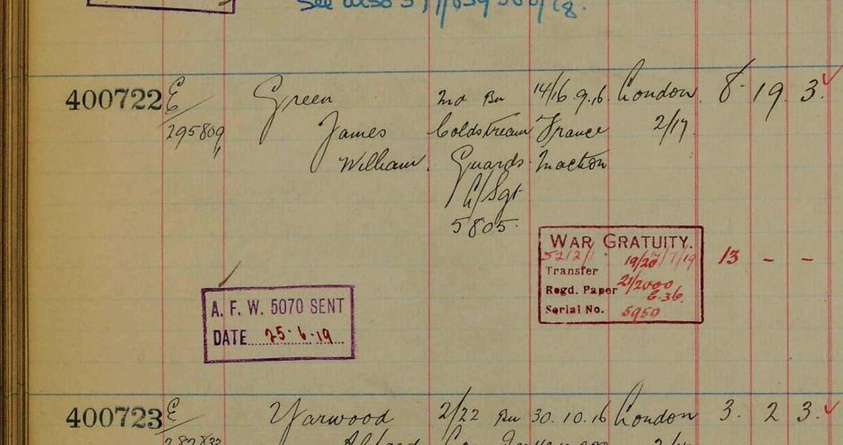

James William GREEN is commemorated
Thiepval Memorial France
Pier and Face 7D and 8D


CWGC
Antecedents for James William GREEN
- Born Langley, Oldbury, Worcestershire in 1883
- Son of Charles Green and Mary Ann (nee Skett).
- He resided at 25 Titford Road, Oldbury (1891 census), and 27 Old Park Road, Oldbury (1901 census), the 1911 census shows him as a boarder at 24 Victoria Road, Stirchley occupation Police Constable.
- He resided at 29 Park Lane, Langley.
- He had 4 sisters, Lucy, Lizzy, Ada and Mary Ann and in 1901 was a wagon works labourer. Probate to his mother, Mary Ann Green wife of Charles Green £434 2s 4d.
- Family information given by great niece

