April 2018
Private L/Corporal 14089 Thomas Gould
3rd Battalion Grenadier Guards
Birmingham City Police ‘D’ Division
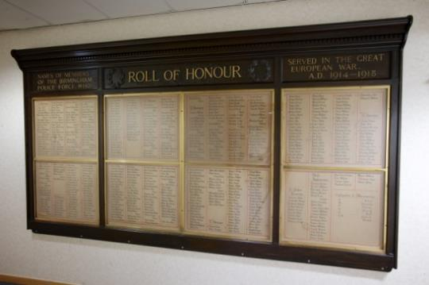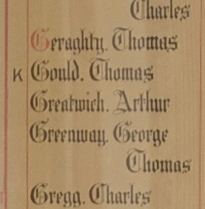
Died France 23rd March 1918 aged 28
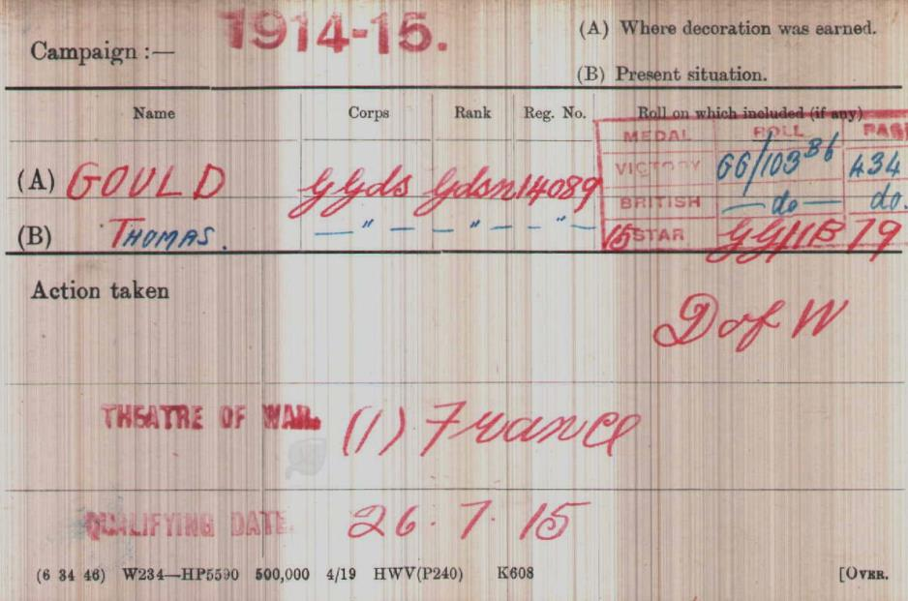
British Army WW1 Medal Rolls Index cards 1914-1920

Police Service history
Thomas joined Birmingham City Police on 2nd January 1912 as a 22 year old farm hand
He served on the ‘D’ Division, with Warrant number 8161
As a reservist, he was recalled on 4th August 1914
Birmingham City Police records dated 29th August 1918 confirmed Thomas’ death having died of wounds received in action 23rd March 1918
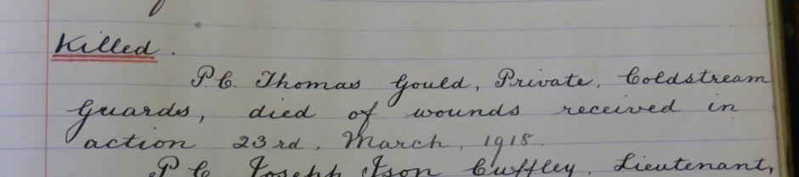

A service was held at The Parish Church, Birmingham
Sunday 5th December 1920 3.30pm
Remembering those police constables killed in action, those who died on active service and those who died from illness due to war service

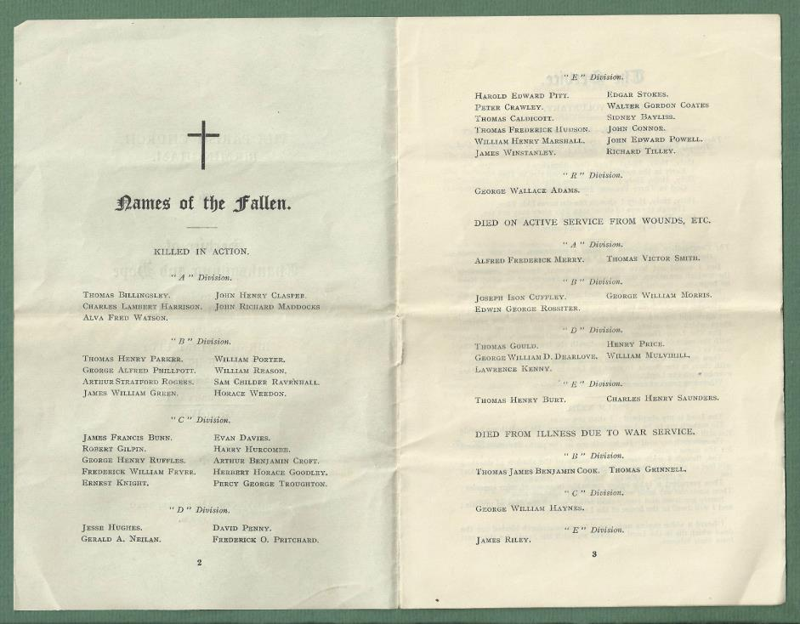

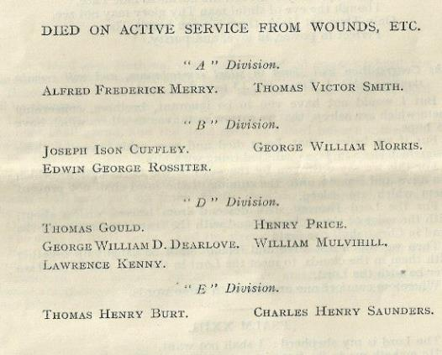

War service history
The census of 1911 shows Thomas residing at Wellington Barracks, St James Park, Westminster one of 186 warrant officers, non-commissioned officers, trumpeters or drummers and rank and file. Thomas is a 21 year old Private of the 3rd battalion Grenadier Guards, single, a shoemaker and born in Pershore, Worcestershire
Thomas was wounded in action and taken to 8 Casualty Clearing Station at Duisans, 6 miles from Arras, France, where he succumbed to his wounds.
On Thursday 21st March 1918 the Germans launched their Spring Offensive, utilising 64 Divisions on a 54 mile front. At the time of the attack Thomas's battalion was in training at Arras. That evening orders were received for the Brigade to which his battalion was attached, the 2nd Guards Brigade, to move to Mercatel, a village about 4 miles south of Arras on the Bapaume road. The battalion arrived at their destination at 9pm and spent the night in some deserted huts. The following day the Germans renewed their attacks in the area with vigour and met with some success. By midday the Germans had advanced to high ground between Croisilles and Henin and orders were received in the battalion to move immediately to defensive positions east of Boyelles.
These positions were taken over by the 1st Battalion, Scots Guards on the right and 1st Battalion, Coldstream Guards on the left with Thomas's battalion in support. Towards the evening the Germans had forced other battalions to the Guards Brigade front to retire leaving the Brigade to confront the German advance. During the night the 2nd Guards Brigade relieved the brigade from its positions, however Thomas's battalion at once moved forward and relieved the 1st Battalion, Coldstream Guards on the left of the line. Although not directly assaulted prior to Thomas's wounding, the lines were bombarded by German artillery and machine gunned, this possibly causing his injuries. Thomas was the only casualty during this period.
The UK Army register of soldiers effects, shows cash being given to Thomas’ brothers William, James, sisters Sarah A Brookes, Mary J, Nellie Bingham, Annie Amphlett, Harriet E and Fanny and confirms he died at 8 Casualty Clearing Station 23rd March 1918.
Thomas’ unit was part of the 2nd Guard Brigade, commanded by Brigadier-General B.N. Sergisson-Brook, wounded on the same day that Thomas died; itself part of the Guards Division, whose commander officer was Major-General G.P.T. Fielding; and they were part of IV Corps, commanded by Lieutenant-General Charles Woollcombe; who formed part of 3rd Army, commanded by General Sir Julian Byng.

Buried VI E 46
DUISANS BRITISH CEMETERY, ETRUN
Pas de Calais France.
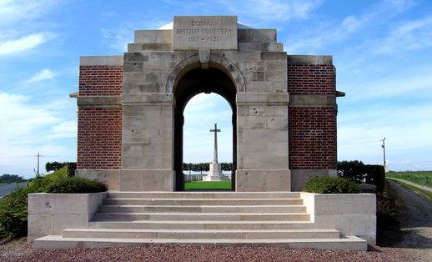
Inmemories.com

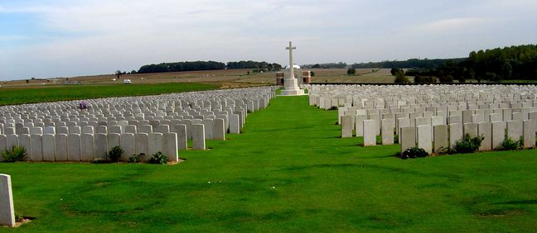
Inmemories.com

At the request of the family the inscription on Thomas’s CWGC headstone was

NOT LEFT TO LIE LIKE A FALLEN TREE
NOT DEAD BUT LIVING UNTO THEE

Antecedents for Thomas GOULD

- Born in 1890 Pershore near Worcestershire Son of Miles and Jane Gould, of Besford, Worcester
- The 1891 census shows Thomas (1), his parents, sisters Nellie (11), Ann (9), and Fanny (3) and brother William (3) are living with Jane's sisters, Emma and Mary in Pershore
- There is a record of Miles Gould marrying Jane Bedenham born 1851, aged 23 years on 25th November 1874 at Saint Alban, Worcester
- By 1901 the Census shows Miles Gould head aged 45 years an agricultural labourer, wife Jane aged 45 years, son Charles 16 years a wagon-man on a horse farm, son William 15 years, daughter Fanny 13 years, son Thomas aged 11 years and son James aged 8 years

