Compiled by Su Handford QPM on behalf of
West Midlands Police Military History Society

Guardsman / Lance Corporal 12628
Herbert Horace GOODLEY
2nd battalion Grenadier Guards
Birmingham City Police ‘C’ Division
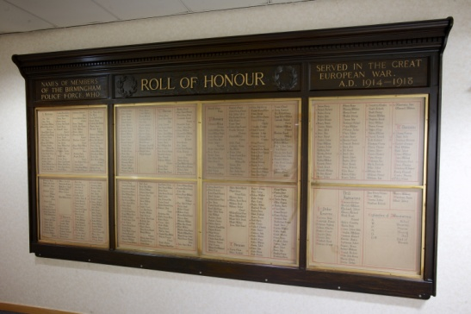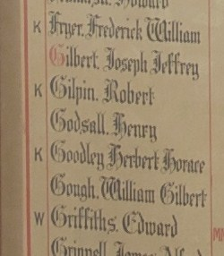
Died of Wounds France 24th December 1914
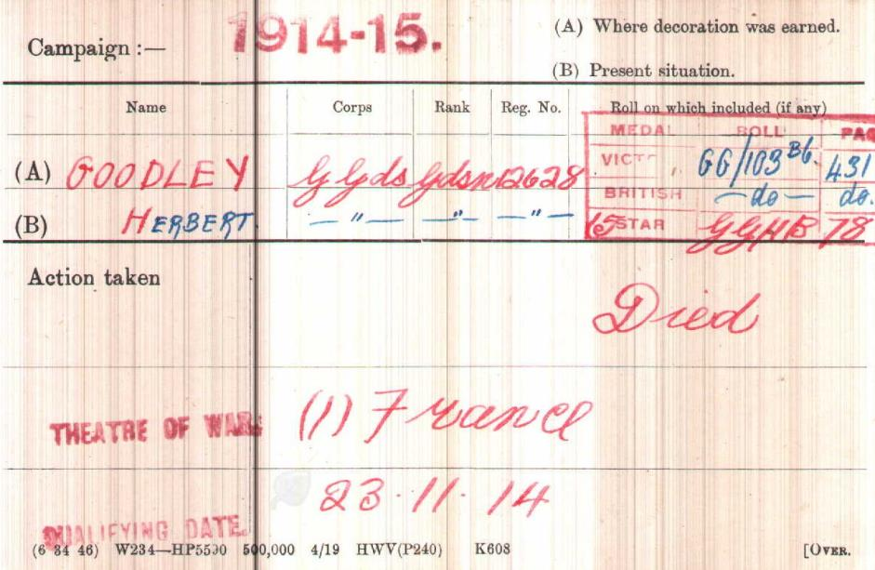British Army WW1 Medal Rolls Index cards 1914-1920

Police service history
Police records as below, show Herbert joined Birmingham City Police aged 25 years, on 13th October 1913, and his occupation was given as a blacksmith's striker.
However, the family of Herbert believe that in 1911 Herbert, was running a hairdresser and tobacconist business at 17 Oundle Road in Peterborough and his mother Sarah had moved in with her youngest son.
A detailed family tree is available to view via ancestry.com
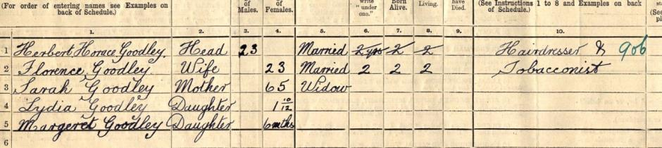
He served on the ‘C’ Division, with warrant number 8379, until he was recalled to military service on 4th August 1914.
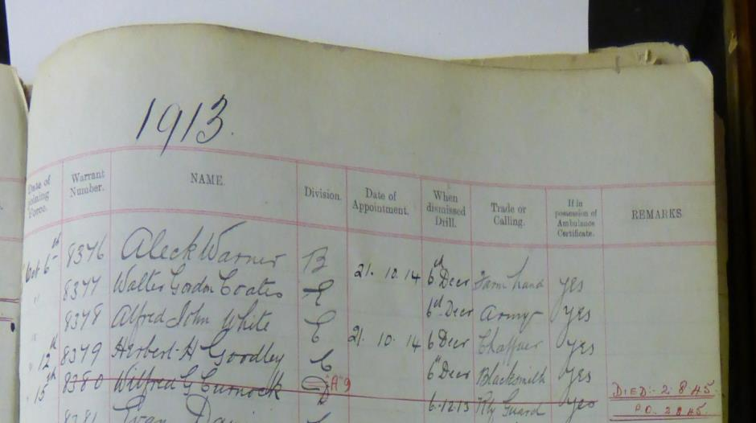

Birmingham City Police Records dated 14th June 1915
With regards to the allowances for the dependents of PC Herbert GOODLEY (and PC Edgar STOKES) both killed on active service.
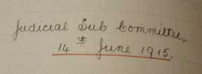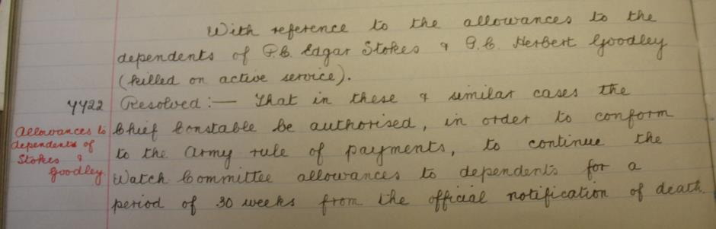
The continuation of Watch Committee Allowances to dependents for a period of 30 weeks from the official notification of death.

Birmingham City Police Records dated 3rd January 1916
The Chief Constable informed the Subcommittee that PC’s Herbert Horace Goodley and George Wallace Adams who had enlisted on the outbreak of War had been reported as missing for more than a year, and the War Office was not making an allowance to the dependants on the assumption that the Constables were no longer living.
Marked as resolved – That the Chief Constable be requested to give directions for the discontinuance of the allowance to the dependants of PCs Goodley and Adams

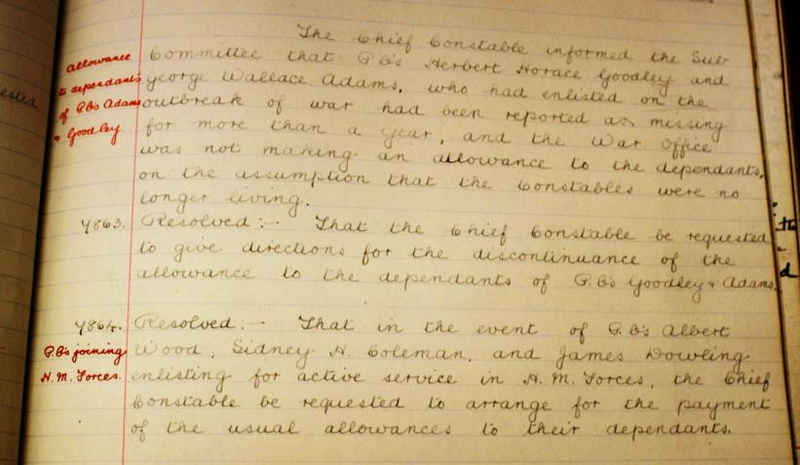

A Service was held at The Parish Church, Birmingham
Sunday 5th December 1920 3.30pm
Remembering those police constables Killed in action, those who died on active service and those who died from illness due to war service

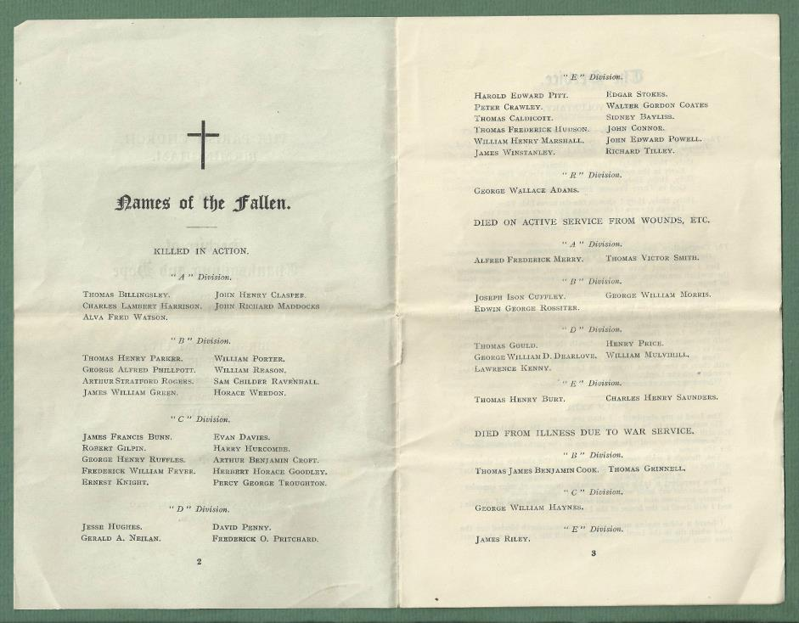

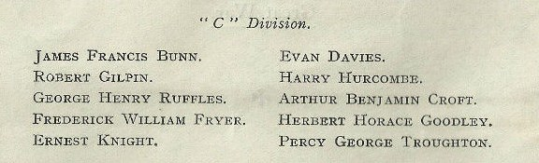

War service history
Herbert sailed to France and died of wounds 24.12.1914
Herbert's battalion sailed for France aboard the S.S.'Cawdor Castle' on Wednesday 12th August 1914 advancing to Spiennes where they clashed with the enemy for the first time on Sunday 23th August 1914.
On Tuesday 22nd December 1914 Herbert's battalion advanced into Bethune and the following day took over the front line trenches at Rue de Cailloux, north east of Bethune, part of the German lines being only 25 yards away. On the day of Herbert's death the Germans mounted an attack on the line, this being repulsed at a cost of 20 men killed.
The following day the battalion was relieved in the trenches to Le Touret by the 3rd Battalion, Coldstream Guards.

Records of Soldiers effects confirms Herbert was killed in action 24th December 1914 and his effects went to his widow Florence

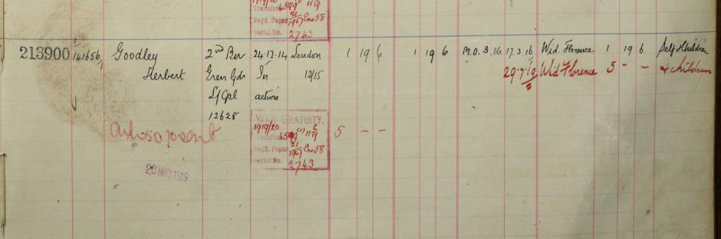

Commemorated Panel 2
Le Touret Memorial, Pas-de-Calais, France
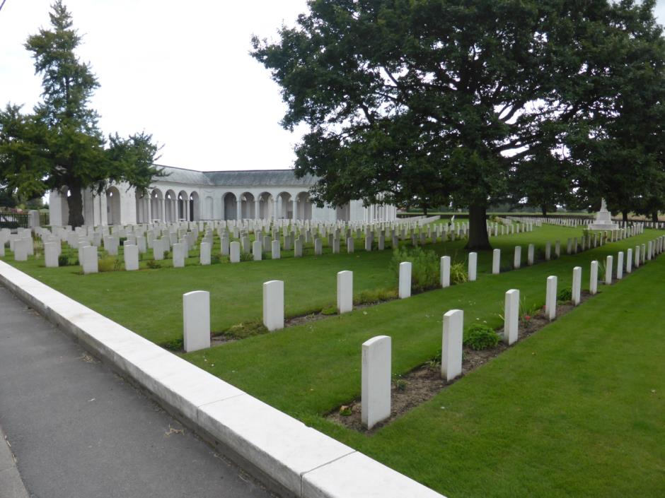
All photographs taken by Su Handford 30th August 2014

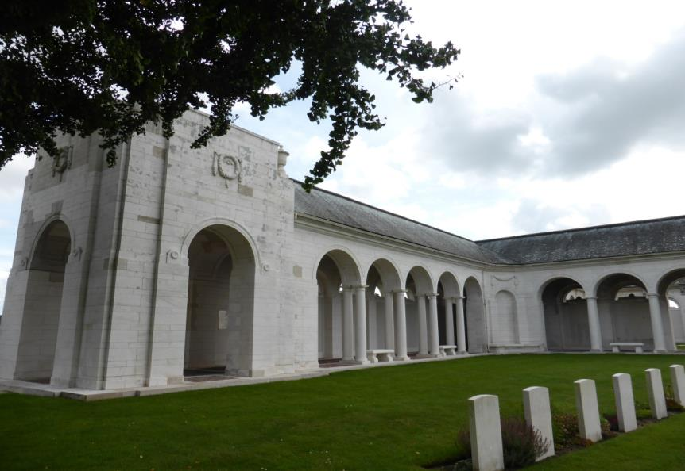
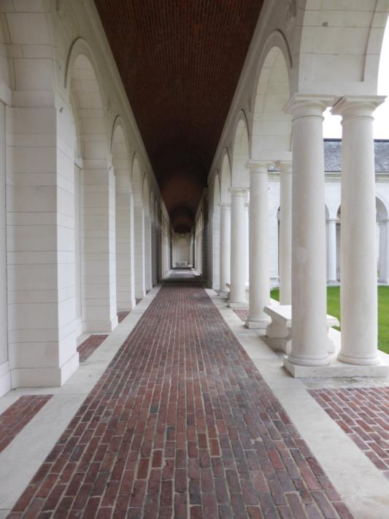

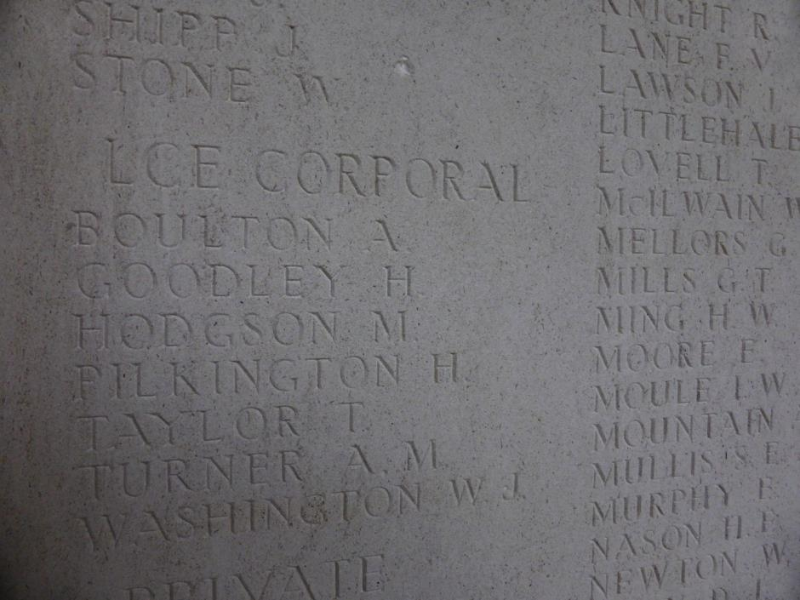
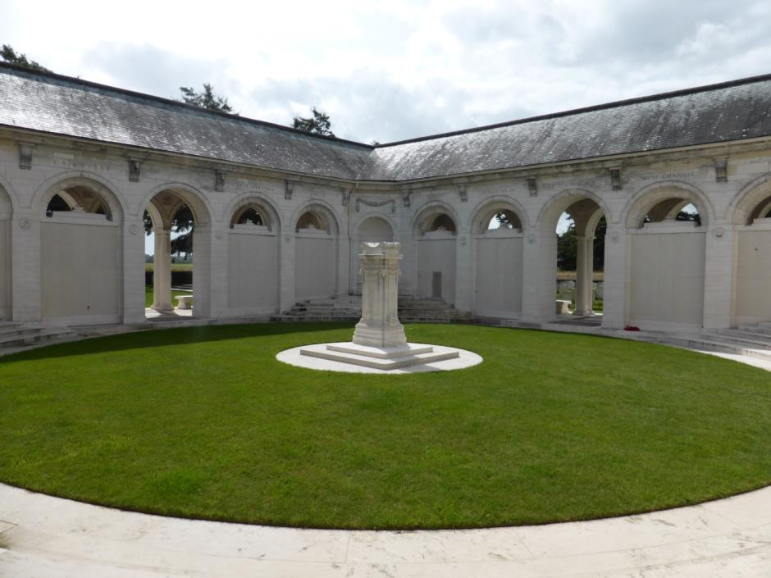
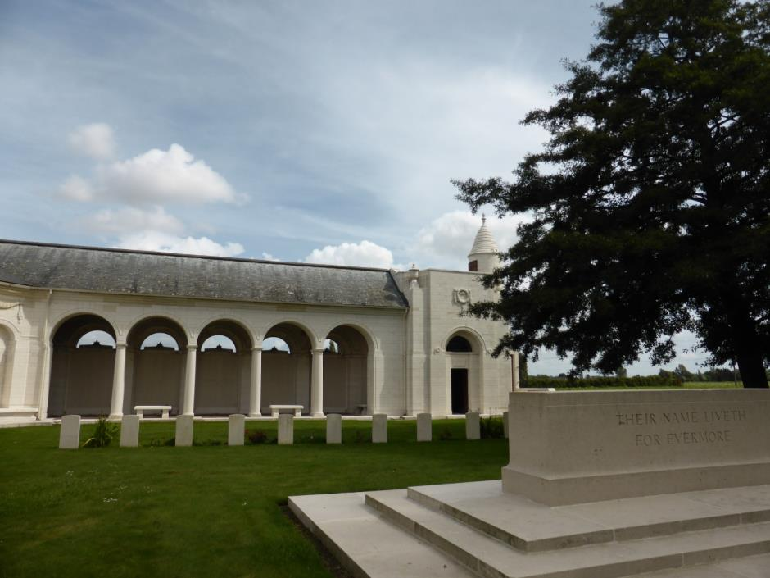

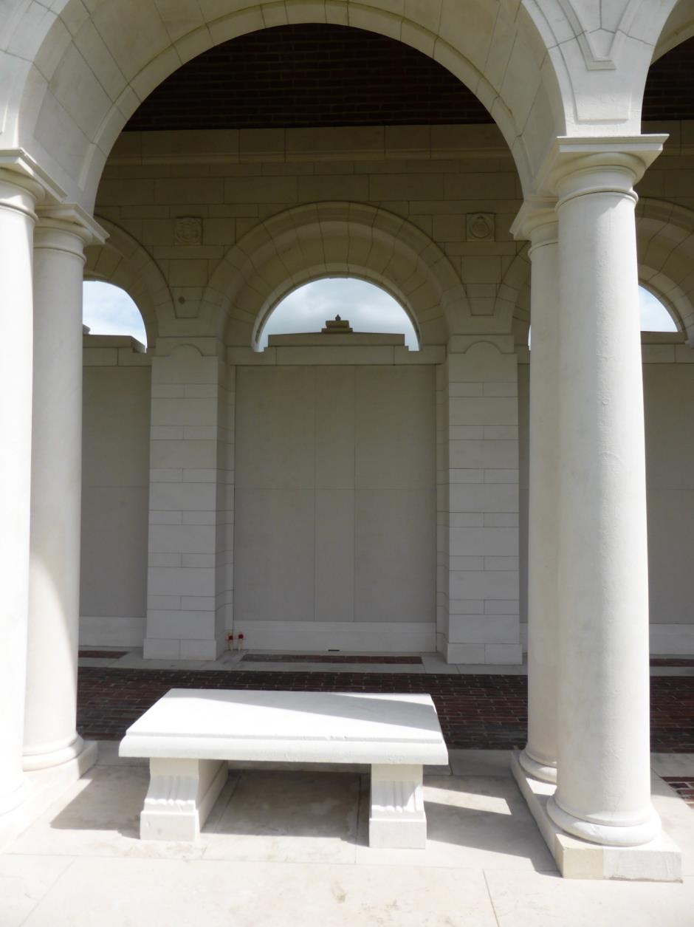
Herbert Horace Goodley alongside Thomas Billingsley both visited and remembered 30th August 2014.

Antecedents for Horace Goodley
- Born in Thorpe Norfolk in the 1887/8 he was the youngest son of William and Sarah Goodley.
- He had 5 older sisters and two older brothers: Sarah, Margaret, John, Ellen, William, Lydia and Gertrude (1881 and1889 census).
- 1891 census shows him living at 104 New Road Thorpe with his parents and older siblings William, Lydia and Gertrude. His father was an engine driver.
- By the 1901 census his father had died, and Herbert, his mother and sister Gertrude were living with his brother William, who was a railway engine stoker, William's wife Elizabeth and their baby son William, in March, Cambridge.
- In 1909 Herbert married Florence, nee Woulds in Peterborough. Florence came from Notttinghamshire.
- In 1911 they were living at 17 Oundle Rd Peterborough, Northamptonshire. He had two little daughters, Lydia and Margaret, and his mother was living with them. Herbert was recorded as working as a hairdresser and tobacconist.

1911 census17 Oundle Road, Peterborough
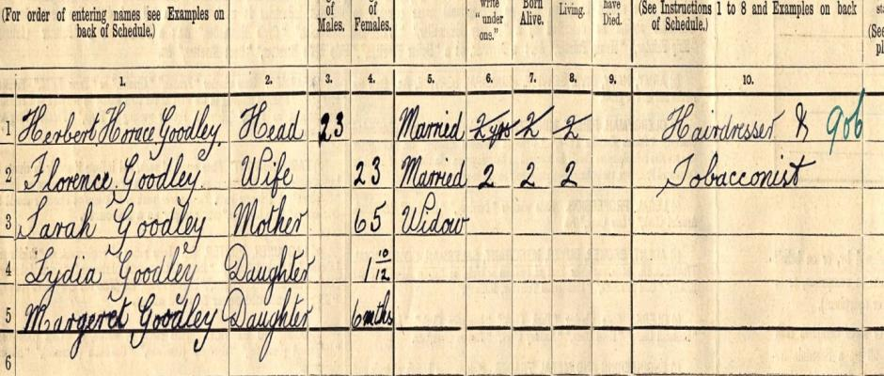

In depth family tree information is available on ancestry.com by family members

