Company Sergeant Major 43753 Robert GILPIN
6th battalion Northamptonshire Regiment
Formerly Warrant Officer 268381 Class 2 Royal Warwickshire Regiment
And formerly 12110 Royal Warwickshire Regiment

Birmingham City Police ‘C’ Division
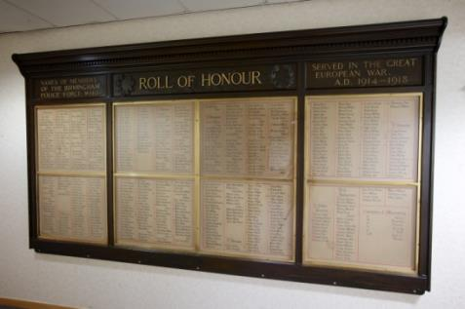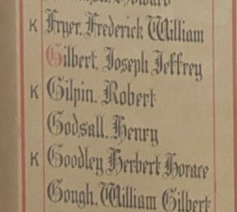
Killed France 30th August 1918 aged 25
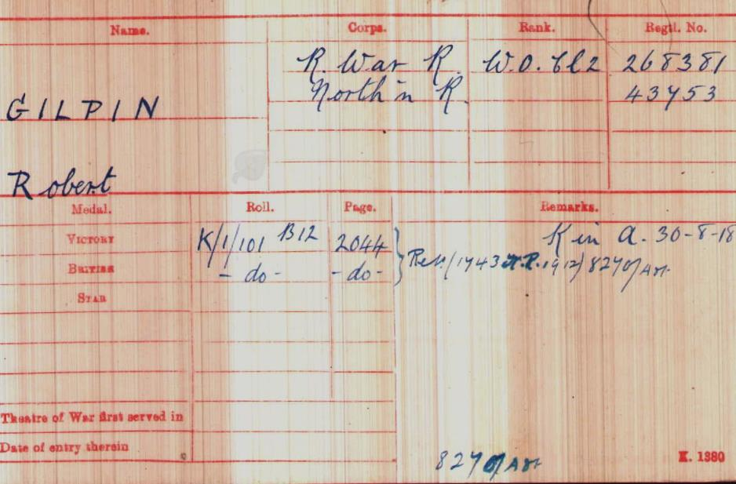
British Army WW1 Medal Rolls Index cards 1914-1920

Police service history
Robert joined Birmingham City Police on July 17th 1914, as a 20 year old linen finisher.
He served on the C Division, with warrant number 8506.
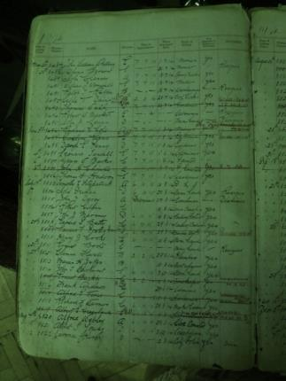
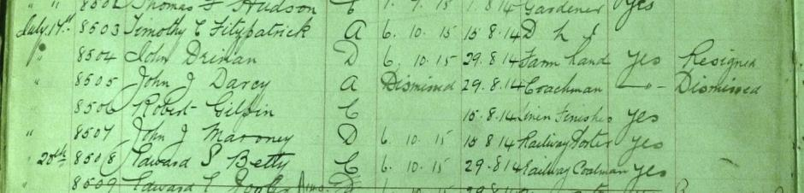
He resigned on 21st May 1918 to enlist with Royal Warwickshire Regiment at Birmingham. His service number was 12110 and he later transferred to the Northampton Regiment. His Medal Index Card shows him Warrant Officer Class 2 268381. He enlisted at Birmingham
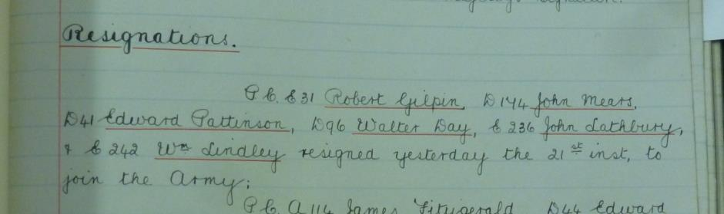
Although on Roll of honour as on ‘C’ Division, police records show him as having a collar number of E31.

Birmingham City Police Records dated 14th May 1915 show an entry of Judicial Subcommittee with regards to applications from policemen including Robert GILPIN for permission to join the Army.

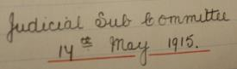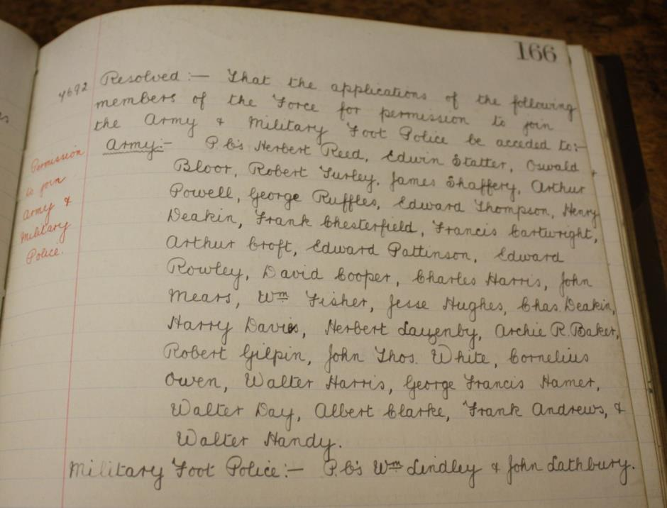

A Service was held at The Parish Church, Birmingham
Sunday 5th December 1920 3.30pm
Remembering those police constables Killed in action, those who died on active service and those who died from illness due to war service

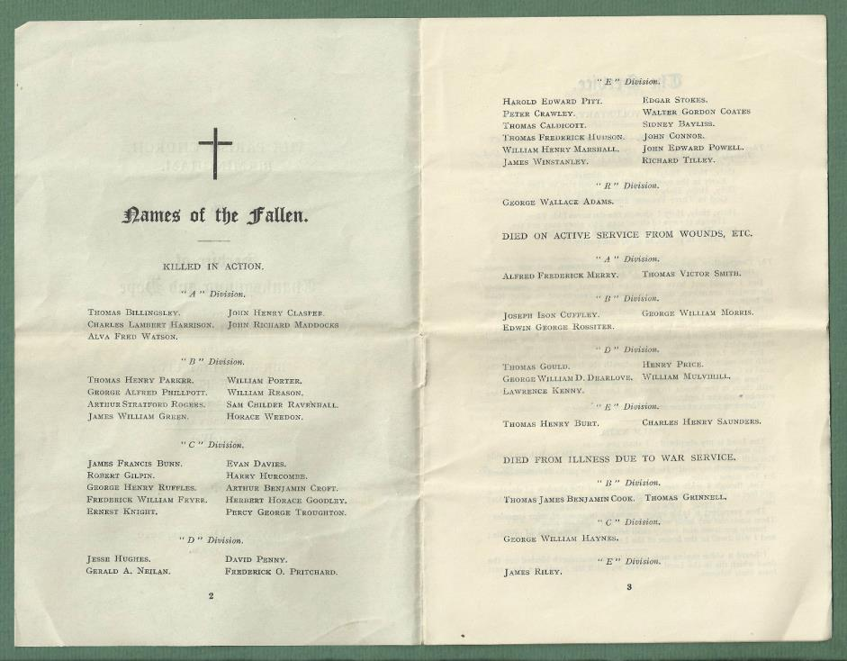

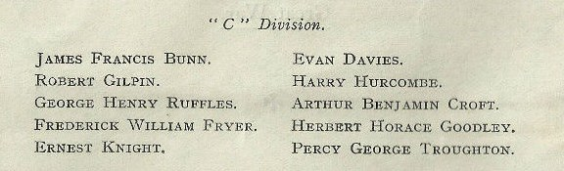

War service history
Robert was killed in action on 30th August 1918
Robert was killed in action at 25 years of age during advances being made against the Germans in the vicinity of Combles, 10 miles south of Bapaume. By Monday 26th August 1918 Robert's battalion had fought their way to Fricourt, when the 11th Battalion, Royal Fusiliers took over responsibility for the advance. His battalion then had a respite from the fighting during which time they rested and cleaned their equipment. At 7.30pm on Wednesday 28th August 1918 the battalion moved forward relieving the 7th Battalion, Queen's Own (Royal West Kent Regiment), 'B' and 'C' Companies in the eastern edge of Trones Wood 'A' and 'D' Companies in support in Bernafey Wood.
During Thursday 29th August 1918 the German retreat continued, Robert's battalion following at 4.30pm taking up positions on the high ground south east of Combles were they spent the night. The War Diary for the following day, the day of Robert's death, recalls, "4.30am 11th Royal Fusiliers and 2nd Bedfordshire Regiment attacked through the battalion. A and D Companies then came into line on left of B and C Companies. 2nd Bedfordshire Regiment on the left were held up by hostile machine guns. The battalion dug in on these positions. Movement on the top was impossible owing to machine guns and snipers" It then continues for the following day, "A,C and D Companies advance in a north easterly direction under a barrage. Heavy hostile machine gun fire was encountered and the companies were held up about 300 yards from their objective which was a line running from just north of Combles Station in a south easterly direction.
B Company moved in support of the Royal Fusiliers to a position just west of Priez Farm. During this operation C Company suffered heavy casualties, all officers and the C.S.M. being wounded. 2 Platoon were surrounded and several men taken prisoner. The battalion remained in this position for the remainder of the day. Hostile sniping and machine gun fire was very heavy from the left. Casualties from 25th up to this date 4 officers and 156 OR. Of this number only 6 were killed".

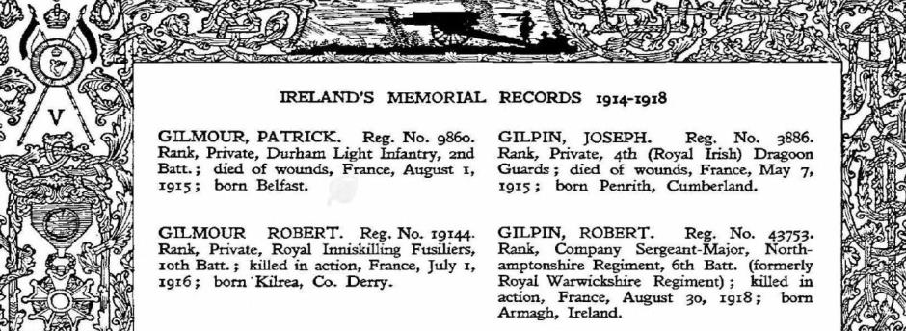

Buried Plot II. F. 7.
Combles Communal Cemetery Extension,
Department de la Somme, Picardie, France
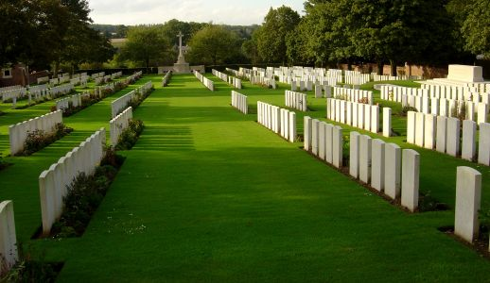
Inmories.com

Antecedents for Robert GILPIN
- Robert was the son of Robert Gilpin 1845-1914 and Ellen Gilpin nee Ross 1859-1935, of Black Island House, Annaghmore, Co. Armagh; husband of the late Ellen Carrol 1889-1920, of Clonmain, Loughgall, Armagh
- He was Born Armagh Ireland and the 1901 census shows him living with his parents, older brother James and younger sisters Jane and Anne.
- 1911 Irish Census shows he was 17 a farmer’s son and living with his mother Ellen nee Ross (52) and father Robert (67) who had been married for 23 years who had had 5 children but only 4 children living, he had two sisters Jane (Jinnie) (14) and Annie (11) all Born Armagh and they were Methodists.
- His siblings were James 1889-1954 Jane (Jinnie) 1986 Henry 1898-1899 and Annie 1900

