February 2018

Second Lieutenant Joseph Ison CUFFLEY MC

61st battalion Machine Gun Corps (Infantry)
Formerly Acting Corporal 36729 3rd Royal Welsh Fusiliers

Birmingham City Police ‘B’ Division PC 105

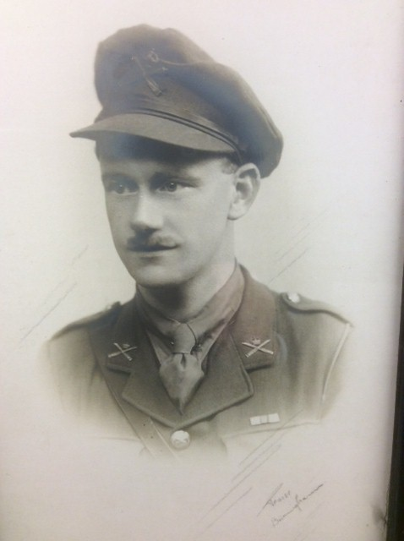

Died of wounds In German Hands 31st March 1918 aged 30

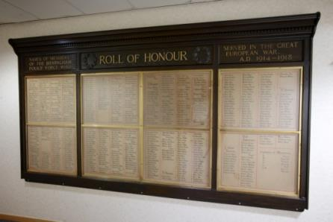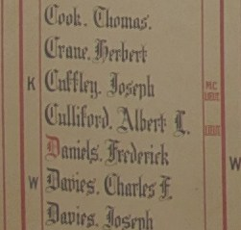
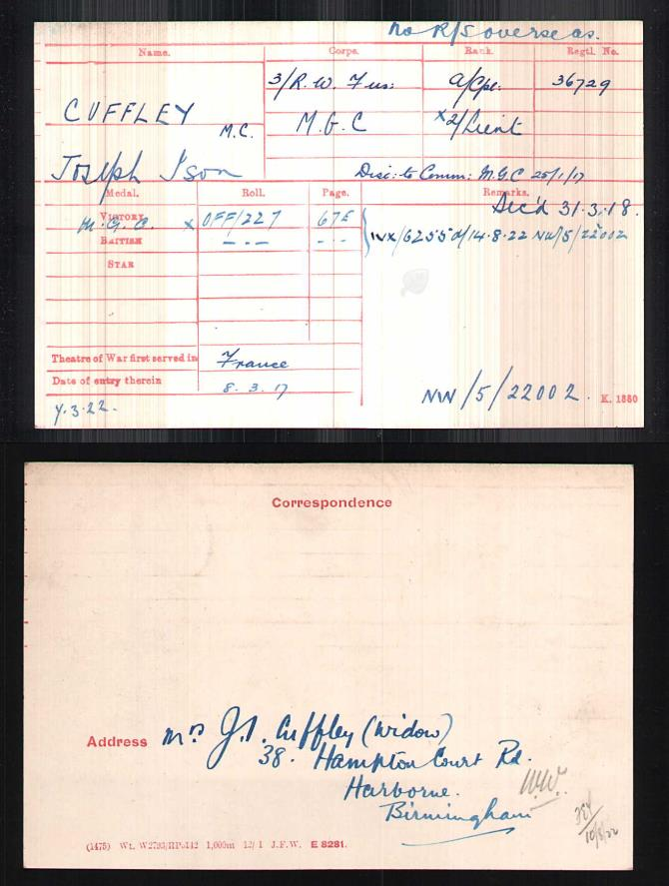

British Army WW1 Medal Rolls Index cards 1914-1920

Police service history

Joseph joined Birmingham City Police on 17th July 1911, as a printer.

He served on the ‘B’ Division, with warrant number 7867 and he resigned on 15th November 1915 to enlist. His collar number was PC B 105

Joseph’s grandson, David Ison Cuffley, states Joseph worked at Harborne Police Station

Birmingham City Police Records dated 12th November 1915

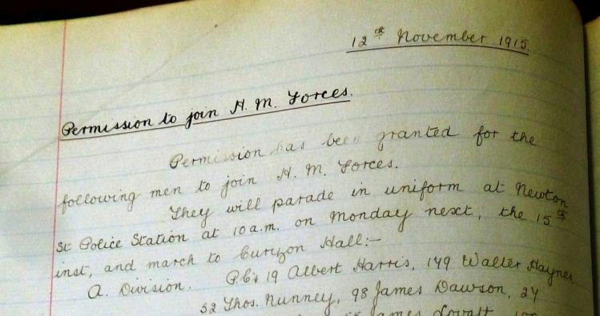

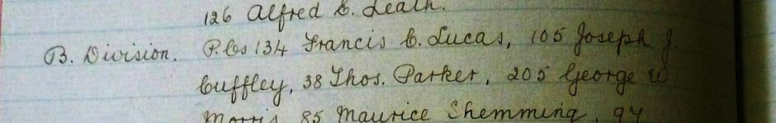

Permission has been granted for the following men to join H.M. Forces. They will parade in uniform at Newton Street Police Station at 10am on Monday next, the 15th inst,
and march to Curzon Street

PC B105 Joseph I Cuffley

Birmingham City Police records dated 29th August 1918

Killed PC Joseph Ison Cuffley Lieutenant Machine Gun Corps died of wounds in enemy hands 31st March 1918

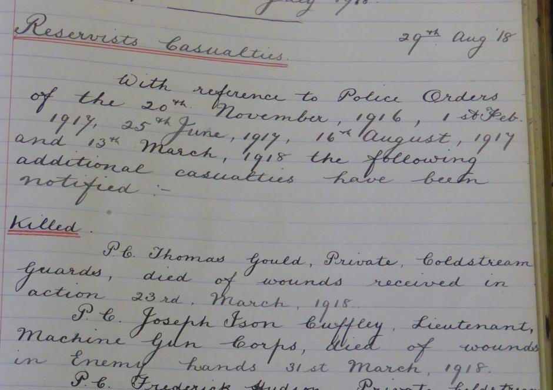

A service was held at The Parish Church, Birmingham
Sunday 5th December 1920 3.30pm
Remembering those Birmingham City Police constables killed in action, those who died on active service and those who died from illness due to war service

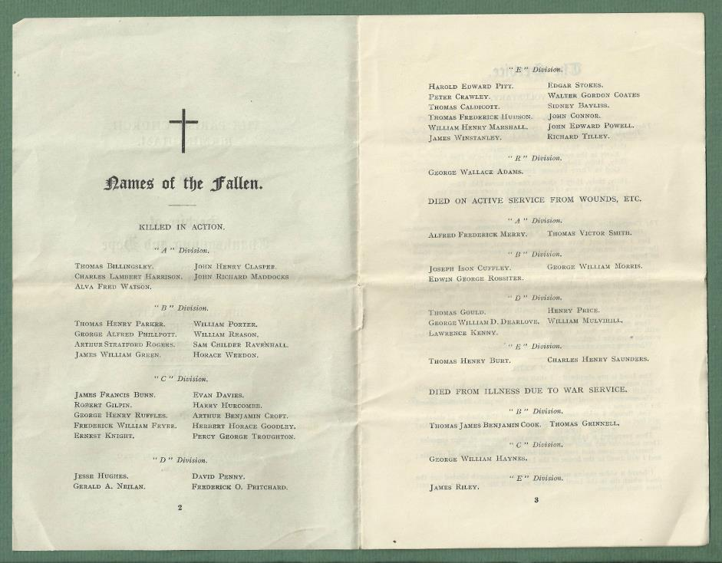

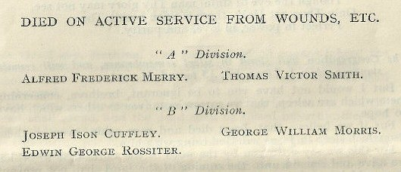

War service history

Joseph Ison CUFLEY MC was Acting Corporal 36729 3rd Royal Welsh Fusiliers then 2nd Lieut 61st battalion Machine Gun Corps (Infantry)

He joined the Machine Gun Corps on 25th January 1917.

Joseph was wounded at some stage and captured by the Germans, most probably in the early stage of their Spring Offensive which commenced on Thursday 21st March 1918.

He succumbed to his injuries whilst in captivity. At the time of the offensive Joseph's division, the 20th Division was in reserve at Beaumont-de-Beine, being moved forward on Thursday 21st March in a failed attempt to stem the German assault.

At the time of Joseph’s death, his wife was pregnant with their son Joseph Lynn Cuffley known as Lynn Cuffley who was believed to be a special constable at Harborne police Station

The Military Cross was awarded to Joseph Ison Cuffley for an act or acts of exemplary gallantry during active operations against the enemy

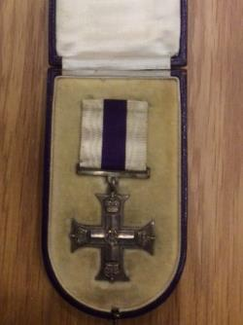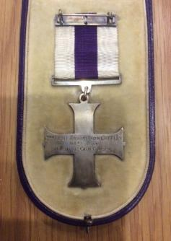

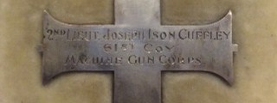
Photographs are by kind permission of Joseph’s grandson, David Ison Cuffley

Joseph’s citation reads
For conspicuous gallantry and devotion to duty
On the enemy gaining a footing in one of our trenches he at once organised and led a party and ejected the enemy. He later went in search of ammunition and delivered it across ground, heavily swept by machine gun fire to two machine guns whose supply had run out. Throughout the attack he displayed great courage and marked energy

There is an entry on a supplement to the London Gazette dated 10th February 1917
Machine Gun Corps ... Cuffley one of many Cadets to be Temp 2nd Lieutenant on 26th Jan 1917
Buried Grave III A 2
Grand-Seraucourt British Cemetery
Aisne, Picardie, France.

Photographs are courtesy of Joseph’s grandson David Ison Cuffley

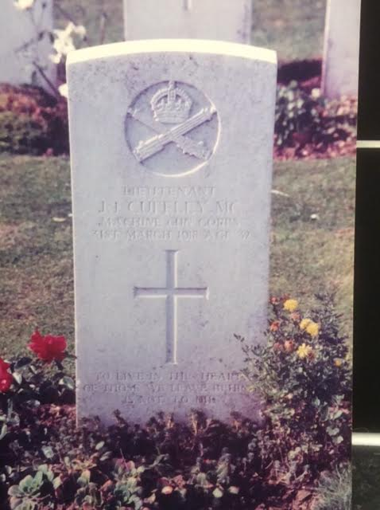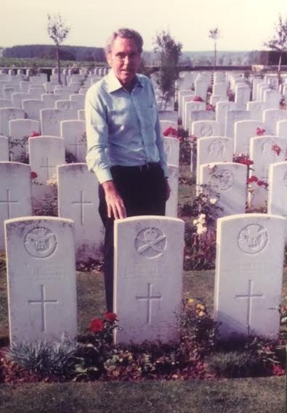

A touching photograph of Joseph Ison Cuffley’s son, Joseph Lynn Cuffley who never knew each other as his father died six months before his birth, his only child.
David believes that, his father Joseph Lynn Cuffley known as Lynn was believed to be a special constable at Harborne Police Station.

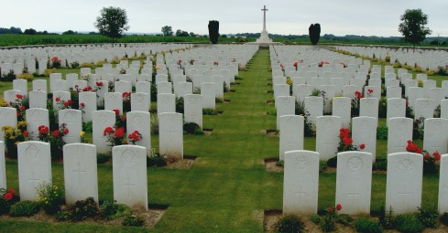
Inmemories.com

Antecedents of Joseph Ison CUFFLEY MC

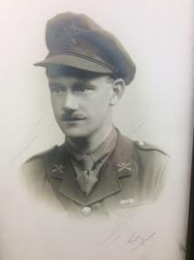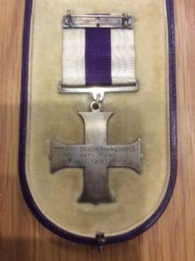

- Joseph Ison Cuffley was born January 1888 in Radford, Nottingham, and worked as a guillotine cutter, in the printing trade
- He was baptised on 1 September 1889 in St Paul Hyson Green Radford, Nottingham
- He was the second child of Joseph (1858) and Fanny Cuffley nee Deacon (1862)
- His father was a boot maker
- In 1891 the family were living at 132 Noel Street, Radford
- He had an older sister, Alice Gertrude (1885-1971) and a younger sister Frances Beatrice (1889-1969).
- In 1901 the family were living at 111 Burford Road Nottingham.
- 1911 census Joseph was listed as a boarder with Mr Mrs Ponberth and their 4 year old daughter at Number 2 Weston Cottages, Prospect Street, Nottingham
- 8.3.1917 Address given as Mrs Alice Mary CUFFLEY 38 Hampton Court Road, Harborne, Birmingham.
- Medal index card confirms the home address of 38 Hampton Court Road, Harborne, Birmingham
- In March 1918 he married Alice Mary Matthews in Kings Norton
- Probate 1920 - Temporary Second Lieutenant M.G.C. died 31st March 1918 at Reserve Field Hospital Dury France Administration Birmingham 30th January 1920 to Alice Mary Cuffley widow Effects £134 1s.

