As of 12 August 2015

Corporal L/10885 Peter CRAWLEY

1st Battalion Middlesex Regiment

Birmingham City Police ‘E’ Division

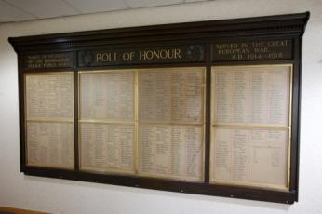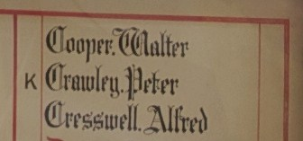

Died of wounds France 27th September 1915 aged 27

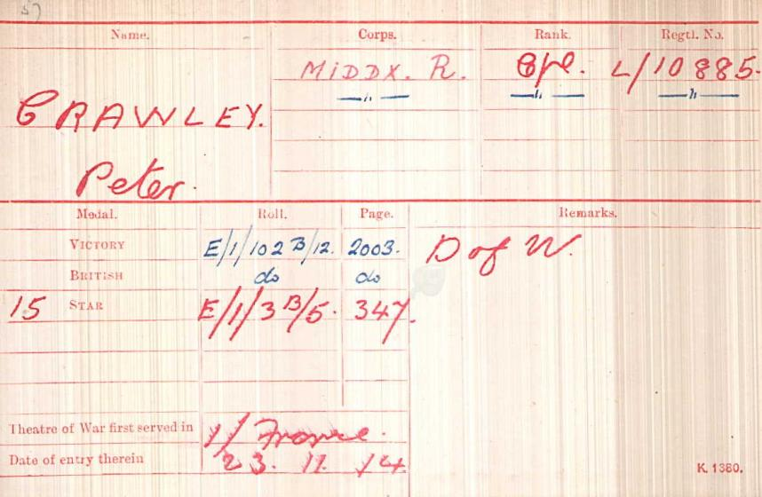
British Army WW1 Medal Rolls Index cards 1914-1920

Police service history

Peter joined Birmingham City Police on 19th May 1913 aged 25 years his occupation was entered as Army so he had previous Military experience. He served on the ‘E’ Division, his warrant number was 8317 and he was recalled to service on 4th August 1914

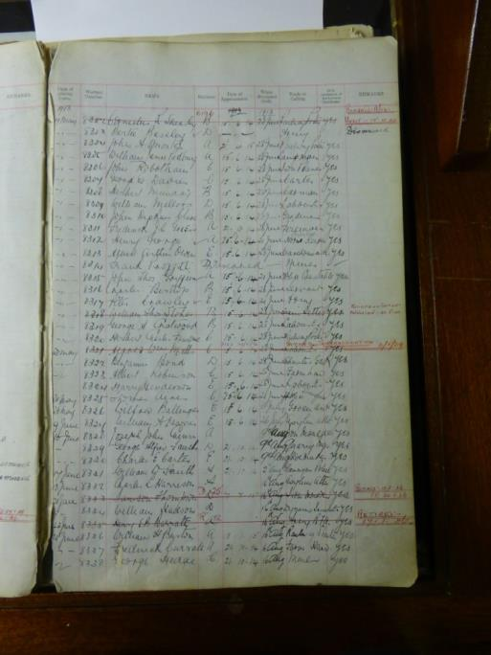

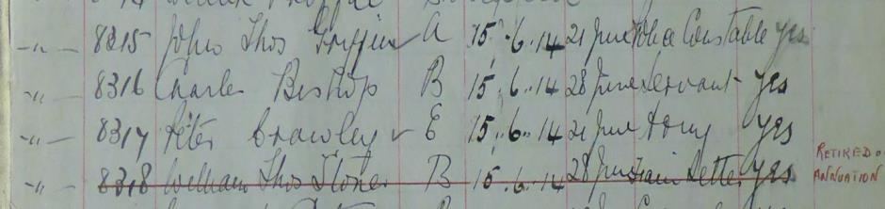

Birmingham City Police Records dated 20th November 1916

Peter CRAWLEY (married) Cpl 1st Bn Middlesex Regt
Killed in action 27th September 1915

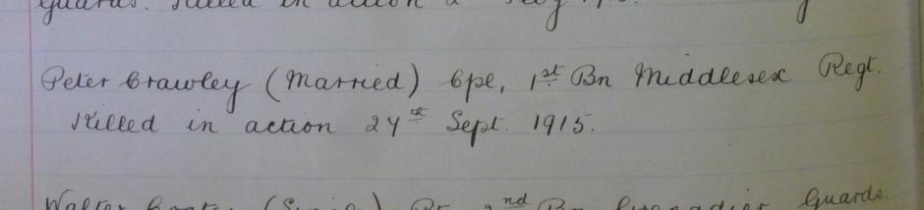

A Service was held at The Parish Church, Birmingham
Sunday 5th December 1920 3.30pm
Remembering those police constables Killed in action, those who died on active service and those who died from illness due to war service

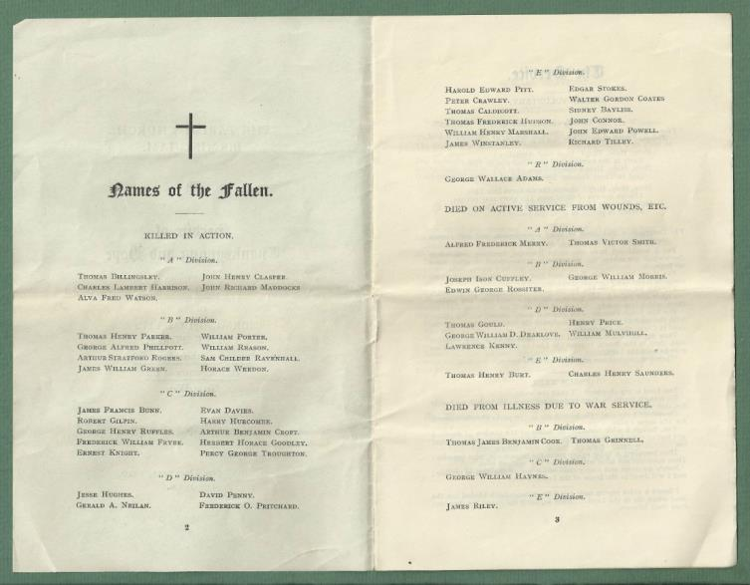

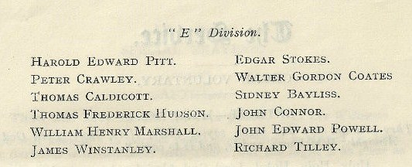

War service history

He was recalled to the Army on 4th August 1914. He was wounded in action at the Battle of Loos, and he was removed to 1st Casualty clearing station at Chocques, just North West of Bethune where he died of his wounds 27th September 1915.

Peter's battalion spent July and August 1915 either in billets in Gispot, near Steenwerck at Laventie or in the front line trenches in the Laventie sector.

Relieved on Sunday 15th August 1915 by the 11th Battalion, King's Royal Rifle Corp, the battalion moved back to billets in the area of Vieux Berquin- Neuf Berquin-Doulieu and from here moved into billets at Annequin.

Most of September 1915 was spent in training for the forthcoming battle this being due to commence at 5.50am on Saturday 25th September 1915.

On Thursday 23th September 1915 Peter's battalion relieved the 2nd Battalion, Royal Welsh Fusiliers in the right subsector on the Cambrin sector taking over trenches between the Vermelles-La Bassee railway and the Vermelles-La Bassee road.The battalion's objective on the first day of the attack was to assault and capture Railway Trench. At 5.50 am on the morning of Saturday 25th September 1915 the British released asphyxiating gas towards the Germans lines, however instead of drifting as desired it hung lifeless in the air or blew back to the British trenches from which it had been projected, in many places with disastrous effects. At 6.30 am the order to attack was given. 'A', 'B' and 'C' Companies of the battalion led the assault with the remaining 'D' Company acting as reserve. Almost immediately the battalion was cut down by German machine gun fire, the enemy gunners being unaffected by the gas.

The War Diary merely records, "At 5.50am a gas attack was opened on the German trenches for 40 minutes. This was not, however successful, and did not have much effect. At 6.30 the battalion attacked with three Companies in the front line and one Company ('D') in reserve. The Battalion was all flung into the battle line, but failed to get further forward than 100 yards and were then hung up. Gunners again shelled the hostile line, but no further advance was made.

At 12 noon the Battalion was ordered to withdraw to Brigade Reserve, having lost very heavily in both officers and men. A large proportion of N.C.O.s, were casualties." At 1.15 pm what was left of the battalion was ordered into reserve at Siding No.3 and Braddel Trench. A role call at this time mustered just 85 other ranks although, others did return from the battlefield during the hours of darkness.

Casualties for the day were 10 officers killed and 7 wounded, with 73 other ranks killed, 290 wounded, 66 missing 7 gassed and 2 suffering from shell concussion, a total of 455 men. From this time until Thursday 30th September 1915 the battalion remained in the Brigade Reserve in dugouts behind the front line.

The medal index card shows Peter Crawley was entitled to the British War Medal and the Victory Medal and the 1914-1915 star, the below confirms both and that he died of wounds

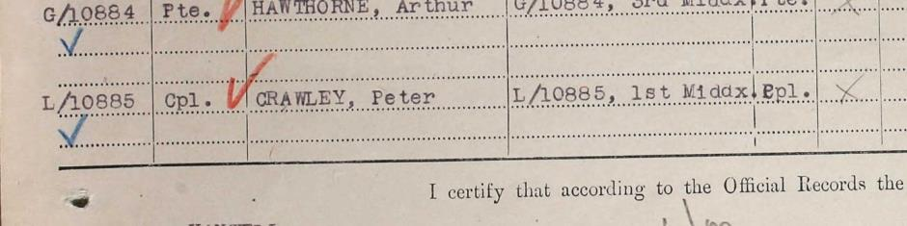
British War Medal and Victory Medal

1914-1915 Star

Record of Soldier’s effects for Peter Crawley confirming he died of wounds 27.09.1915 Widow shown as Edith

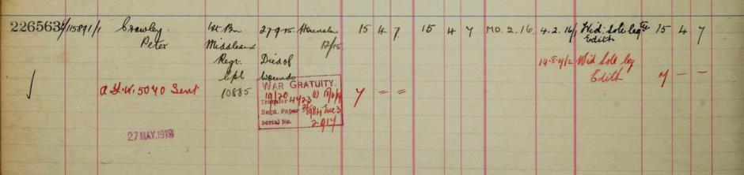

The Graves Registration Report

Grave Registration Reports (GRRs) are standard forms which detail graves for which the Commission is responsible within a particular burial ground. They provide basic details of the individuals, such as name, service number, rank, regiment, unit and date of death, and are listed in Plot, Row and Grave order

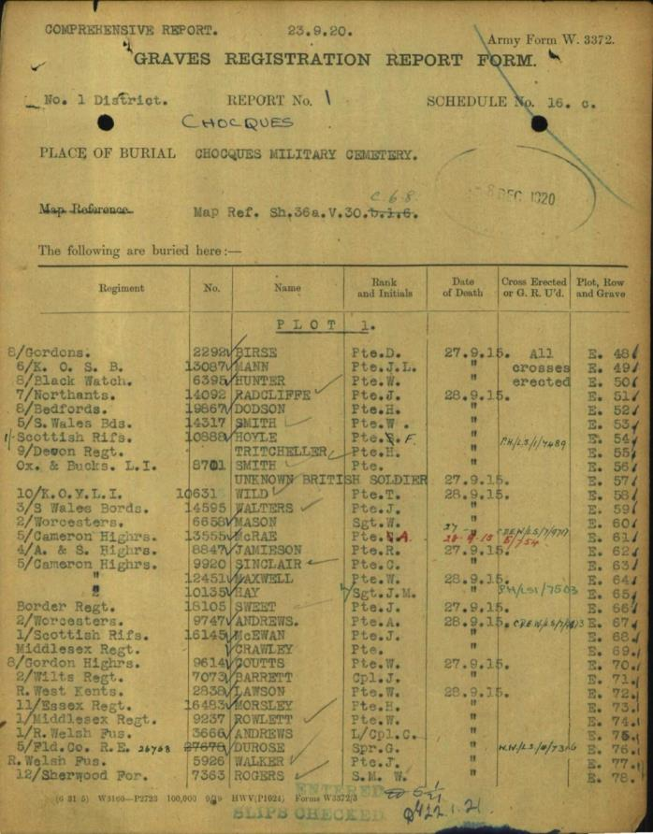

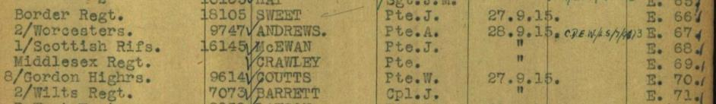

Grave registers

Registers were produced by the Commission on a cemetery-by-cemetery or memorial-by-memorial basis, and eventually ran to 1,500 volumes. They contain an entry for each individual, with details of their rank, regiment, unit and date of death. Many of the entries also include additional information such as next of kin details.

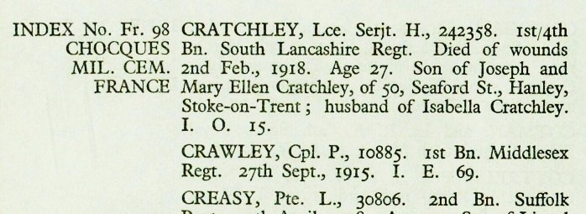

Headstone documents

These documents provide details of what was actually inscribed on an individual’s headstone. Their main purpose was to help manage the enormous programme of headstone production and engraving the Commission embarked on in the immediate aftermath of the First World War.

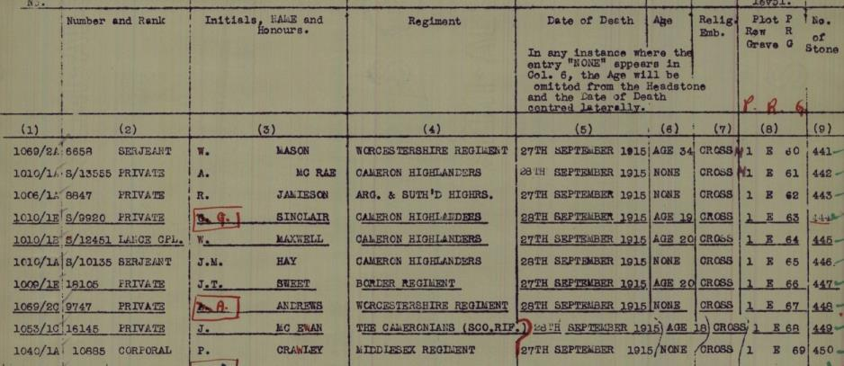

Headstone Schedules
These documents provide details of what was actually inscribed on an individual’s headstone.

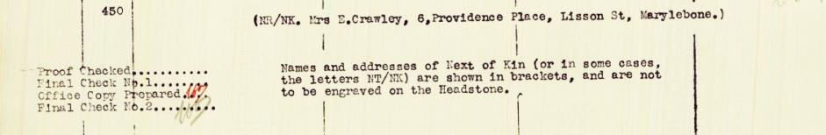
Peter Crawley’s next of kin did not request an inscription on his headstone
Buried I. E. 69
CHOCQUES MILITARY CEMETERY
Pas de Calais France

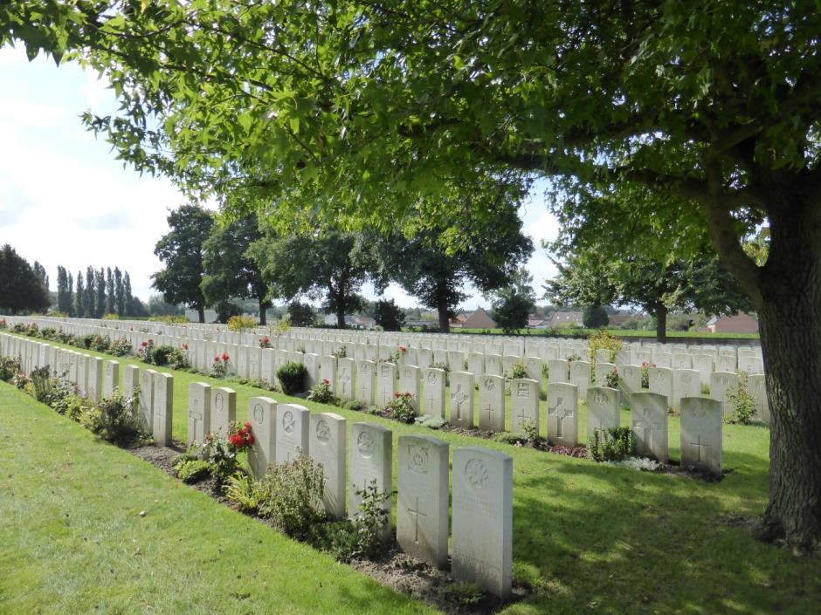
All photographs courtesy of Su Handford taken 29th August 2014

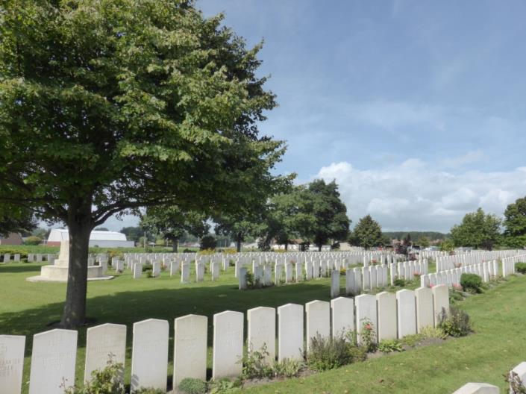

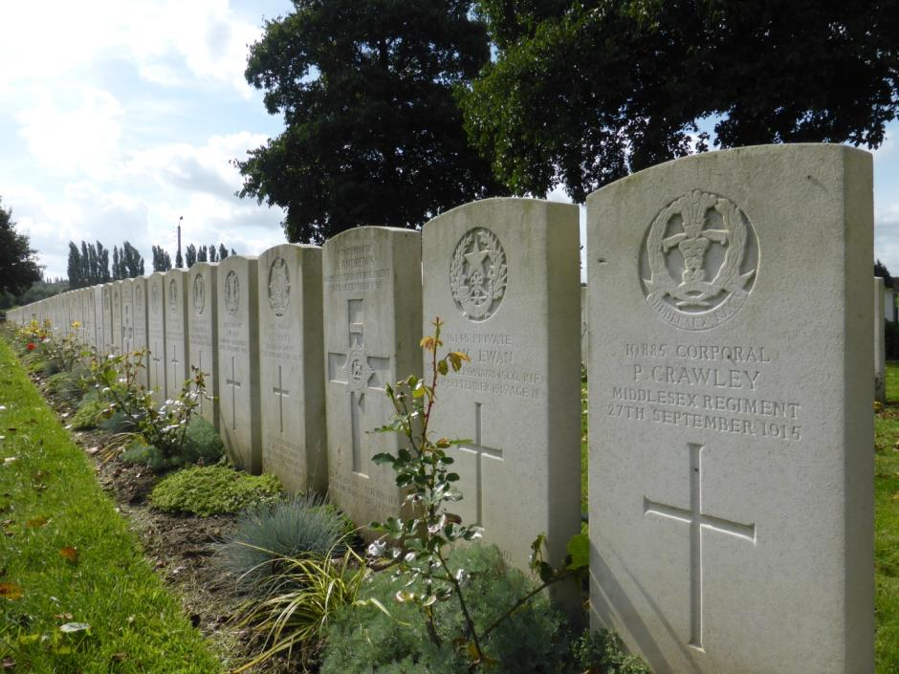

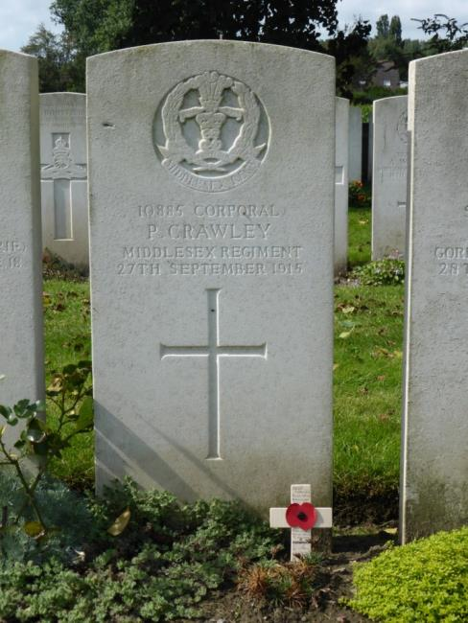

Antecedents for Peter CRAWLEY

Not to be confused with Private S/8248 Peter Crawley Gordon Highlanders who died three days later on 30th September 1915 and is commemorated at Ypres Memorial

- CWGC Shows Peter was born in Holborn, Middlesex
- His widow was shown as Edith on the personal effects register and the headstone inscription request forms show the next of Kin as Mrs E Crawley 6 Providence Place, Lisson Street, Marylebone

