March 2018
Private 21916 John CONNOR
3rd Battalion Coldstream Guards
Birmingham City Police ‘E’ Division PC 260

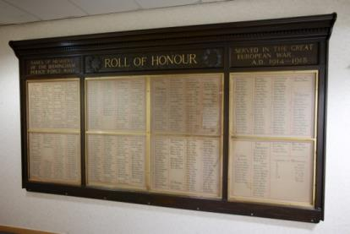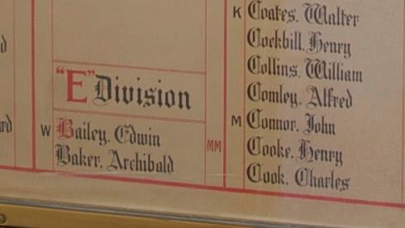
John is shown as missing on the Roll of honour
John Died in France 13th April 1918 aged 33

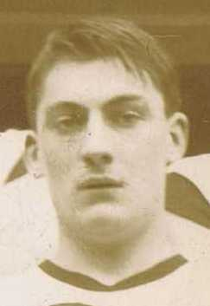
John was photographed with members of the
Birmingham City Police gymnastic class
January 1915

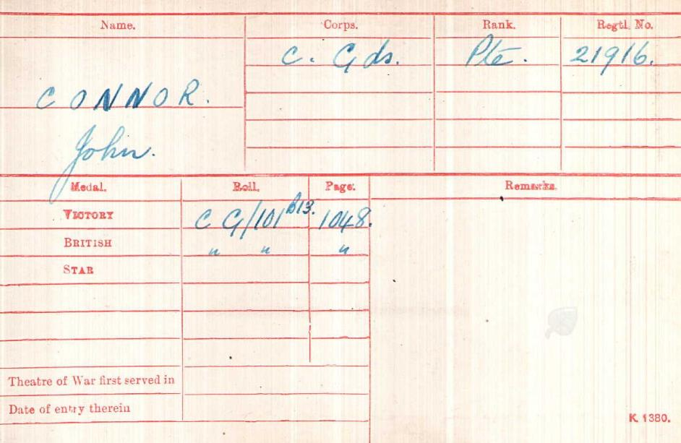
British Army WW1 Medal Rolls Index cards 1914-1920

Police Service History
John joined Birmingham City Police on 11th December 1914, he served on the ‘E’ Division, with warrant number 8570 and his collar number was PC E260

He was a member of Birmingham City Police gymnastic class and pictured here in January 1915.

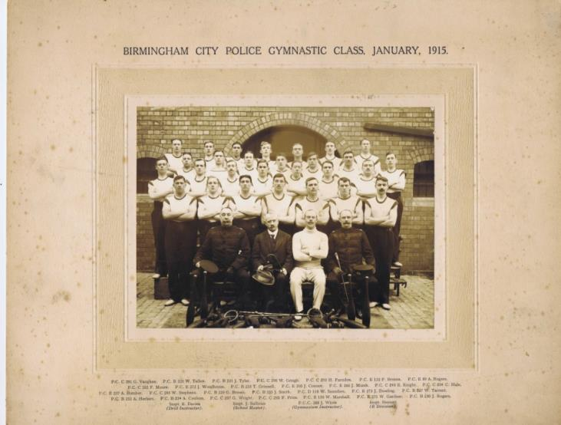

John resigned 5 March 1917 to enlist

A service was held at The Parish Church, Birmingham
Sunday 5th December 1920 3.30pm
Remembering those police constables killed in action, those who died on active service and those who died from illness due to war service

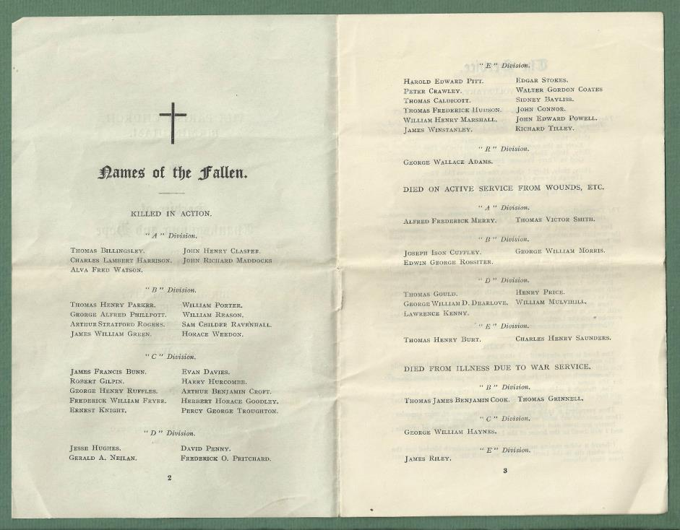

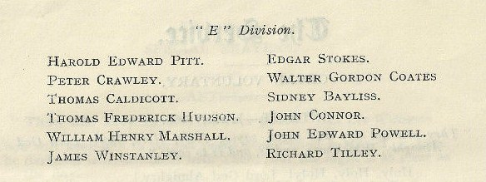

War Service History

John was killed whilst his battalion held positions just north of Merville in the valley the Lys, the battalion being rushed here to attempt to stem the German advances being made in the area.

On 12th April 1918 the battalion took up defensive positions from I'Epinette to le Cornet Perdu. At first light the following morning the German artillery began bombarding the battalion's lines, this being followed at 8 am by an infantry attack which was beaten off.

Orders were then given for the battalion to make an advance at 11 am. At the allotted time the battalion moved forward, being immediately hit by a cross fire of machine guns situated in houses in le Puresbecques and in an orchard south west of Vierhouck.

In spite of numerous casualties the battalion made an advance of 400 yards where they dug in. At 4.30pm, after an artillery barrage, the Germans again attacked the battalion's lines but were again repulsed with huge loss of life. The positions gained were held overnight.

Casualties in the battalion amounted to 1 officer and 115 other ranks killed.

John’s unit was part of the 4th Guards Brigade; part of the 31st Division, commanded by Maj-Gen R.J. Bradford; and they were part of XV Corps, under General Sir John Philip Du Cane; itself part of 1st Army, commanded by General Henry Horne. The fighting was part of the rearguard action to counter the German Operation Georgette.

Buried Grave 3 D 12
Aval Wood Military Cemetery
Vieux-Berquin, France
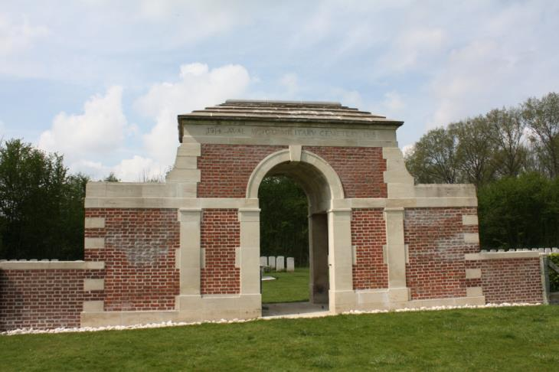
Photographs courtesy of Su Handford taken 23rd April 2014
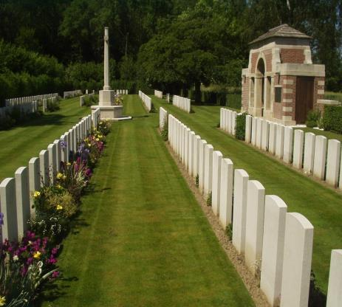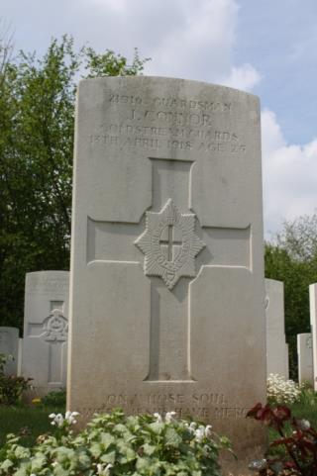
Photographed by Su Handford

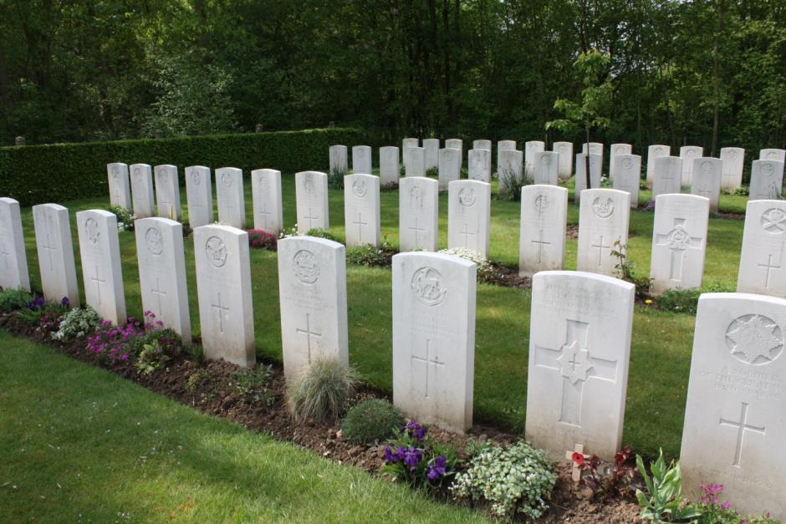
Photographed by Su Handford

Antecedents of John CONNOR
- Born in Oldham September 1884 and a clogger by trade

- Son of Martin and Kate Connor, of 26 Mort St, Oldham.

- His father was a spindle maker.

- John was third in a family of 5 children: Mary/Polly, Elizabeth/Lizzie, John, Ann/Annie, Charles.

- 1911 John was living at home and was an apprentice clogger.

