As of 9th March 2105
Private 14909 Walter Gordon COATES

2nd Battalion Grenadier Guards

Birmingham City Police ‘E’ Division
Killed France 16th September 1914 aged 25

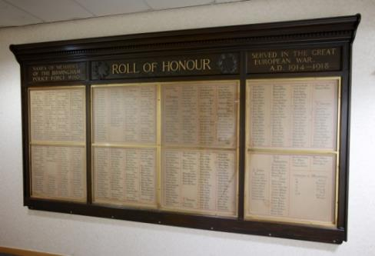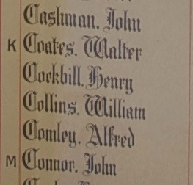
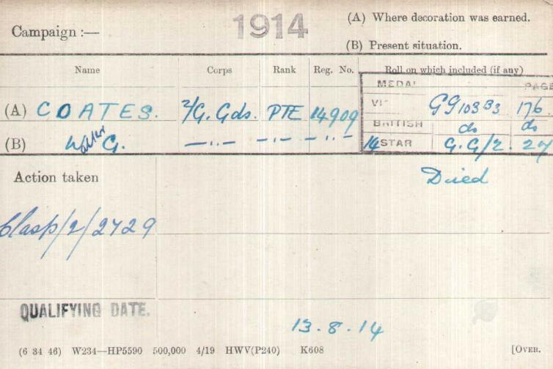
British Army WW1 Medal Rolls Index cards 1914-1920

Police service history

Walter enlisted in the Army in Nottingham, then left the army and joined Birmingham City Police giving his occupation as Army Chef.

He served on the ‘E’ Division, his Warrant number was 8337

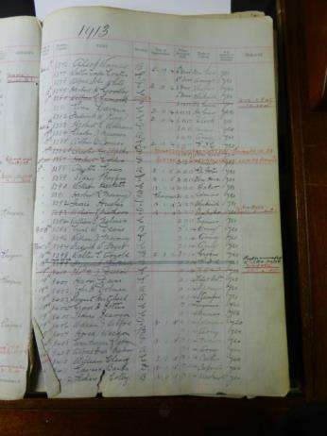

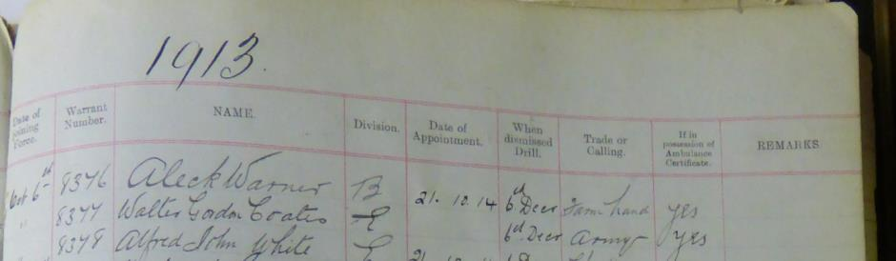

Birmingham City Police Records dated 20th November 1916 records the death of Walter Gordon COATES killed in action 14th September 1914

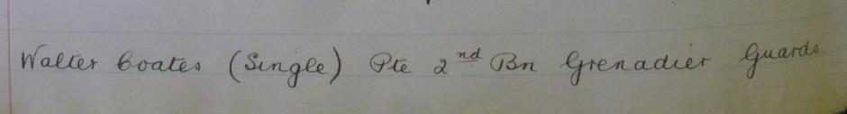

War service history

He was killed 16th September 1914 aged 25, along with a fellow Birmingham City Policeman, Pte 14903 Horace WEEDON, also 2nd Bttn Grenadier Guards, in the same engagement, their role numbers were only 6 numbers apart, 14903 and 14909.

He arrived at Le Havre 9 days later, on 13th August 1914 and died on the 16th September, two days after the death of Horace.

Their battalion was immediately drafted to France aboard the SS Cawdor Castle, arriving at Le Havre on 13th August 1914. On 14th September, Walter and Horace’s battalion crossed the Aisne at Pont Arcy and advanced under shellfire to La Cour de Soupir farm which they reached at 1030am. The Germans immediately attacked the battalion’s positions but were repulsed. Heavy fighting continued throughout the remainder of the day with the battalion successfully defending the positions but at a cost of 500 men killed, missing or wounded.

The following day the battalion dug defensive trenches and held the positions although continually attacked and shelled by the Germans until relieved to Soupir on 17th September 1914.

However, the newspaper article as below, states Walter was taken prisoner of war at Souper.

Horace and Walter have no know graves and are commemorated on the La Ferte-sous-Jouarre Memorial, Seine-et-Marne.

Medal entitlement for Walter Gordon Coates, a British War Medal and a Victory Medal
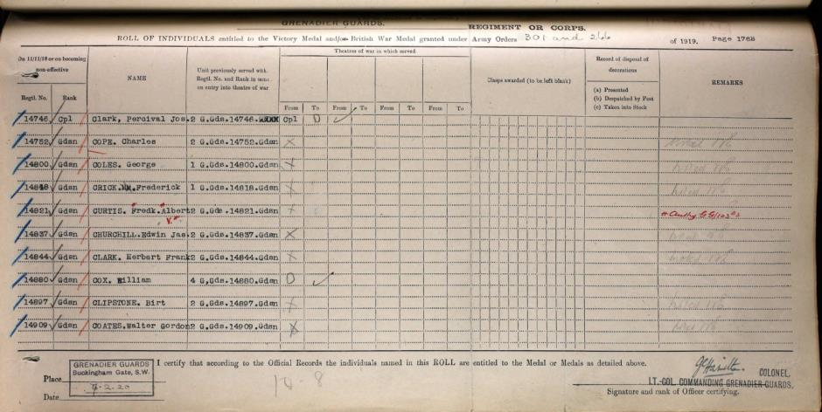

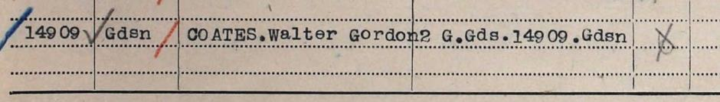

Soldiers effects records

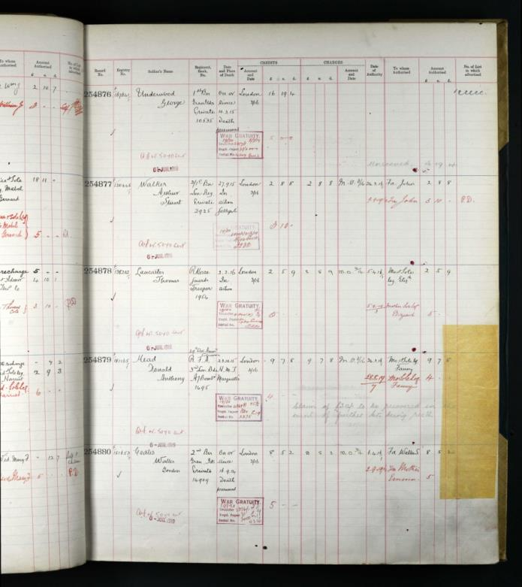

The record shows Walter died on or since 16th September 1914, death presumed.
And awards were given to his father Walter S and a latter on to his mother Emma

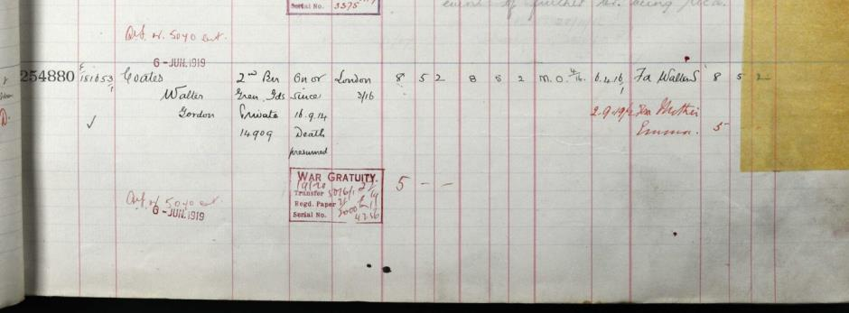

The Evening despatch dated Monday 21st December 1914 states ‘News has reached his father at Tutbury, Burton-on-Trent that Private Walter Coates, Grenadier Guards, a member of The Birmingham City Police Force up to the outbreak of the war, was taken prisoner by the enemy at Souper.

Service held at The Parish Church, Birmingham
Sunday 5th December 1920 3.30pm
Remembering those police constables Killed in action, those who died on active service and those who died from illness due to war service

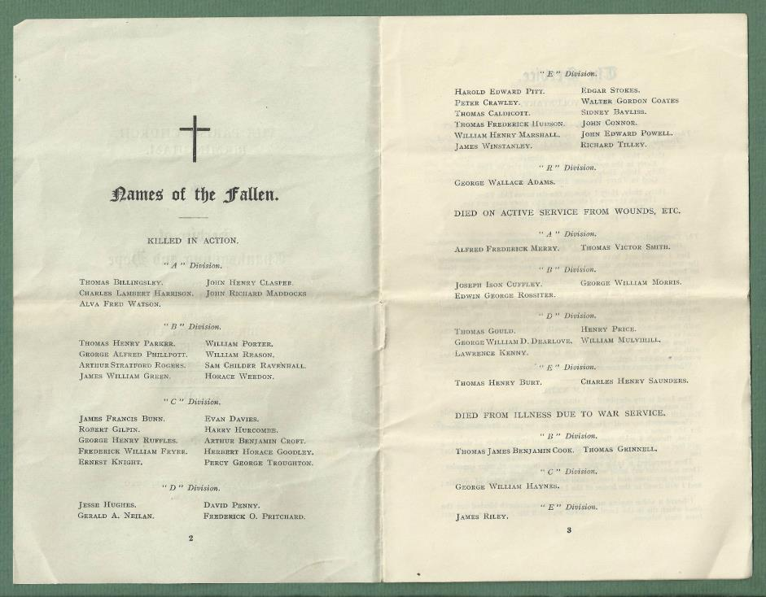

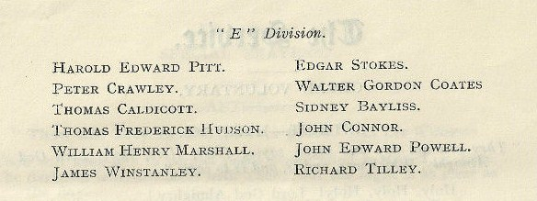

Commemorated
Le Ferte-Sous-Jouarre Memorial,
Seine-et-Marne, France

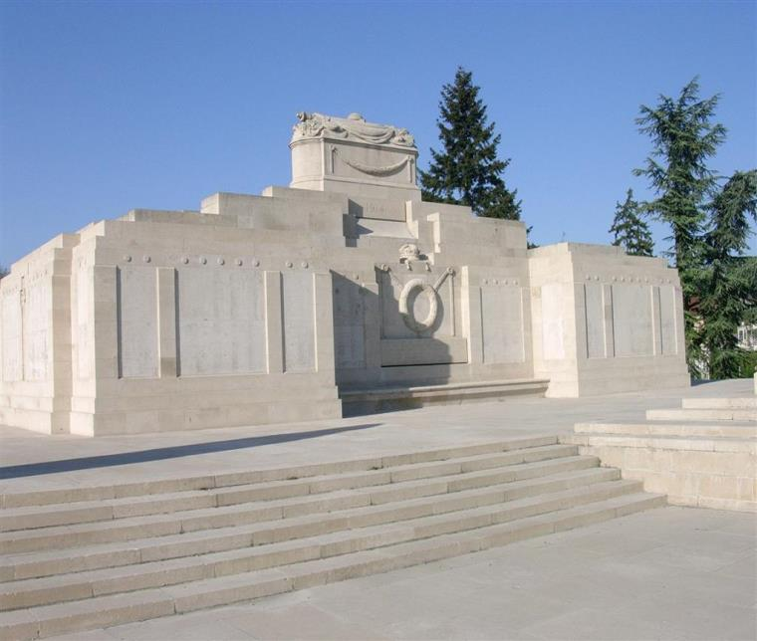
Photographs courtesy of Su Handford taken 23rd April 2014

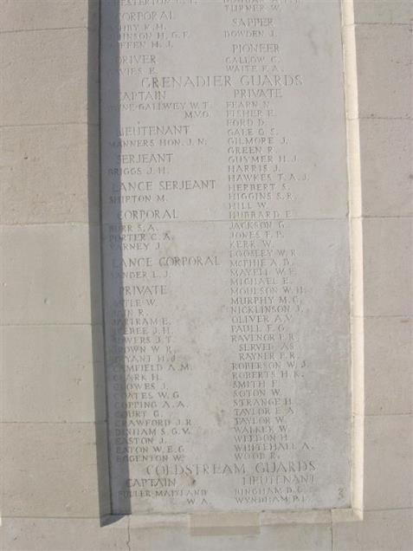
Photographed by Su Handford

Antecedents for Walter Gordon COATES

- Born in Crumpsall, Lancaster in the first quarter of 1889.
- His Parents were Walter and Emma Coates, Nee Broughall.
- In 1889 the family must have fallen on hard times as he was in Manchester Workhouse with his parents, his brother William and his sister Marguirite.
- His father’s profession is stated as a farm bailiff, but he was unemployed.
- In the 1901 census the family are lodging with another family in Littleover Derby.
- His older brother William is no longer with the family, but there is a younger sister Annie.
- In the 1911 census Walter has joined the army. He is in the 2nd Battalion of the Grenadier Guards Blenheim Barracks, Government House, Camp Nursery, Vine Cottage, Poverty Place and Blandford House, Marlborough Lines, Aldershot.

