Private 17322 Thomas CALDICOTT
1st Battalion Coldstream Guards
Birmingham City Police ‘E’ Division PC E167
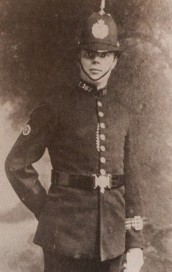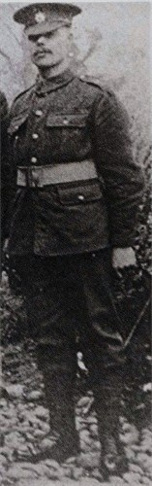
By kind permission of family member John Perry

Died Belgium 5th August 1917 aged 27

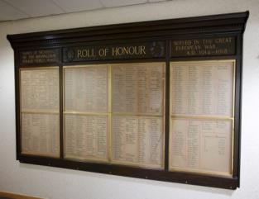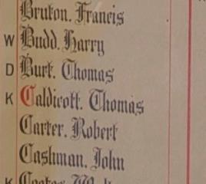
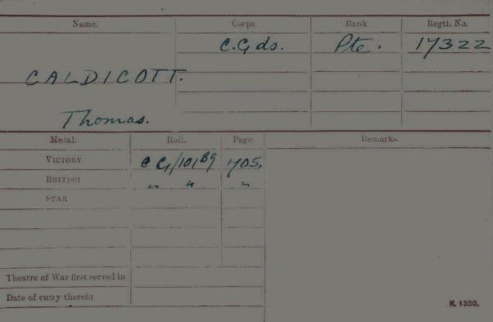
British Army WW1 Medal Rolls Index cards 1914-1920

Police Service History

Thomas joined Birmingham City Police 17th July 1911 as a plate layer. He served on the ‘E’ Division with warrant number 7865. He resigned 15th November 1915 to join the army.

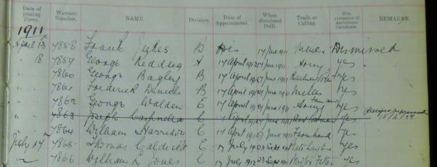

Birmingham City police Records dated 12th November 1915 show constables granted permission to join H.M. Forces

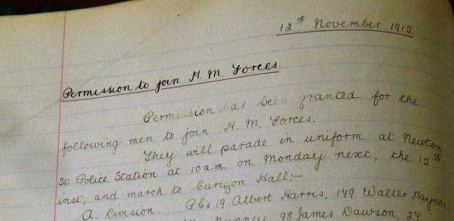
Permission has been granted for the following men to join H.M. Forces

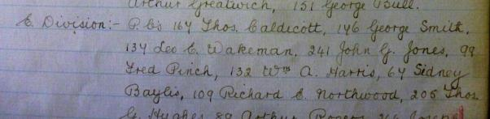
PC E167 Thos Caldicott

Birmingham City police records dated 13th March 1918
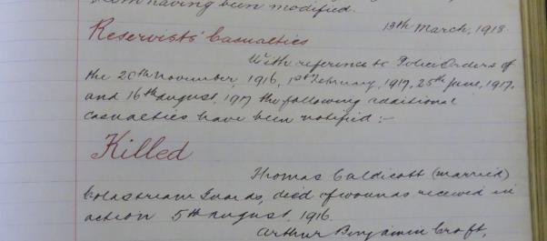

Reservists’ casualties
With reference to Police Orders of the 20th November 1916, 1st February 1917, 25th June 1917, and 16th August 1917, the following additional casualties have been notified;
KILLED Thomas Caldicott (married) Coldstream Guards died of wounds received in Action 5th August 1916

War Service history

Thomas’ entitlement to Victory Medal and British War Medal

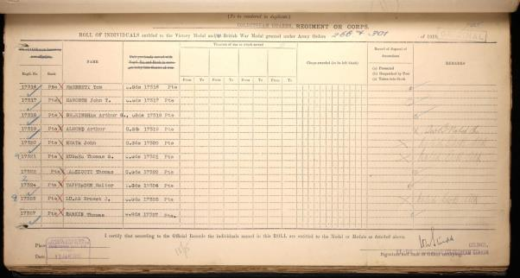

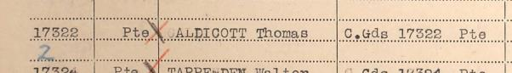

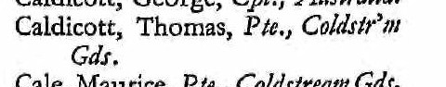
National Roll of the Great War

Thomas was wounded in action and removed to Bleuet Farm dressing station, Elverdinge where he succumbed to his injuries, aged 27.

At 3.50 am on Tuesday 31st July 1917, the first day of the Battle of Pilckem Ridge, Thomas's battalion attacked towards Langermarck from the trenches situated just north east of Boesinghe, supporting 1st Battalion, Grenadier Guards and 1st Battalion, Welsh Guards.

All initial objectives were taken with ease, with the supporting battalions taking over the advance at 7.15 am. Thomas's battalion then successfully took Fourche and Captain's Farms and consolidated the positions gained. From this time onwards rain fell without cessation for 4 days and nights effectively cancelling any further advances due to the ground being turned into a bog. All positions gained were held, no doubt under artillery and sniper fire, until the battalion was relieved during Tuesday 7th August 1917

By kind permission of family member John Perry
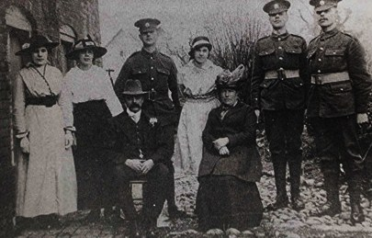
By kind permission of family member John Perry

The Caldicott family.
All three sons were Coldstream Guards, Thomas was killed in France in August 1917. Brother Charles, was wounded and spent 13 months in hospital in France and the third brother William Arthur also served and survived the War.
The photograph was taken in front of Keeling’s cottages in 1916.

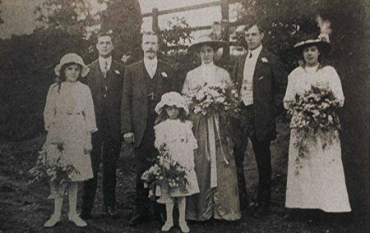
By kind permission of family member John Perry

A wedding celebrated in Gilson Hall.

The photograph was taken on the lane leading up to Gilson hall farm.

This is the wedding of Tom Caldicott to Dorothy Nurse.

The chief bridesmaid is Emma Caldicott.

The date is April 1916......Thomas was killed 5th August 1917

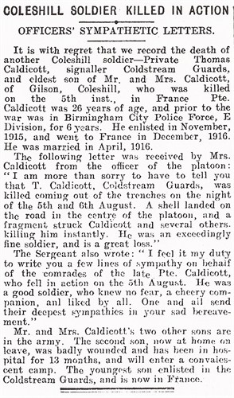

Buried Grave I B 36
BLEUET FARM CEMETERY
West-Vlaanderen, Ypres, Belgium

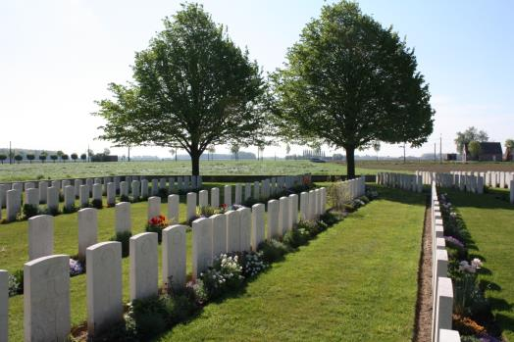
Photographs courtesy of Su Handford taken 22 april 2014

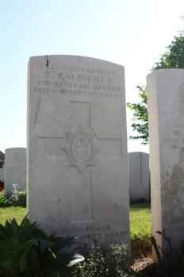

Thomas CALDICOTT IS also commemorated on Coleshill Memorial

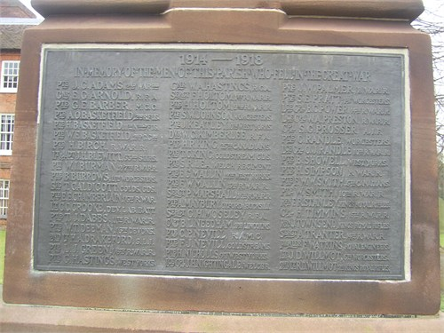

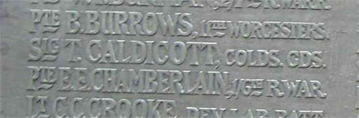

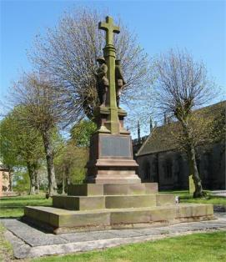
By kind permission of family member John Perry

As can be seen from the above newspaper article, Thomas’ two brothers were also in the Army and both have been researched and are within this document

Antecedents of Thomas Caldicott

- Born 1892 Polesworth.
- He was the son of John and Mary Caldicott, nee Allsop.
- His father was a railway labourer.
- He was the oldest of 6 children: Thomas, Ethel May, Mary, Charles, William Arthur, Emma In the 1901 and 1911 census he is living in the family home in Gilsow, Coleshill.
- At that date he stated he was a plate layer for the Midland Railway, as was his father.
- He was married in 1916 to Dorothy Baugh.

Pte 16328 Charles Caldicott Coldstream Guards
16 February 1897 – June 1977

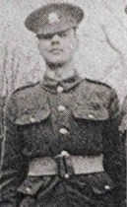

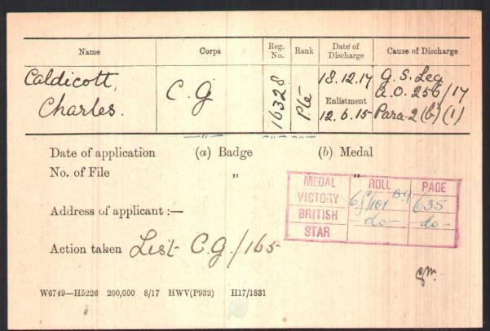

Silver War Badge records for Pte 16328 Charles Caldicott, discharged 18th December 1917 with a gunshot wound to the leg.

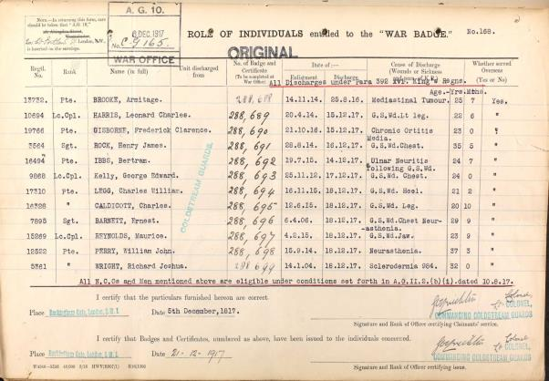

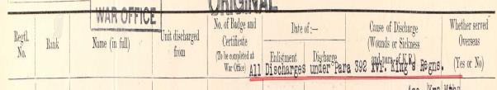

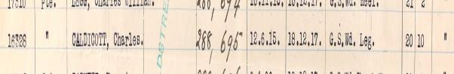

Charles’ entitlement to British War medal and Victory Medal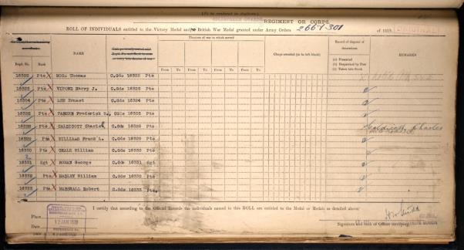

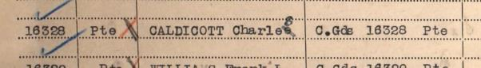

Pte 17305 William Arthur Caldicott
Coldstream Guards

June 1898 – 20 February 1965

