A/Lance Corporal P/8105 THOMAS Henry BURT

Military Police Corps (Regt) / Military Mounted Police (Bttn)

Birmingham City police ‘E’ Division PC 209

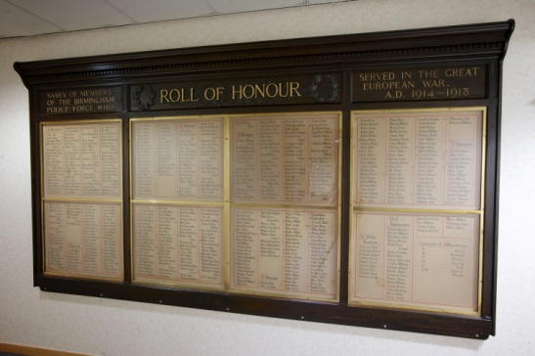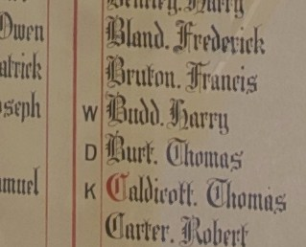

Died Aldershot, England, 27th March 1917 aged 41

There is no medal index card as Thomas did not serve abroad and had no medal entitlements

Police Service History

Thomas joined the Worcestershire Police on 16 March 1900 at which time his occupation was given as a groom.

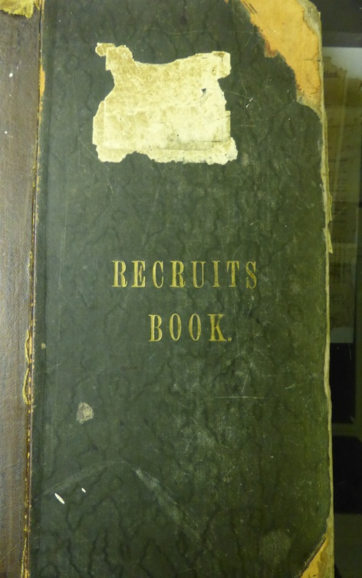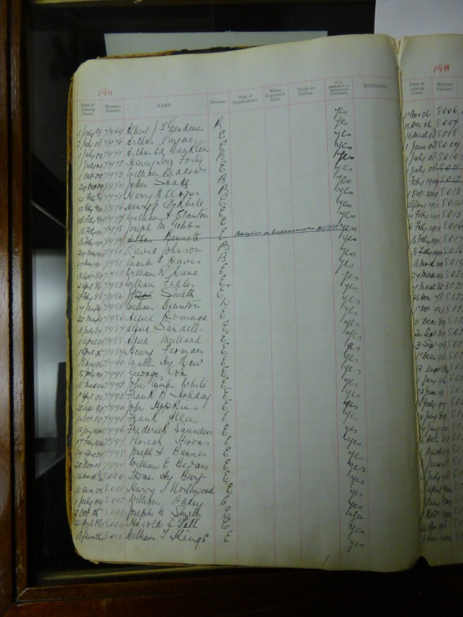

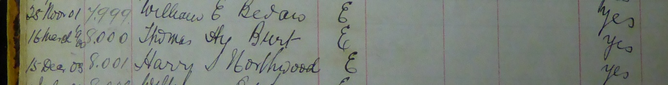

He was initially stationed at Stourport and Acocks Green before being stationed at Billesley, near King’s Heath in 1904.

When his force joined the Birmingham City Police in the 1911 Annexation, Thomas transferred on 9th November 1911 and served with warrant number 8000 and collar number E209 on the ‘E’ Division.

On reserve, he was recalled to the Army at Birmingham on 26th November 1914.

Birmingham City police Records dated 28th February 1917 show officers joining the Military Mounted Police

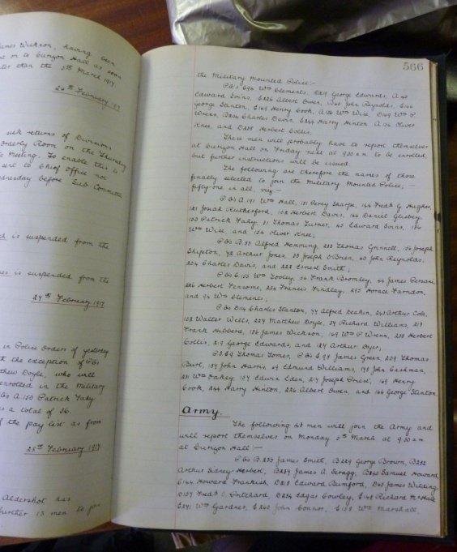

E Division constables joining the Military Mounted Police including
PC E 209 Thomas BURT

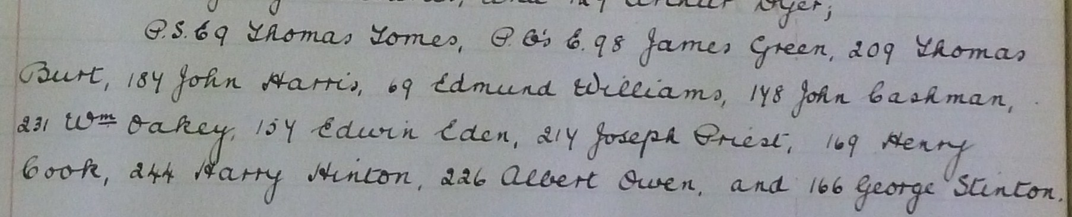

Birmingham City Police Records dated 4th April 1917 confirm PC E 209 Thomas BURT who has died whilst serving in the Military Mounted Police was not a member of the Police Mutual Association.

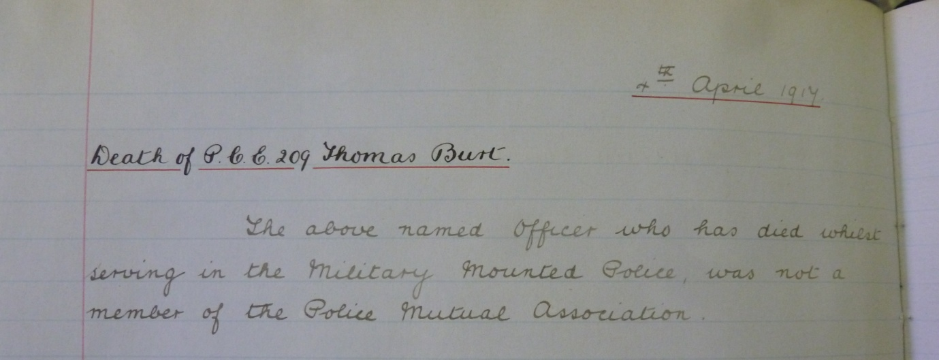

Birmingham City Police Records dated 3rd December 1917

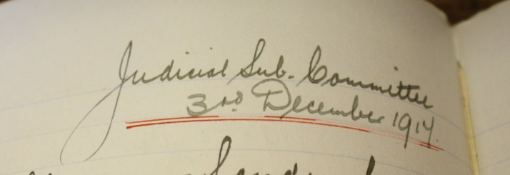
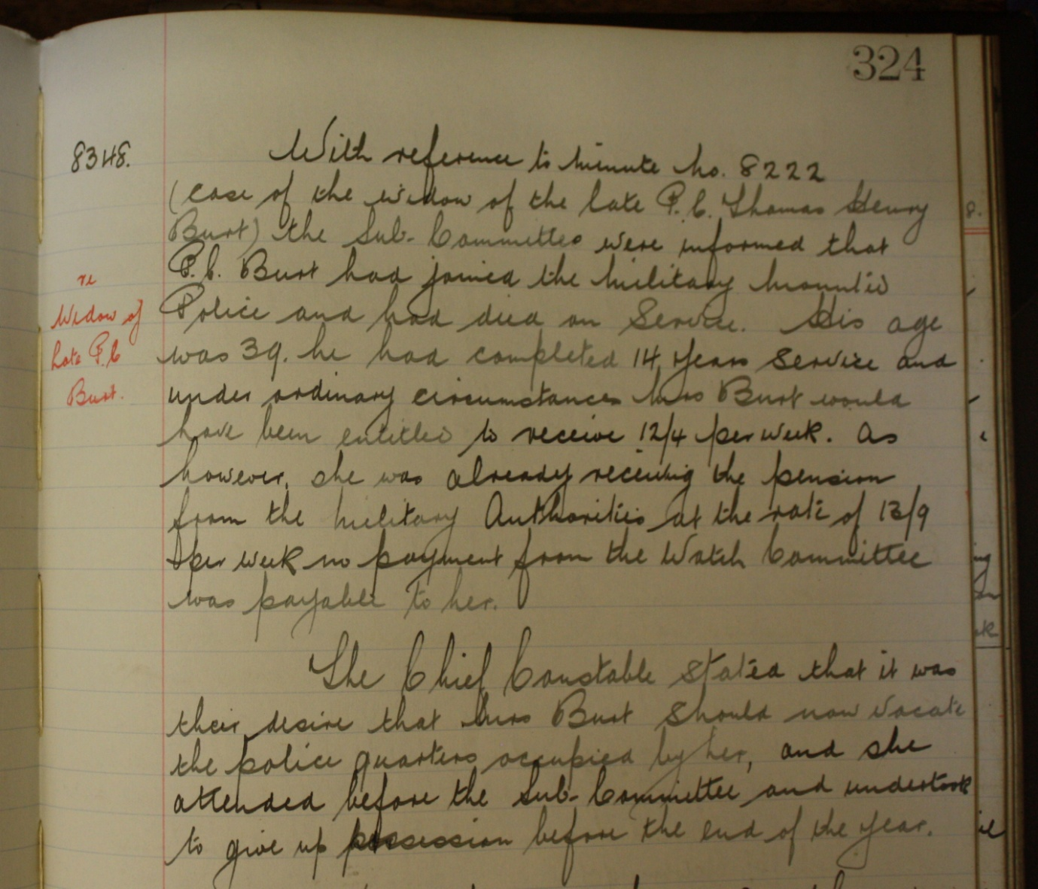

With regards to the late PC Thomas Henry BURT had joined the Military Mounted Police and had died in service, aged 39 (other records state he died aged 41).

The widow Mrs BURT is to vacate the Police Quarters, she attended before the Sub Committee and she undertook to leave by the end of the year.

Birmingham City Police Records dated 31st March 1917 give details of
PC E 209 Thomas Burt’s funeral

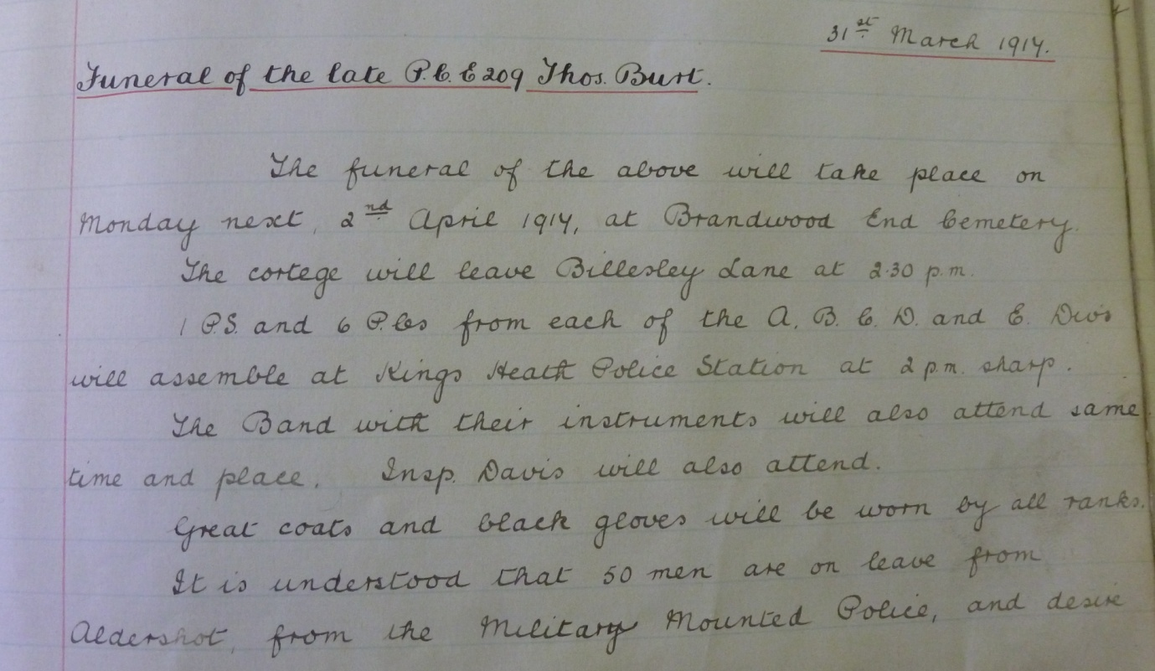
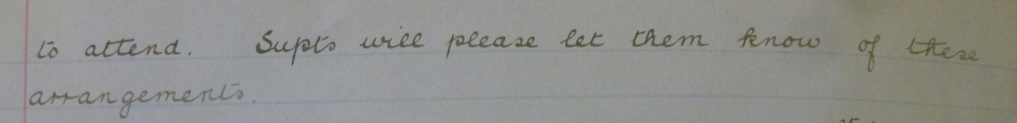

The funeral of the above will take place on Monday next 2nd April 1917, at Brandwood End Cemetery. The cortege will leave Billesley Lane at 2.30pm.

1 PS and 6 PCs from each of the A B C D and E Divs will assemble at Kings Heath Police station at 2pmsharp.

The band with their instruments will also attend same time and place. Insp David will also attend.

Great coats and black gloves will be worn by all ranks.

It is understood that 50 men are on leave from Aldershot from the Military Mounted Police and desire to attend. Supts will please let them know of these arrangements.

Birmingham Constable’s death

The City Police have received official intimation of the death yesterday at Aldershot, of Police constable Thomas Henry BURT of the E Division who for a number of years had been stationed at Billesley in the Yardley district. An old cavalryman he served in the South African War. Selected for the Military Mounted Police he left Birmingham a month ago (February 1917) and had been training at Aldershot where he died. He was a married man, and was about 40 years of age.

War service history

He served for 16 years in the Army and the Reserves; he saw active service in South Africa and was in Ladysmith at the time of the siege.

He died at the age of 41 at Aldershot of cerebo-spinal meningitis and was buried in Brandwood End Cemetery, Woodthorpe Road, King’s Heath, Birmingham, in Grave B. 2. “C.” 1173 on 2 April 1917.

The burial was attended by 1 Police Sergeant and 6 Constables who acted as bearers, the Police band and 50 soldiers from Aldershot barracks.

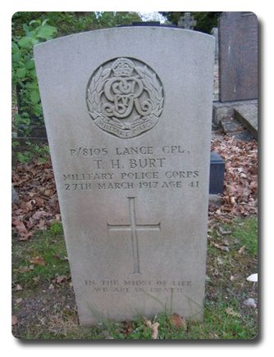
www.twgpp.com

Inscription on gravestone: In the midst of life we are in death.

9th June 1917 National Probate Calendar

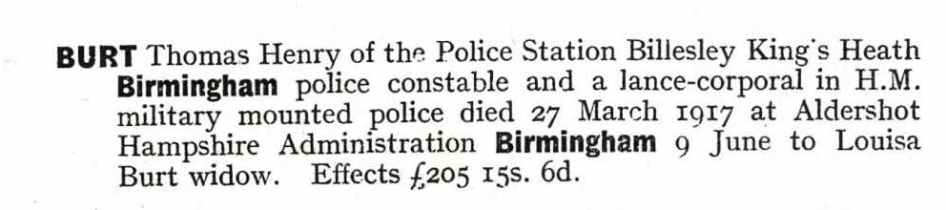

ANTECEDENTS FOR THOMAS HENRY BURT

- Thomas was born in Hanley Castle, Worcestershire, the son of Charles and Abigail (nee Medens) Burt of Malvern Common, Great Malvern, Worcestershire and later of 1, Laburnum Cottage, Court Road, Elmside, Great Malvern, his father being a domestic gardener. His mother passed away in 1904.
- Thomas was married to Louisa Schofield at Ledbury in 1904 and resided at 1, Chepstow Terrace, Brook Lane, King’s Heath, Birmingham.

1911 Census shows Thomas Henry BURT aged 32 Head of household and a police officer serving in Worcestershire Constablulary and a British subject by parentage.
Married for seven years to Louise BURT aged 33 born in Great Malvern.
Residing with his sister Gertrude BURT aged 38, single and a dressmaker.
Residing with his mother in law Elizabeth SCHOFIELD a 76 year old widow.
1911 census shows him living at this addres and married to Louisa. His sister was also living at the address.

