As of 2nd March 2015
A/Corporal 777 JAMES FRANCIS BUNN
1st Battalion Royal Warwickshire Regiment
Birmingham City Police ‘C’ Division
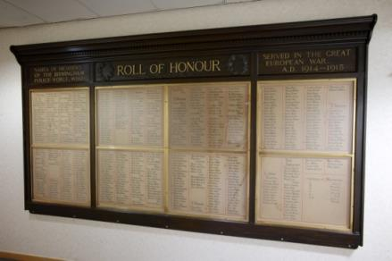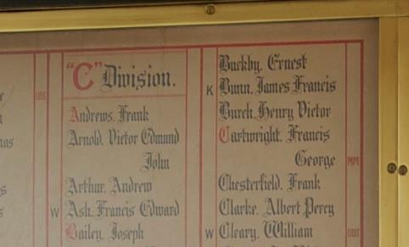
Killed in Action Belgium 23rd March 1915 aged 27

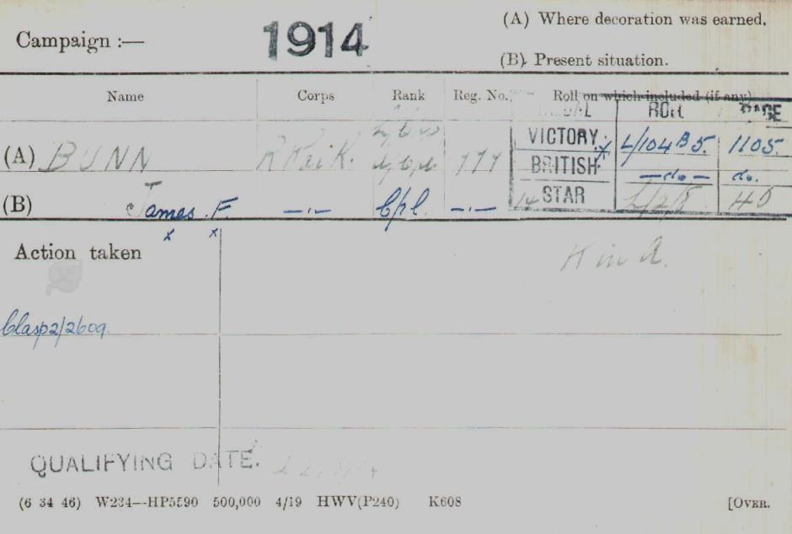

British Army WW1 Medal Rolls Index cards 1914-1920

Police Service History
(Birmingham City Police Records)

James joined Birmingham City Police 14th March 1913 his warrant number was 8295 on ‘C’ Division. He was a reservist and recalled to the colours 4th August 1914.

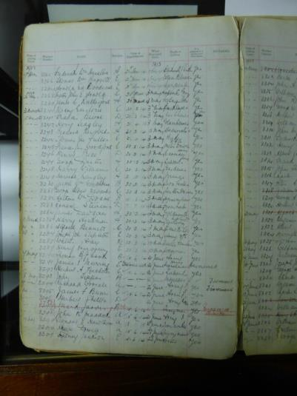

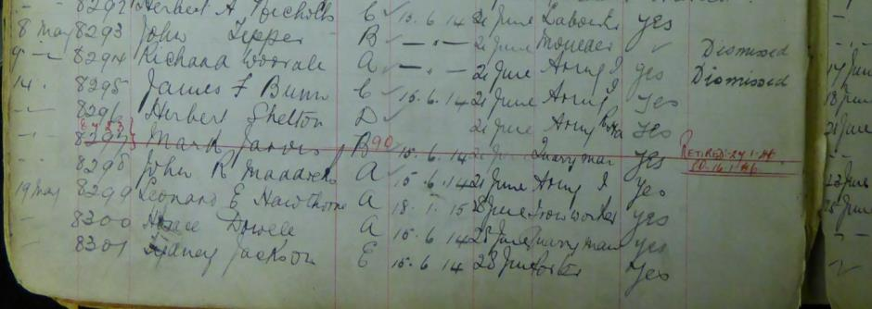

Birmingham City Police records dated 20th November 1916, recorded James’ death, killed in action 23rd March 1915 at Wulverghem, recorded some 19 months after the death. He is recorded as a single man and Corporal 1st battalion Royal Warwickshire Regiment.

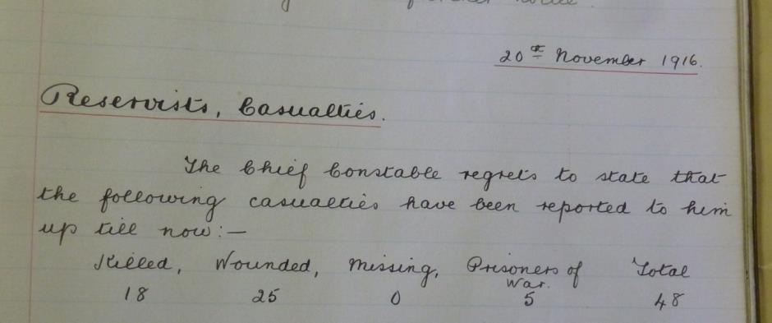

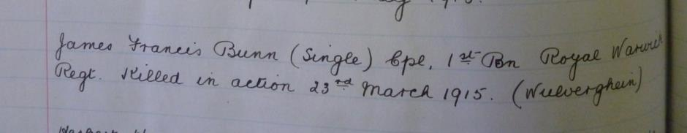

The Royal Leamington Spa Courier and Warwickshire Standard dated January 22nd 1915.

CORPORAL J. F. BUNN
“So many thanks for your most kind and welcome letter and card, which I received quite safe this morning. I can assure you, sir, it came as a pleasant surprise to me. I am pleased to tell you that I am in the best of health and spirits. Dear Mr. Taylor, I don’t know how you came to find out about me being a soldier after so many years. I joined the army in February 1906, and went to India, where I stopped until December 1912. Then I joined the Birmingham City Police Force and remained a member until war broke out. Of course, my place was back in the Army again, and I have been in the very thick of the fighting from the beginning. We are having it very rough indeed this month on account of the heavy rains. We are up to our knees in water and mud in the trenches, but I am pleased to tell you that the spirit of the troops, are really wonderful: they never seem downhearted. I think it is because we all know that we are fighting for a good cause and the Germans are only a lot of cowards, as they don’t like fighting men. Poor women and children are what they like to fight.”

A service was held at The Parish Church Birmingham Sunday 5th December 1920 3.30pm to remember the members of Birmingham City Police who were killed in action, those who died on active service from wounds and those who died from illness due to war service.

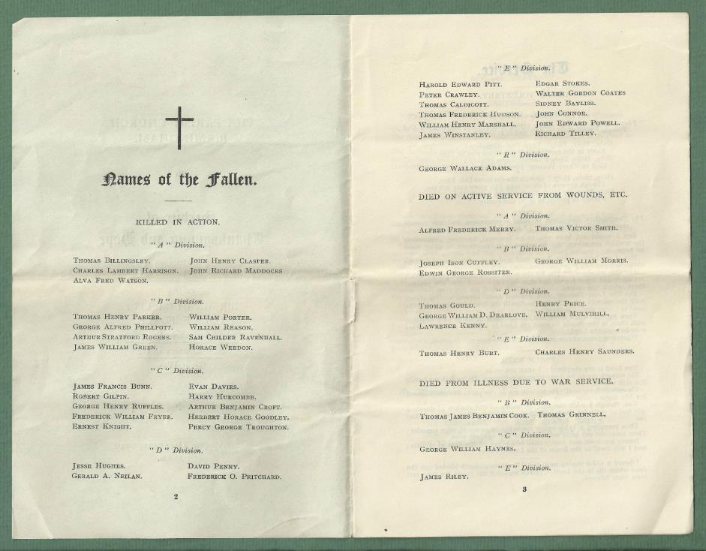

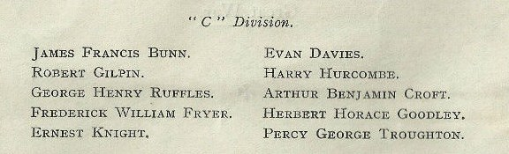

War service History

He enlisted at Warwick, and as can be seen from his letter, he joined the army in February 1906, and went to India, where he stopped until December 1912. Then he joined the Birmingham City Police Force and remained a member until war broke out and said, “Of course, my place was back in the Army”

He was killed in action on 23 March 1915 Aged 27

At the beginning of March 1915 James's battalion was in the line in the St Yves sector being relieved to Armentieres on Monday 15th March 1915. A return was made to the front lines on Sunday 21st March 1915 with the battalion taking over positions on the Steenbeek and a reserve line at La Plus Douve Farm in the Wulverghem sector.

From the time the battalion took over responsibility for the trenches, they were continually shelled and sniped at, the War Diary records the events:

"21 March 1915 - Battalion relieved D.C.L.I and Manchester regiments in trenches at Wulverghem in evening. 1 Coy Argyles attached and placed in reserve at La Plus Douve Farm. 1 killed, 2 wounded.

22 March 1915 - sniping rather active during the morning opposite 'D' Coy. No shelling. 1 Coy Seaforth Highlanders relieved 'D' Coy in right trench. 'D' Coy relieved Argyles in reserve. 1 killed, 1 wounded." On the day of James's death the War Diary records, " 'A' Coy trenches were shelled during the morning while some heavies dropped near trenches more to our left.

Sniping very active, during the night of 22/23 rd patrols went out from all Companies but no German movements were located. 1 killed, 4 wounded".

Buried Grave I D 7
RATION FARM (LA PLUS DOUVE) ANNEXE
Comines-Warneton, Hainaut, Belgium

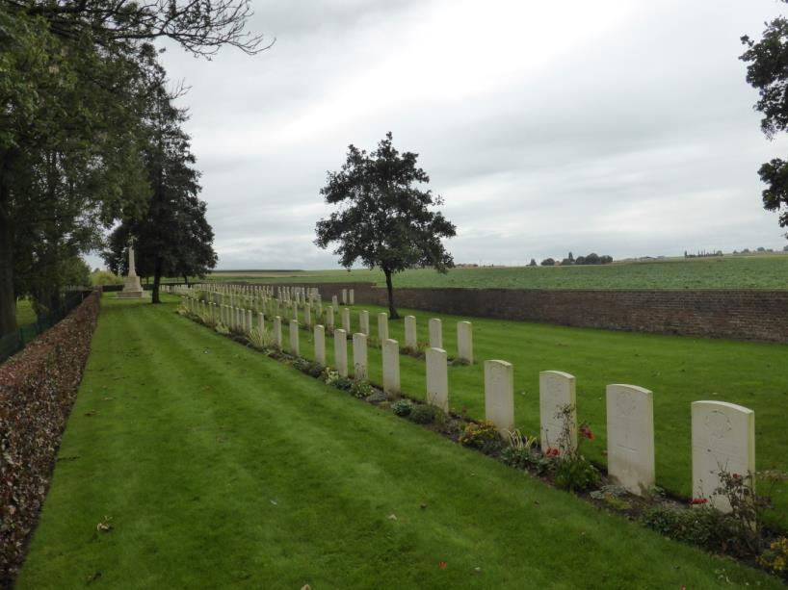
All photographs courtesy of Su Handford taken 28th August 2014

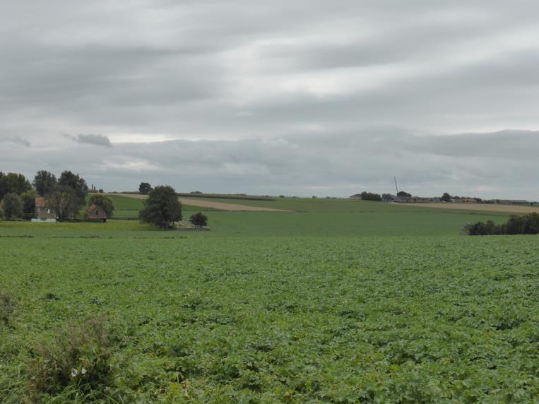

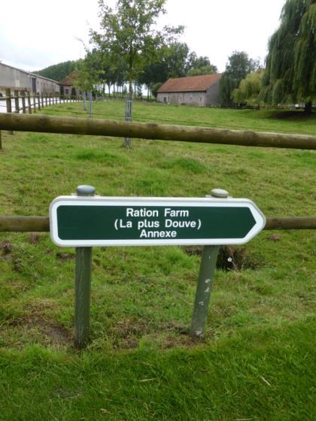

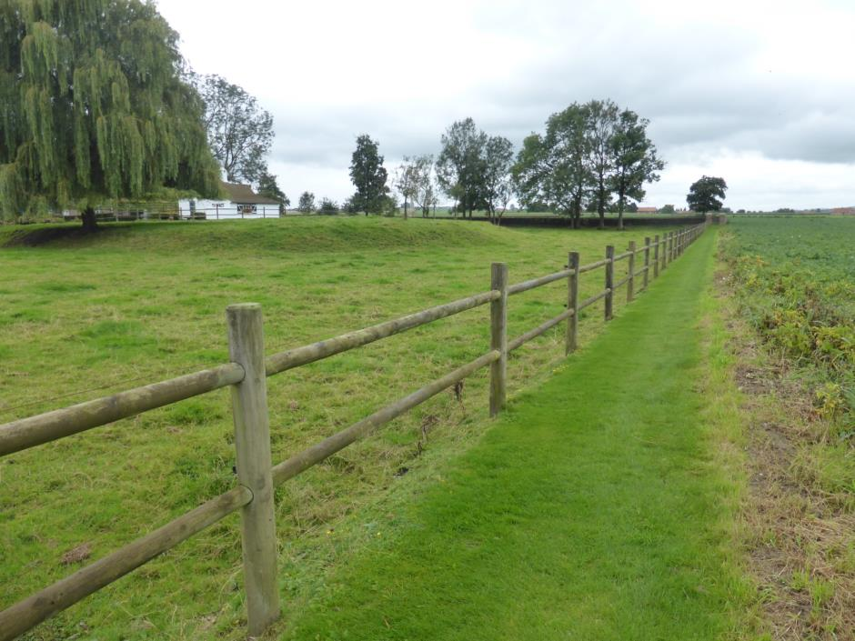

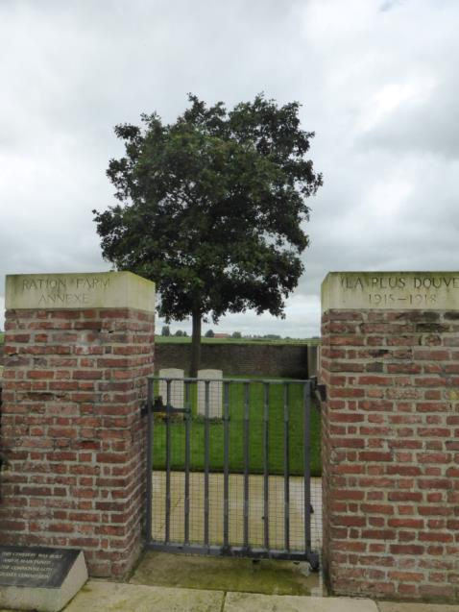

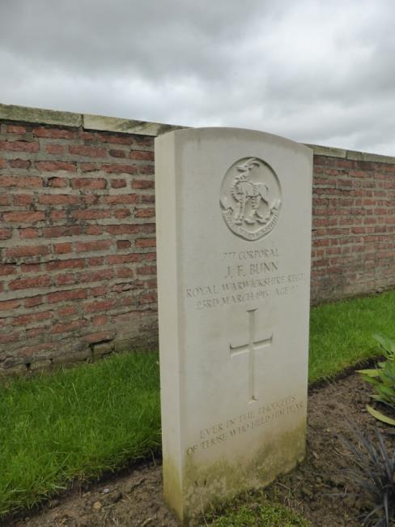

His family paid to have his headstone inscribed
'EVER IN THE THOUGHTS OF THOSE WHO HELD HIM DEAR'

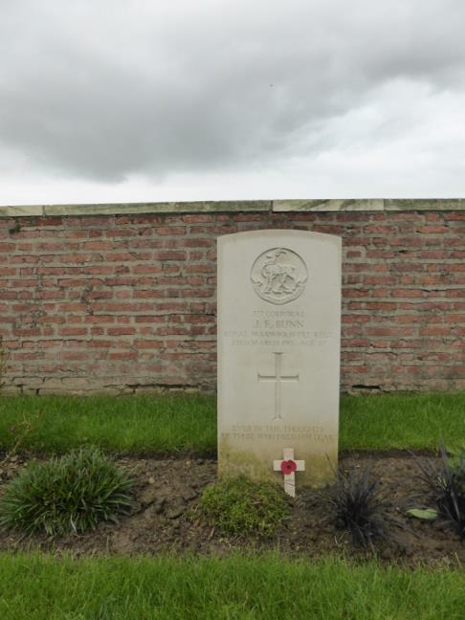
Antecedents for James Francis BUNN

- Born in 1888 St John’s in Leamington
- Son of James and Emma Louisa Bunn of 71, Shrubland St, Leamington Spa.
- His father was a general labourer.
- 1911 Census shows James Francis BUNN as a Lance Corporal aged 23, single and in the Royal Warwickshire Regiment.
- James was baptised 26 October 1887 in St John the Baptist, Leamington Spa, Warwickshire.
- He was one of 9 children Frank, William, James, Annie, Lily, Alice, Lizzie, Harry, Joseph.
- The family are recorded as living in Leamington in each of the census documents, in 1891 at 102 Shrubland Street, 1901 at 37 Scotland Place and in 1911 at 11 Shrubland Street Leamington where James is recorded as a soldier.
- Information from his family tree on ancestry link - richann_1

