Private 13178 Thomas BILLINGSLEY
1st Battalion Grenadier Guards
Birmingham City Police ‘A’ Division
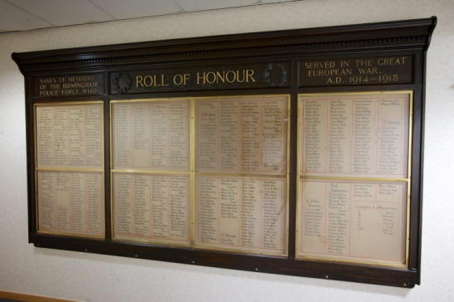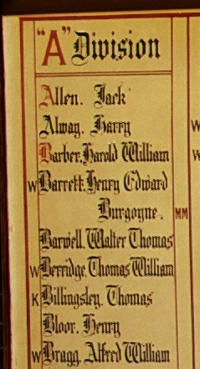
Died in France between 10th - 13th March 1915

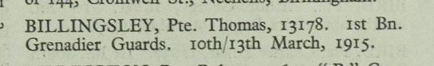

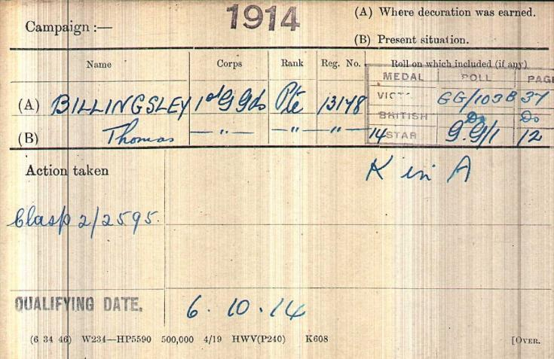
British Army WW1 Medal Rolls Index cards 1914-1920

Police Service History

Birmingham City Police records show Thomas joined Birmingham City Police 23rd May 1910 as a 21 year old labourer, and he served on the ‘A’ Division, with warrant number 7801. In the remarks filed it is written, Grenadier Guards.

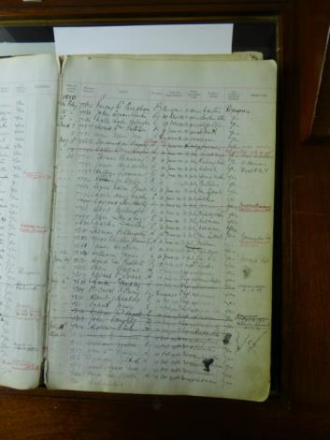

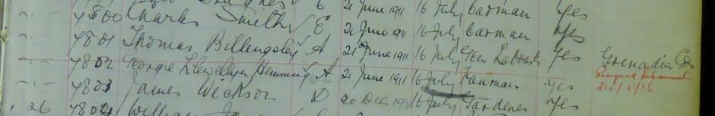

Birmingham City Police Records dated 20th November 1916, tells of Thomas’ death. He was recorded as single, and killed in action between 10th and 13th March 1915 however, it would appear Thomas was killed on the 13th from The War Diary entry.

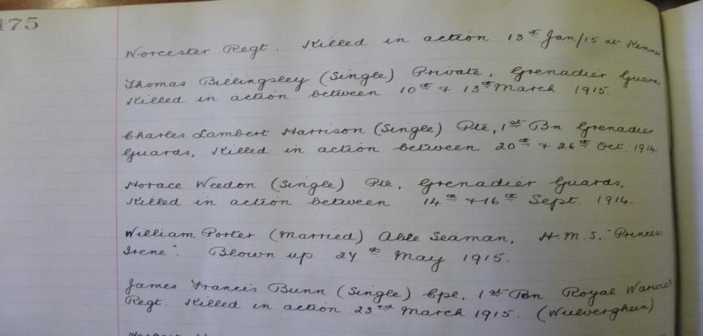

1911 census shows Thomas Billingsley aged 22 years residing at Duke Street Police Station.

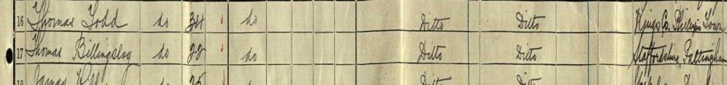

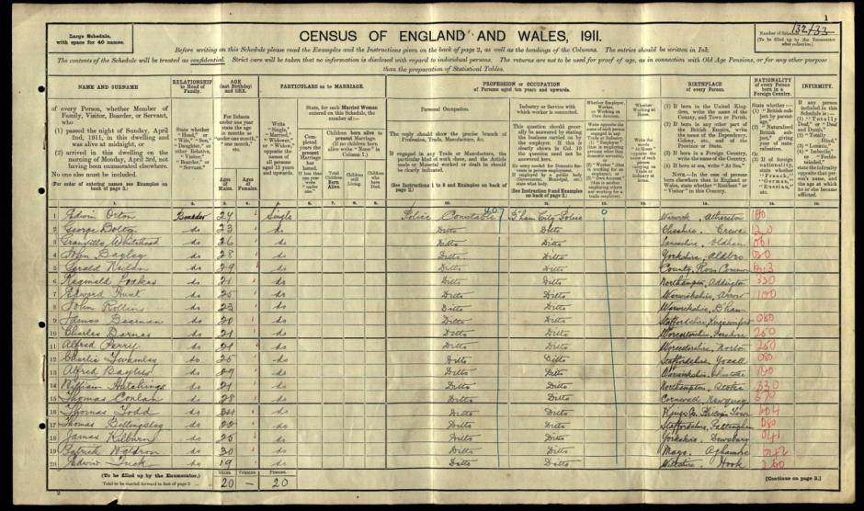

War Service History

An Army Reservist who enlisted at Wolverhampton and on 5th August 1914, he was recalled to military service

Records show he was killed between 10th – 13th March 1915, in the battle of Neuve Chapelle, but believed to be the 13th March.

On Wednesday 10th March 1915 his battalion took up reserved positions near Neuve Chapelle in Rue du Bacquerot and Cameron Lane preparatory for an attack the following day. The next day his battalion was sent forward to link up with other battalions in captured German trenches near Moulin de Pietre, their objectives being a road junction called High Trees Corner situated between Mauquissart and Nameless Cottages.

The battalion endeavoured to advance but could make no progress due to the intensity of the enemy machine gun fire encountered.

On Friday 12th March 1915 the battalion resumed their attack and made small headway consolidating all gains during the evening. Little or no progress was made the following day with the battalion having to endure German artillery barrages which caused several casualties. Relief took place that night.

Casualties for the aforementioned period amount 16 officers and 325 other ranks killed, wounded or missing.

Details from the records of soldier’s effects shows it appears the effects of Private 13178 Thomas Billingsley 1st bttn Grenadier Guards who died in action between 10th and 13th March 1915 were awarded to his mother Jane.

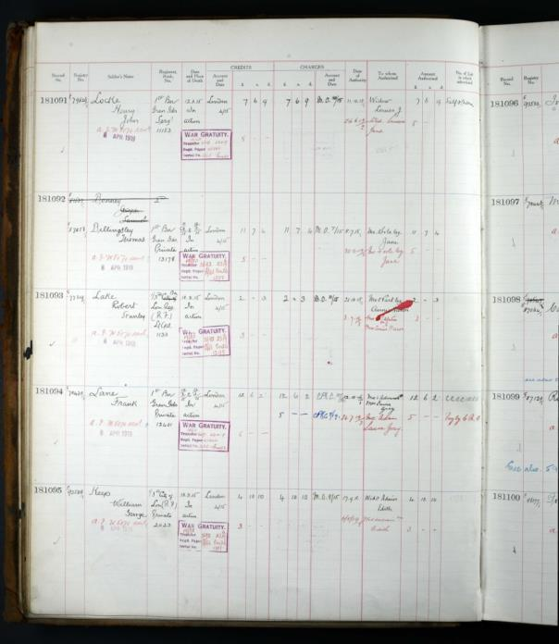

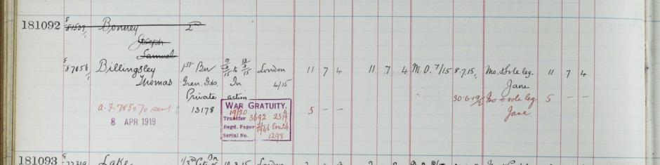

WW1 Service medal and wards roll shows Guardsman 13178 Thomas Billingsley’s entitlement to the British War Medal and Victory Medal

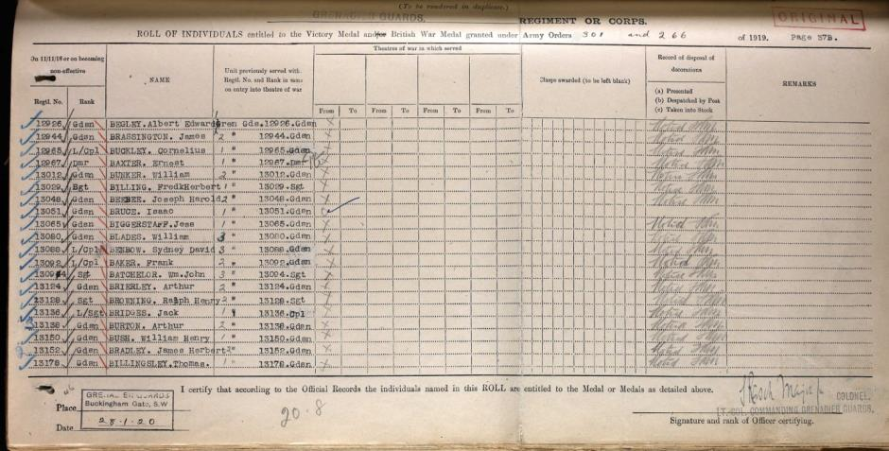

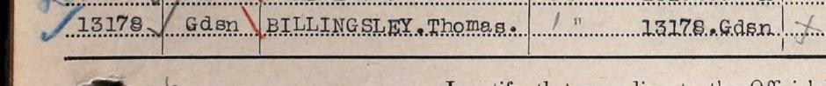

Commemorated Panel 2
Le Touret MEMORIAL Pas de Calais France

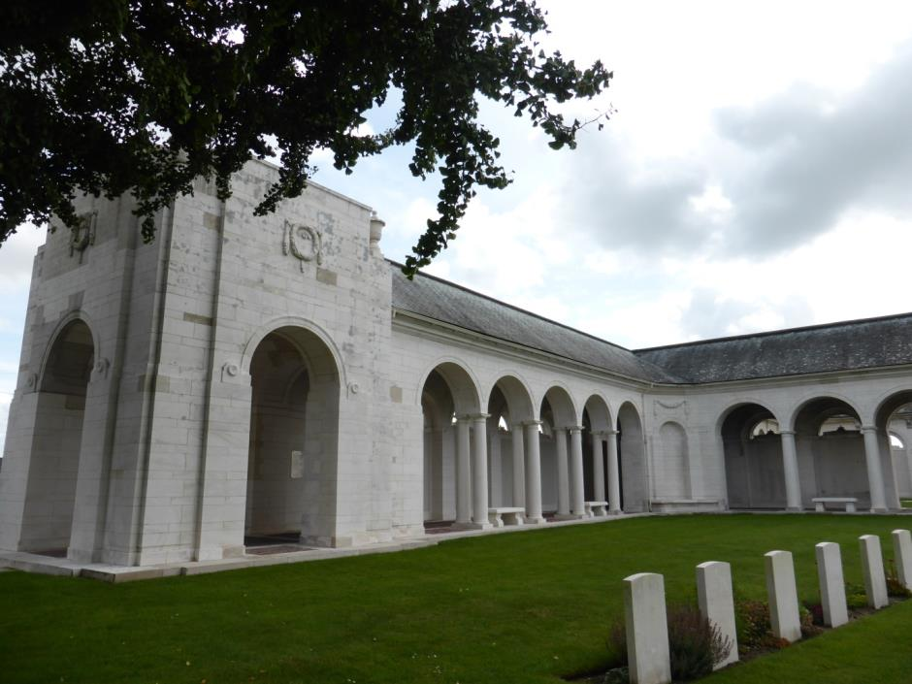
All photographs courtesy of Su Handford taken 29th August 2014

Cemetery records of Thomas’ memorial which were typed 28th November 1927

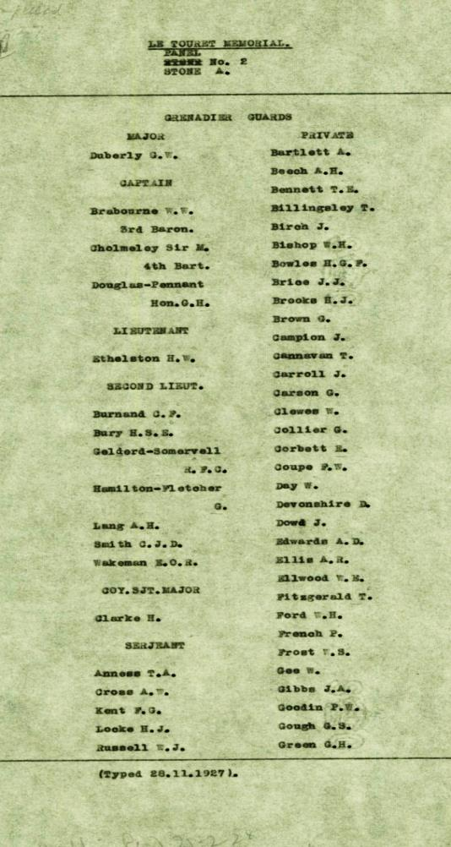

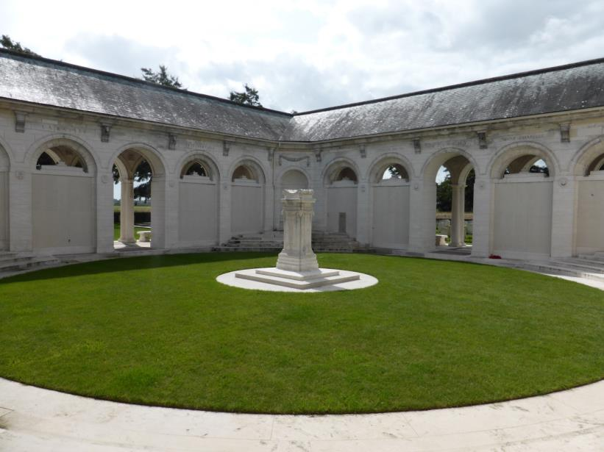

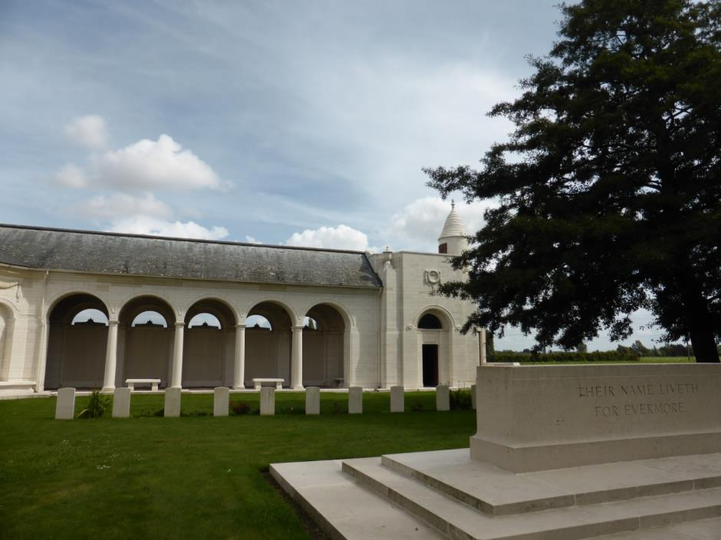
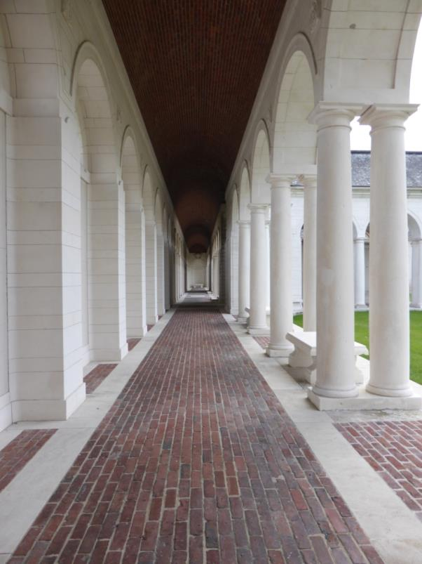

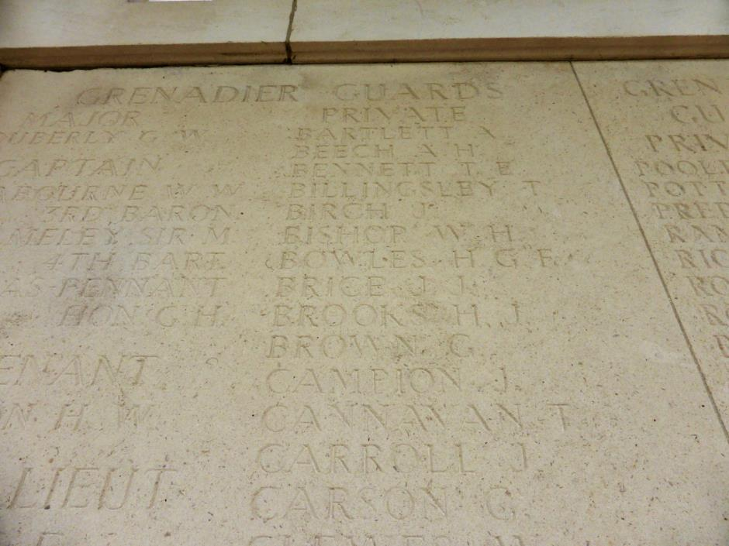

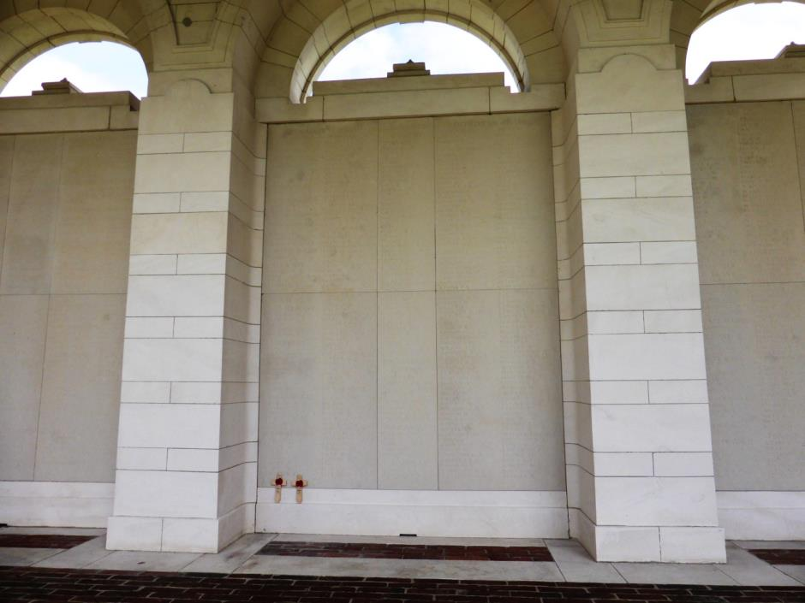

Thomas Billingsley and Herbert Horace Goodley,
both remembered 29th August 2014

Antecedents for Thomas BILLINGSLEY
CWGC.com

- Born in Pattingham Staffordshire

Contact has been made with the Archivist of Pattingham Local History Society, who after being told of Thomas’ plight in the First World War, has stated that Thomas does not appear on the Church Memorial, so thanks to the work undertaken by the members of Birmingham City Police Memorial WW1 project, the archivist has been given the details as above, so Thomas may be added to the Church Memorial. (22nd December 2014)

