March 2017
Private 25157 Sidney BAYLISS

8th Battalion East Surrey Regiment
(Formerly Pte 7476 Royal Warwickshire Regiment)

Birmingham City Police ‘E’ Division PC E 67

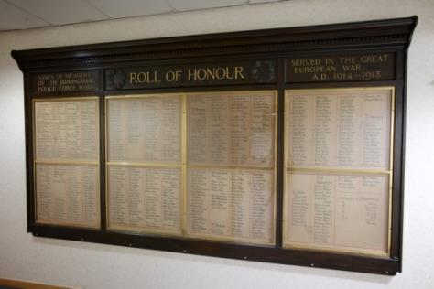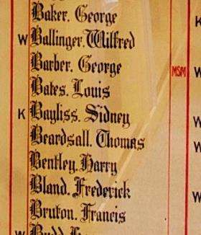

Died of wounds in France 3rd March 1917 aged 26

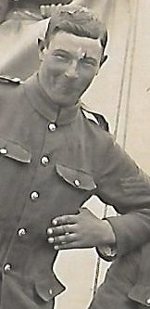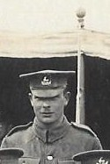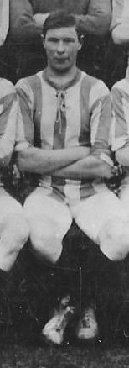

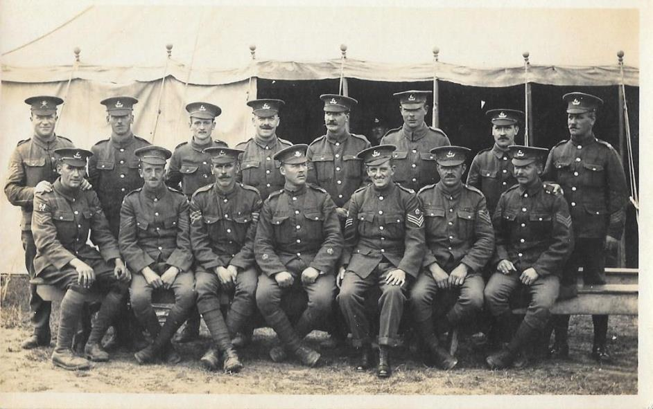
Sidney 3rd from right back row

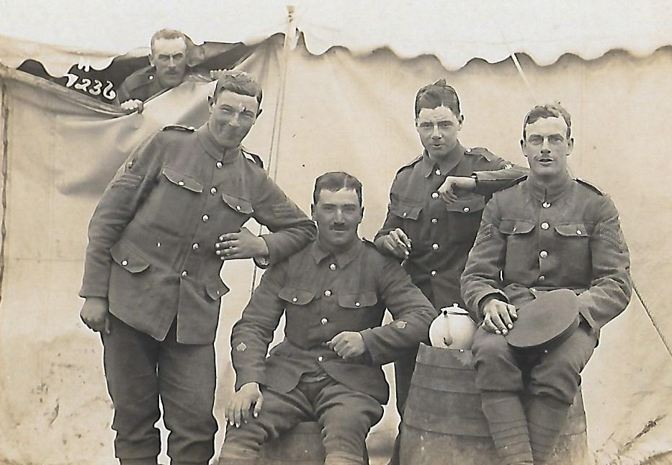
Sidney far left standing

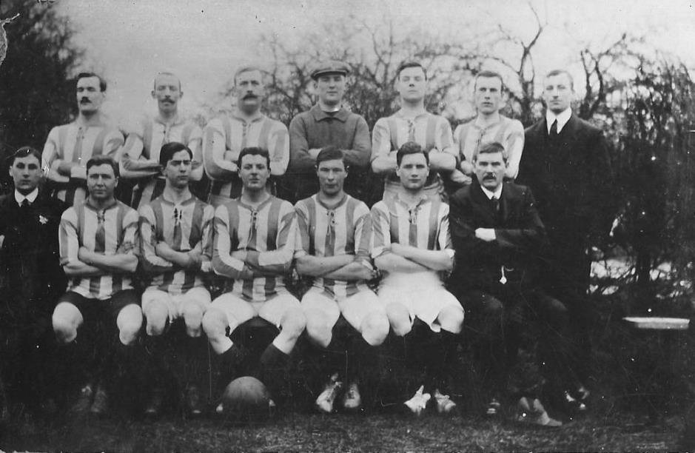
Sidney third from right front row

Photographs by kind permission and courtesy of Sidney’s great niece

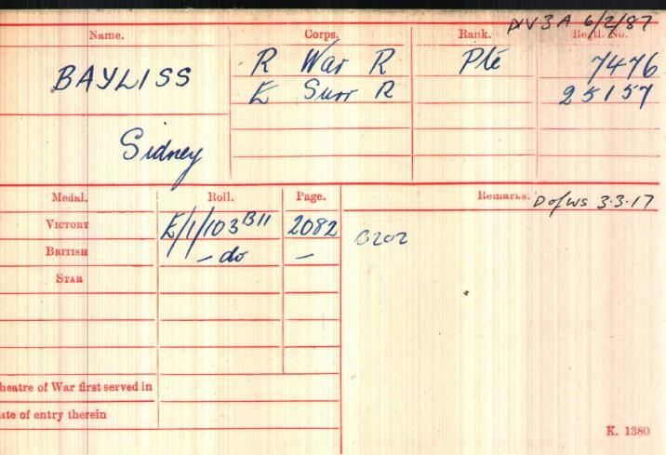
British Army WW1 Medal Rolls Index cards 1914-1920

Police Service History

Birmingham City Police Records record Sidney joined Birmingham City Police on 27th October 1913 as a 22 year old farmhand.

He served on the 'E' Division with warrant number 8389, and collar number PC E 67. Sidney resigned from the force on 5th November 1915 to enlist in the Army in Birmingham.
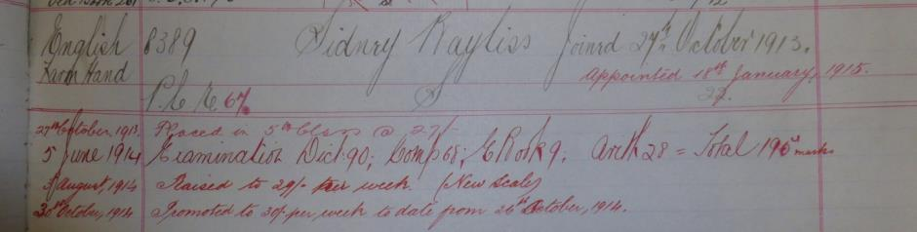
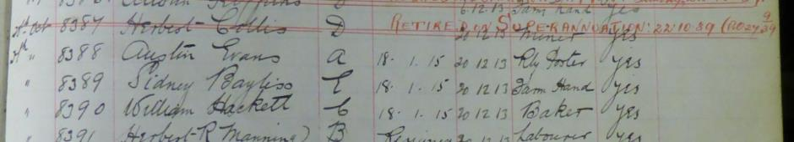

Birmingham City Police records dated 12th November 1915 show Sidney was named along with many officers who were granted permission to join the H.M. Forces
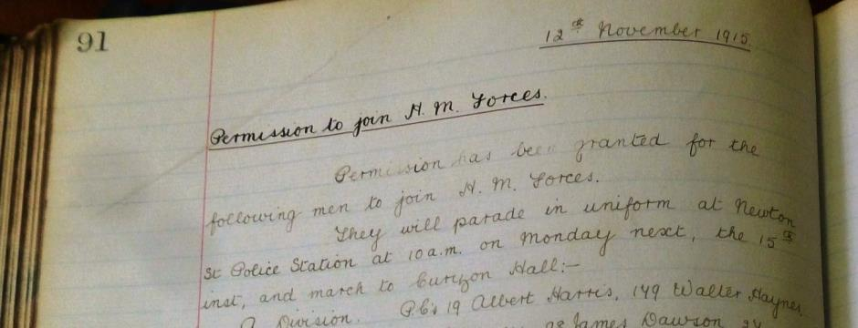
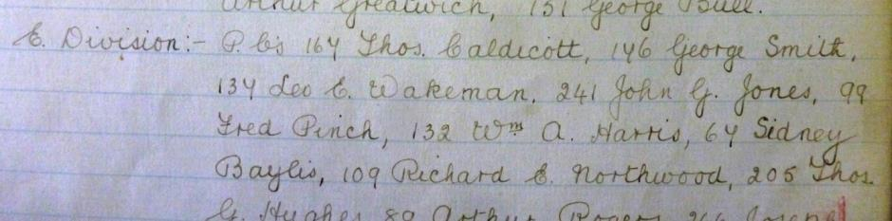

Birmingham City Police records dated 25th June 1917 give details of reservist’s casualties, with reference to Police Orders of the 20th November 1916 and 1st February 1917, the following additional casualties have been notified

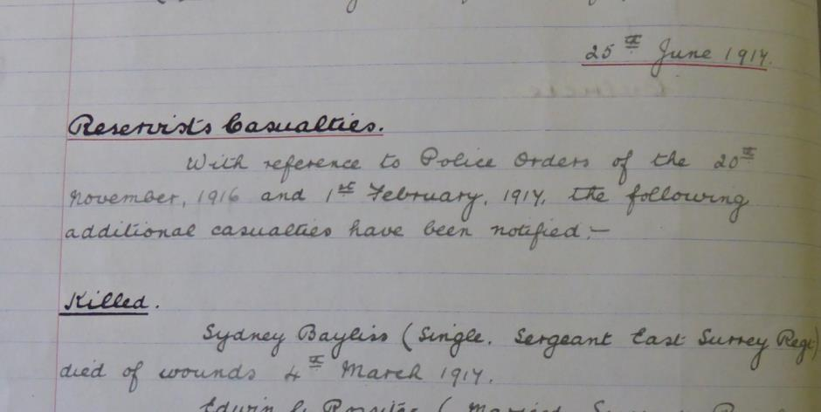

Killed Sydney Bayliss (Single, Sergeant East Surrey Regt) died of wounds
4th March 1917 (sic)

A service was held at The Parish Church Sunday 5th December 1920 3.30pm to remember those killed in action, died on active service from wounds and those who died from illness due to War service
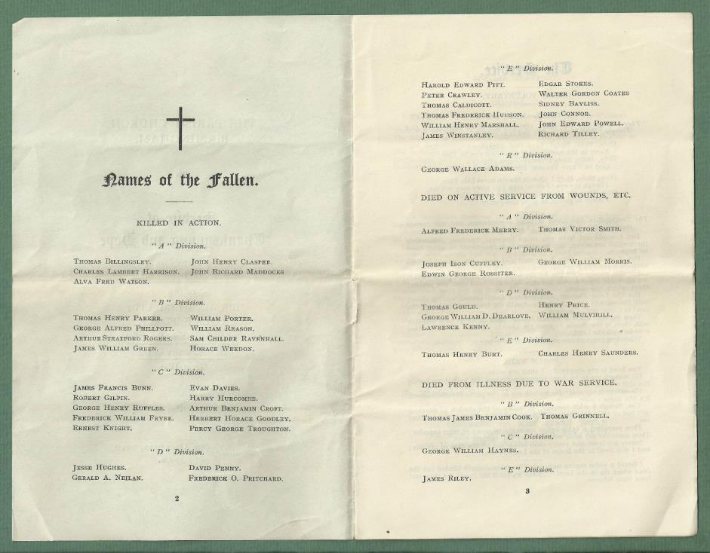
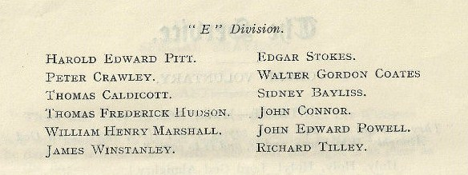

War Service History
Sidney enlisted in Birmingham. He initially joined the Royal Warwickshire Regiment, his service number was 7476 and he later transferred to the 8th battalion East Surrey Regiment.
He was later wounded in action and succumbed to his injuries at a casualty clearing station in Doullens, France aged 26.
A detailed account of Sidney’s last days can be read later within this document from letters sent to Sidney’s mother from a Canadian Chaplain who remained with him during his last days. These letters have been kindly provided by Sidney’s great niece, along with the photographs of him and his colleagues.
Sidney's battalion moved into trenches just east of Grand Court on Friday 23rd February 1917 and moved forward at 2 pm on Monday 26th February 1917 relieving battalions in South Miraumont Trench, Regina Trench and Boom Ravine. At 4.30 am on Wednesday 28th February 1917 a small patrol under 2nd Lieutenant Astington was ordered to make its way up Resurrection Trench from the Irles - Miraumont Road to ascertain what had happened to a previous patrol sent up the night before and of which there had been no news. During the day it was decide to send a further patrol under 2nd Lieutenant Hall and that the two patrols should attack and occupy a nearby German trench.
The attack took place at midnight and was entirely successful for the loss of Lance Corporal Rice. The War Diary continues, "This small attack drew a very heavy bombardment from the enemy guns, which spread right and left over a considerable distance, and indicated that the enemy had been expecting that an attack would be made on Irles.
Our casualties from this artillery fire were one man killed and two wounded - all of 'A Company'. At 2.30 am on Friday 2nd March 1917 the battalion made an attack on a German trench running parallel to that held by 2nd Lieutenant Hall and about 100 yards to the north.
The War Diary records, "The attack at 2.30 am having been postponed half an hour by Captain Place. It was not a success. 2nd Lieutenant William's platoon, which was taking the east end of the trench, met with heavy machine gun fire and suffered 12 casualties.
Sergeant Fidgett's platoon lost its way in the darkness and broke ground and was unable to find the trench. During the day arrangements were made with the 7th Queens Regiment who relieved us that evening. The relief started at 6.30 pm and was carried out quickly and without hitch."

Army Form dated February 26th 1917
Confirming Sidney was ill at 3 Canadian Stationary Hospital
Boulogne France from gun shot wounds received on 25th February 1917

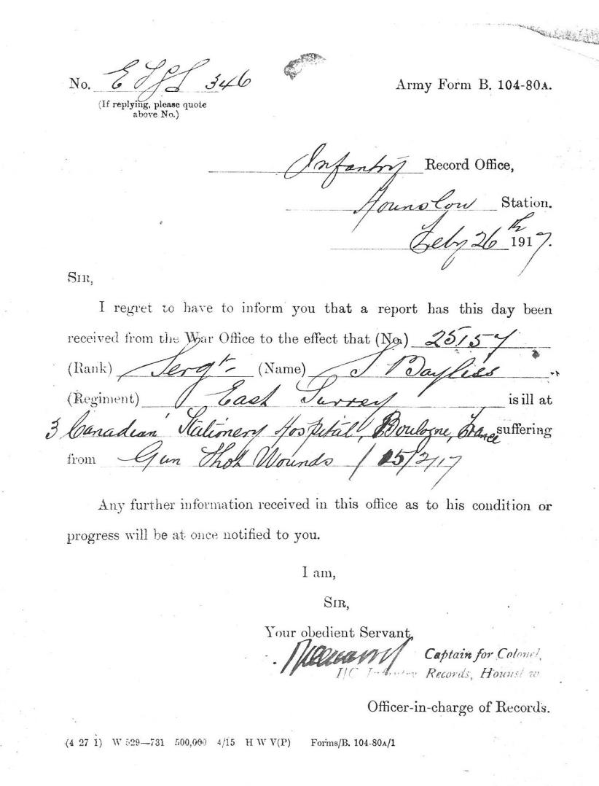
Number 3 Canadian Stationary Hospital BEF France
Dated 22nd February 2017
Dear Sir
Your son is making steady progress and is in the very best of spirits. He is getting every thing he requires and is quite content
Faithfully yours
J C Davidson
Chaplain Canadian service
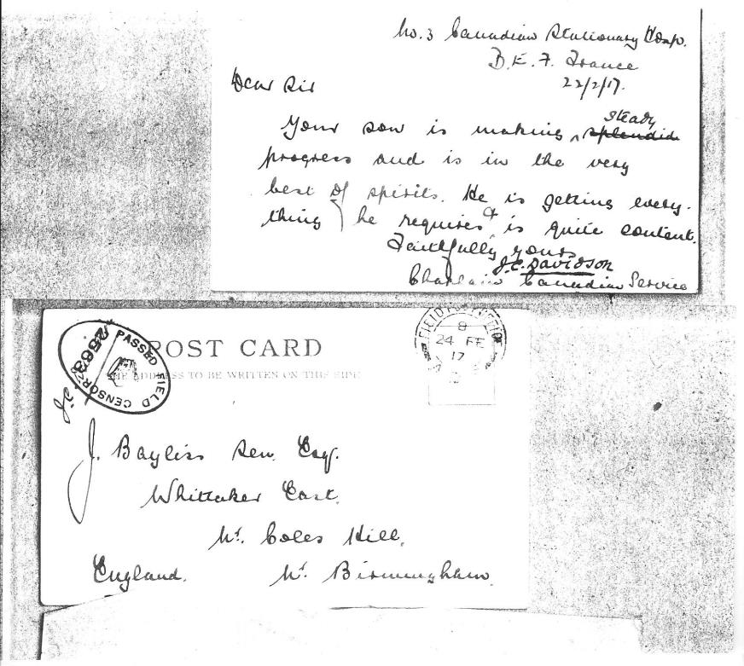
Posted 24th February 1917 to
J Bayliss Sen Esq
Whittaker East
Nr Coles Hill
Nr Birmingham England

Letter dated 1st March 1917
From Chaplain J C Davidson
To Mrs Bayliss

Dear Madam
I regret having to inform you that since writing to you last Sergt Bayliss has taken a turn for the worse. The docotrs having seen that infection was spreading through his leg decided than an operation was necessary and the leg has been taken off. The operation took place yesterday and he has not yet recovered consiousness. He is of course receiving every attention that medical skill and good nursing can possibly give him but I regret to say that is is impossible to speak definitley for the future just at present.

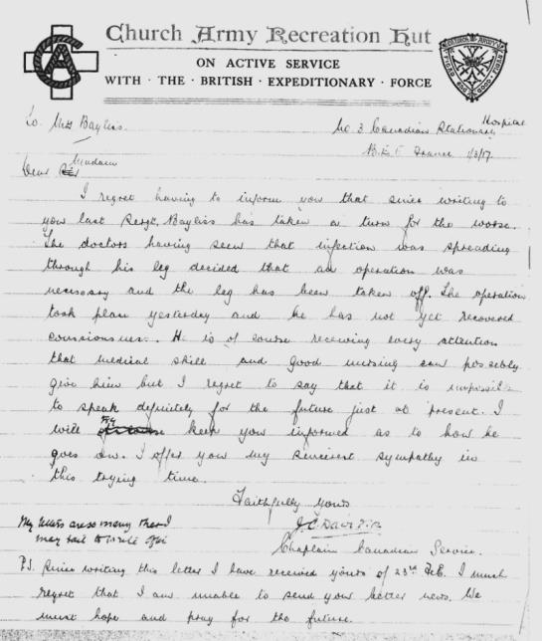

I will keep you informed as to how he goes on. I offer you my sympathy in this trying time.
Faithfully yours J C Davidson Chaplain Canadian Service
PS Since writing this letter I have received yours of 23rd Feb I much regret that I am unable to send you better news. We must hope and pray for the future

Dated 2nd March 1917 Friday evening
Dear Mrs Bayliss
I have just come from the bedside of your son Sergt Bayliss who seems to be steadily sinking. He is week and quite unconcious and the end may come at any time. In company with his nurse I had the last prayers of the Church with him.
His ease is a great disappointment to us as every effort had been made and at first things looked brighter. He was a great favoutite with us and we all liked him.
My very deepest sympathy you and his other relatives. I am so sorry to have to give you this information.
Faithfully yours J C Davidson Chaplain Canadian Service

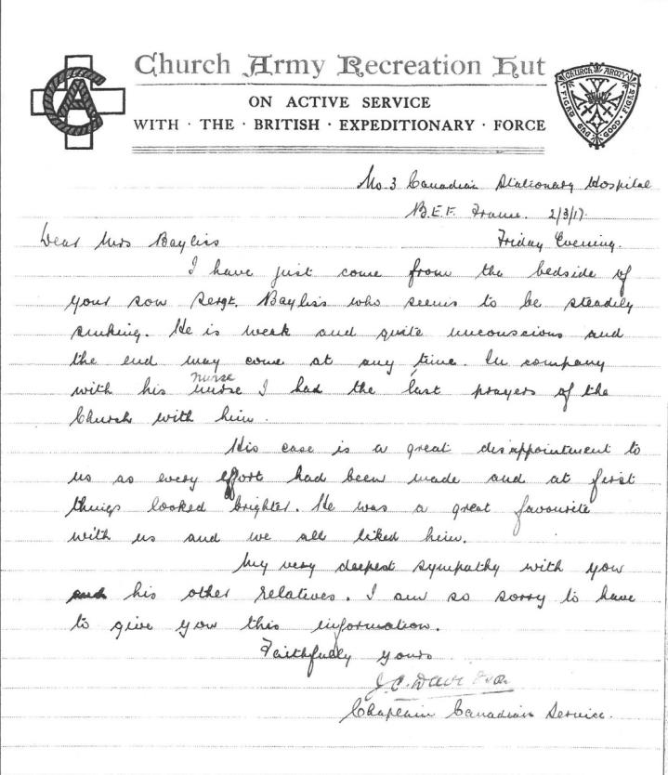

8th bttn East Surrey Regiment
11.3.1917 BEF France
Dear Mrs Bayliss
It is with much regret that I have to inform you that your son 25157 Sgt S Bayliss died of wounds on 4th March 1917. He was wounded in the taking of a German strong point on the 14th Feb.
Sgt Bayliss was a fine NCO and greatly respected by both officers and men and I am convinced had he been spared that he would have climbed still higher in his military career. After the first bitterness of your sorrow has abated I hope you will find some little consolation in the fact that your son died doing his duty with his face to the enemy. If I can supply any further informaiton I shall be only too glad to do so.

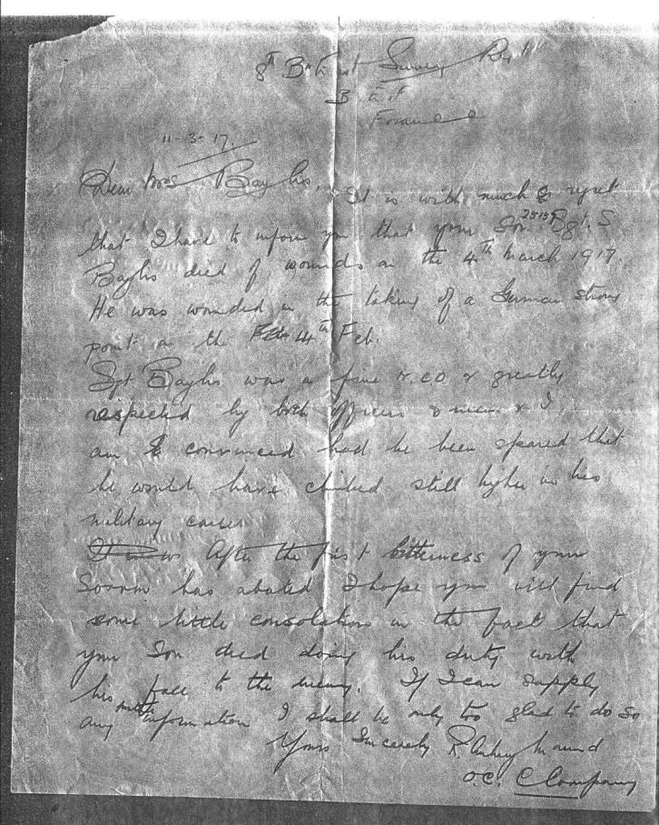
Buried grave G 20
DOULLENS COMMUNAL CEMETERY
Extension Number One Doullens, France.
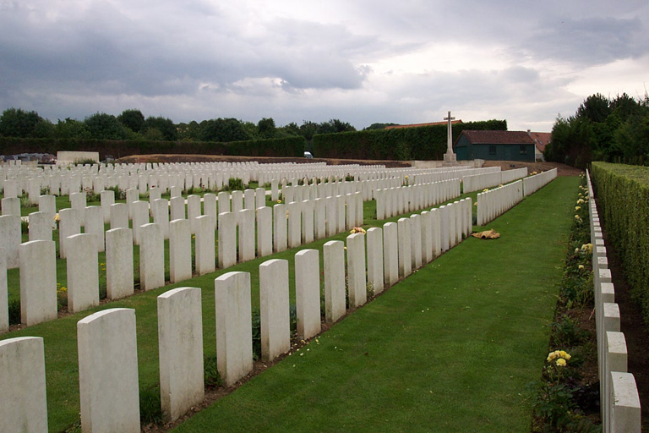
CWGC.com
Sidney is also remembered on the War Memorial/Roll of Honour in the Church of St Giles, Nether Whitacre, Coleshill
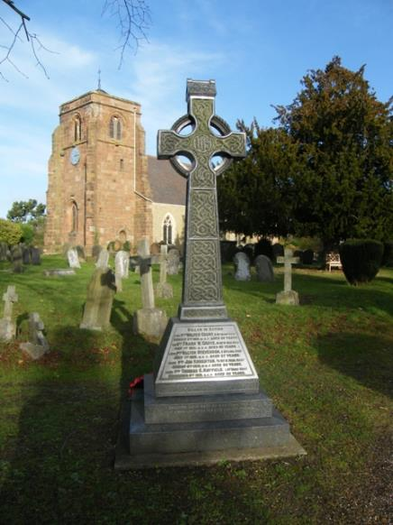
www.nnwfhs.org.uk/catch.../war-memorial-a-roll-of-honour-index

Antecedents of Sidney Bayliss

- Born Circa 1891 in Whitacre Heath, Coleshill and he also resided in Whitacre Heath, Birmingham
- Parents: James (1856) and Ann Bayliss (1856-1904) of Nether Whitacre, Coleshill, Birmingham.
- He was a resident of 3 Cottage Lane, Nether Whitacre
- Sidney's father was a farmer and sub postmaster and the children helped in the post office and on the farm. Sidney was the 6th of 9 children: Thomas (1881) Alfred (1882) Sarah Jane (1884) , John, Mary (1889) Sidney (1891) Charles (1893) Arthur (1896) and Frank (1901)
- Thomas John and Alfred were also police officers, John was believed to be in London and it would appear Thomas and Alfred served in Birmingham
- The 1911 census shows them living at Whitacre Heath.
- Sidney is remembered on the War Memorial/Roll of Honour in the Church of St Giles, Nether Whitacre.

As a result of the web site which was created by the Military History Society West Midlands Police detailing the Birmingham City Police Officers who served and feature on the WW1 Roll Of Honour, contact has been made with the great niece of Sidney who has provided the wonderful photographs and moving letters telling Sidney’s mother of his last and dying days.
Sidney’s memory and his sacrifice continue to be remembered.

